COFFEE BOARD: BENGALURU
Daily Coffee Market Report Monday, February 08, 2016

Futures Prices 05.02.2016
ICE (New York)- Arabica- US cents / lb |  |  | LIFFE(London) – Robusta -US $ / tonne and cents / lb in brackets (10 MT contract)
Month | Price | Prev. Price | Month | Price | Prev. Price
Mar – 2016 | 120.40 | 123.20 | Mar - 2016 | 1427 (64.73) | 1435 (65.09)
May – 2016 | 122.40 | 125.15 | May – 2016 | 1454 (65.95) | 1462 (66.32)
July – 2016 | 124.25 | 126.90 | July – 2016 | 1481 (67.18) | 1488 (67.49)
ICO Group Indicator price on 04.02.2016 and previous price in brackets
Other Mild Arabica |  | Robusta |  |  | Exchange Rate Rs/ US $
US Cents/lb | Rs/kg | US Cents/lb | Rs/kg
153.54 (151.76) | 228.96 (226.31) | 79.19 (74.57) | 118.09 (111.20) |  | 67.64
Futures Price Trend
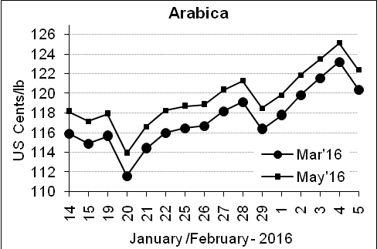
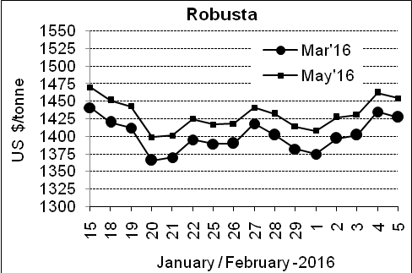

Market Analysis
ICE arabicas coffee futures eased on pressure from the weaker Brazilian real against the dollar, while a drawdown of certified exchange stocks underpinned prices. ICE March arabica coffee futures settled down 2.8 cent, or 2.3 percent, at $1.204 per lb. LIFFE March robusta coffee futures settled down $8, or 0.6 percent, at $1,427 per tonne.

.  Differentials: | Ar. Plant. A | Ar.Chy.AB | Rob.Pmt.AB | Rob.Chy.AB
.  Differentials: | NY +35 to +40 | NY –22 to –25 | LIFFE +600 to +650 | LIFFE +200 to +220

ICTA Auction Prices Rs/Kg as on 04.02.2016 (2014-15 season crop)
Grade | MNEB | AA | PB | A | AB | B | C | BBB
Arabica Plantation | --- | 218.50 | 159.06 | 214.00 | --- | 166.10 | 131.00 | 105.00
Arabica Cherry | --- | --- | 123.00 | --- | --- | --- | --- | ---
 | RKR | A | PB | AA | AB | B | C | BBB
Robusta Parchment | 120.00 | --- | --- | --- | 118.00 | --- | --- | ---
Robusta Cherry | --- | --- | 113.00 | 119.00 | --- | --- | --- | ---

ICTA Auction Prices Rs/Kg as on 04.02.2016 (2015-16 season crop)
Grade | MNEB | AA | PB | A | AB | B | C | BBB
Arabica Plantation | --- | 250.00 | 189.50 | 232.50 | --- | 182.26 | 148.00 | ---
Arabica Cherry | --- | --- | --- | --- | --- | --- | --- | ---

Raw Coffee Price (Karnataka) as on 06.02.2016 in Rs/50 kg
Ar.Pmt |  |  | Ar.Chy |  |  | Rob.Pmt |  |  | Rob.Chy
8300 | - | 8400 | 3400 | - | 3450 | 5325 | - | 5400 | 2700 | - | 2860

Export update: From 1st January 2016 to 05th February 2016 (in metric tonnes)
 | INDIAN COFFEE | Ar.Pmt | Ar.Chy | Rob.Pmt | Rob.Chy | Roasted seeds | R & G | Instant | Total
1 | Provisional exports (Indian coffee) | 5299 | 1319 | 1306 | 12228 | 4 | 17 | 1876 | 22049
2 | Provisional exports corresponding period last year | 4074 | 1625 | 994 | 8471 | 4 | 19 | 1960 | 17148
3 | Provisional re-exports | 0 | 0 | 0 | 0 | 0 | 5 | 8117 | 8122
4 | Provisional re-exports corresponding period last year | 0 | 0 | 0 | 0 | 1 | 5 | 5997 | 6002
5 | Total provisional exports (1+3) | 5299 | 1319 | 1306 | 12228 | 4 | 21 | 9993 | 30171
6 | Total provisional exports corresponding period last year (2+4) | 4074 | 1625 | 994 | 8471 | 4 | 24 | 7957 | 23150

Disclaimer: The Board neither guarantees the accuracy of the information nor accept any liability whatsoever for any direct or consequential loss arising from the use of this report

