COFFEE BOARD: BENGALURU
Daily Coffee Market Report Wednesday, February 10, 2016

Futures Prices 09.02.2016
ICE (New York)- Arabica- US cents / lb |  |  | LIFFE(London) – Robusta -US $ / tonne and cents / lb in brackets (10 MT contract)
Month | Price | Prev. Price | Month | Price | Prev. Price
Mar – 2016 | 114.75 | 115.75 | Mar - 2016 | 1387 (62.91) | 1386 (62.87)
May – 2016 | 116.85 | 117.95 | May – 2016 | 1416 (64.23) | 1416 (64.23)
July – 2016 | 118.85 | 119.95 | July – 2016 | 1445 (65.54) | 1445 (65.54)
ICO Group Indicator price on 08.02.2016 and previous price in brackets
Other Mild Arabica |  | Robusta |  |  | Exchange Rate Rs/ US $
US Cents/lb | Rs/kg | US Cents/lb | Rs/kg
146.88 (151.01) | 220.71 (225.79) | 73.80 (75.69) | 110.90 (113.17) |  | 68.16
Futures Price Trend
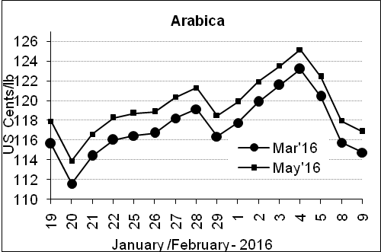
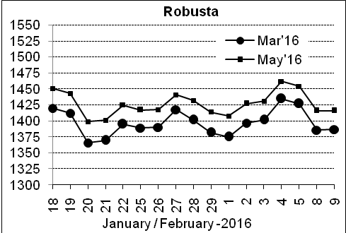

Market Analysis
ICE March arabica coffee futures settled down 1 cents, or 0.86 percent, at $1.1475 per lb. LIFFE March robusta coffee futures settled up $1, or 0.07 percent, at $1,387 per tonne.

.  Differentials: | Ar. Plant. A | Ar.Chy.AB | Rob.Pmt.AB | Rob.Chy.AB
.  Differentials: | NY +35 to +40 | NY –22 to –25 | LIFFE +600 to +650 | LIFFE +200 to +220

ICTA Auction Prices Rs/Kg as on 04.02.2016 (2014-15 season crop)
Grade | MNEB | AA | PB | A | AB | B | C | BBB
Arabica Plantation | --- | 218.50 | 159.06 | 214.00 | --- | 166.10 | 131.00 | 105.00
Arabica Cherry | --- | --- | 123.00 | --- | --- | --- | --- | ---
 | RKR | A | PB | AA | AB | B | C | BBB
Robusta Parchment | 120.00 | --- | --- | --- | 118.00 | --- | --- | ---
Robusta Cherry | --- | --- | 113.00 | 119.00 | --- | --- | --- | ---

ICTA Auction Prices Rs/Kg as on 04.02.2016 (2015-16 season crop)
Grade | MNEB | AA | PB | A | AB | B | C | BBB
Arabica Plantation | --- | 250.00 | 189.50 | 232.50 | --- | 182.26 | 148.00 | ---
Arabica Cherry | --- | --- | --- | --- | --- | --- | --- | ---

Raw Coffee Price (Karnataka) as on 09.02.2016 in Rs/50 kg
Ar.Pmt |  |  | Ar.Chy |  |  | Rob.Pmt |  |  | Rob.Chy
8250 | - | 8300 | 3200 | - | 3375 | 5400 | - | 5500 | 2700 | - | 2880

Export update: From 1st January 2016 to 09th February 2016 (in metric tonnes)
 | INDIAN COFFEE | Ar.Pmt | Ar.Chy | Rob.Pmt | Rob.Chy | Roasted seeds | R & G | Instant | Total
1 | Provisional exports (Indian coffee) | 6028 | 1449 | 1383 | 13676 | 5 | 17 | 2152 | 24710
2 | Provisional exports corresponding period last year | 4606 | 2113 | 1291 | 10206 | 4 | 24 | 2232 | 20476
3 | Provisional re-exports | 0 | 0 | 0 | 0 | 0 | 5 | 8723 | 8728
4 | Provisional re-exports corresponding period last year | 0 | 0 | 0 | 0 | 6 | 10 | 7114 | 7130
5 | Total provisional exports (1+3) | 6028 | 1449 | 1383 | 13676 | 5 | 22 | 10875 | 33438
6 | Total provisional exports corresponding period last year (2+4) | 4606 | 2113 | 1291 | 10206 | 10 | 34 | 9347 | 27606

Disclaimer: The Board neither guarantees the accuracy of the information nor accept any liability whatsoever for any direct or consequential loss arising from the use of this report

