COFFEE BOARD: BENGALURU
Daily Coffee Market Report Tuesday, February 09, 2016

Futures Prices 08.02.2016
ICE (New York)- Arabica- US cents / lb |  |  | LIFFE(London) – Robusta -US $ / tonne and cents / lb in brackets (10 MT contract)
Month | Price | Prev. Price | Month | Price | Prev. Price
Mar – 2016 | 115.75 | 120.40 | Mar - 2016 | 1386 (62.87) | 1427 (64.73)
May – 2016 | 117.95 | 122.40 | May – 2016 | 1416 (64.23) | 1454 (65.95)
July – 2016 | 119.95 | 124.25 | July – 2016 | 1445 (65.54) | 1481 (67.18)
ICO Group Indicator price on 05.02.2016 and previous price in brackets
Other Mild Arabica |  | Robusta |  |  | Exchange Rate Rs/ US $
US Cents/lb | Rs/kg | US Cents/lb | Rs/kg
151.01 (153.54) | 225.79 (228.96) | 75.69 (79.19) | 113.17 (118.09) |  | 67.82
Futures Price Trend
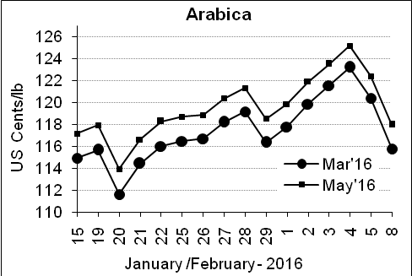
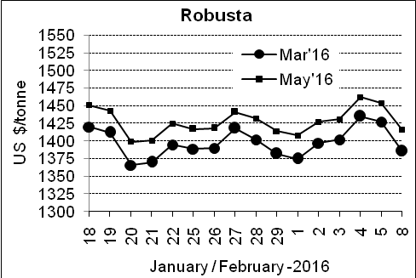

Market Analysis
ICE Arabica coffee futures fell sharply and robustas followed them lower. ICE March arabica coffee futures settled down 4.65 cents, or 3.9 percent, at $1.1575 per lb. LIFFE March robusta coffee futures settled down $41, or 2.9 percent, at $1,386 per tonne. According to the dealers they expected light producer selling this week due to Carnival in top arabica producer Brazil and the Tet holiday in leading robusta grower Vietnam.

.  Differentials: | Ar. Plant. A | Ar.Chy.AB | Rob.Pmt.AB | Rob.Chy.AB
.  Differentials: | NY +35 to +40 | NY –22 to –25 | LIFFE +600 to +650 | LIFFE +200 to +220

ICTA Auction Prices Rs/Kg as on 04.02.2016 (2014-15 season crop)
Grade | MNEB | AA | PB | A | AB | B | C | BBB
Arabica Plantation | --- | 218.50 | 159.06 | 214.00 | --- | 166.10 | 131.00 | 105.00
Arabica Cherry | --- | --- | 123.00 | --- | --- | --- | --- | ---
 | RKR | A | PB | AA | AB | B | C | BBB
Robusta Parchment | 120.00 | --- | --- | --- | 118.00 | --- | --- | ---
Robusta Cherry | --- | --- | 113.00 | 119.00 | --- | --- | --- | ---

ICTA Auction Prices Rs/Kg as on 04.02.2016 (2015-16 season crop)
Grade | MNEB | AA | PB | A | AB | B | C | BBB
Arabica Plantation | --- | 250.00 | 189.50 | 232.50 | --- | 182.26 | 148.00 | ---
Arabica Cherry | --- | --- | --- | --- | --- | --- | --- | ---

Raw Coffee Price (Karnataka) as on 08.02.2016 in Rs/50 kg
Ar.Pmt |  |  | Ar.Chy |  |  | Rob.Pmt |  |  | Rob.Chy
8300 | - | 8400 | 3400 | - | 3450 | 5325 | - | 5400 | 2700 | - | 2860

Export update: From 1st January 2016 to 08th February 2016 (in metric tonnes)
 | INDIAN COFFEE | Ar.Pmt | Ar.Chy | Rob.Pmt | Rob.Chy | Roasted seeds | R & G | Instant | Total
1 | Provisional exports (Indian coffee) | 5542 | 1319 | 1325 | 12819 | 4 | 18 | 2123 | 23150
2 | Provisional exports corresponding period last year | 4167 | 2038 | 1033 | 9048 | 4 | 21 | 1984 | 18295
3 | Provisional re-exports | 0 | 0 | 0 | 0 | 0 | 5 | 8294 | 8299
4 | Provisional re-exports corresponding period last year | 0 | 0 | 0 | 0 | 1 | 5 | 6632 | 6637
5 | Total provisional exports (1+3) | 5542 | 1319 | 1325 | 12819 | 4 | 21 | 10417 | 31449
6 | Total provisional exports corresponding period last year (2+4) | 4167 | 2038 | 1033 | 9048 | 4 | 25 | 8616 | 24932

Disclaimer: The Board neither guarantees the accuracy of the information nor accept any liability whatsoever for any direct or consequential loss arising from the use of this report

