COFFEE BOARD: BENGALURU
Daily Coffee Market Report Monday, February 15, 2016

Futures Prices 12.02.2016
ICE (New York)- Arabica- US cents / lb |  |  | LIFFE(London) – Robusta -US $ / tonne and cents / lb in brackets (10 MT contract)
Month | Price | Prev. Price | Month | Price | Prev. Price
Mar – 2016 | 115.55 | 113.00 | Mar - 2016 | 1419 (64.36) | 1382 (62.69)
May – 2016 | 117.50 | 115.00 | May – 2016 | 1441 (65.36) | 1408 (63.87)
July – 2016 | 119.35 | 116.95 | July – 2016 | 1468 (66.59) | 1437 (65.18)
ICO Group Indicator price on 11.02.2016 and previous price in brackets
Other Mild Arabica |  | Robusta |  |  | Exchange Rate Rs/ US $
US Cents/lb | Rs/kg | US Cents/lb | Rs/kg
144.27 (145.75) | 217.68 (218.56) | 73.34 (73.92) | 110.66 (110.85) |  | 68.44
Futures Price Trend
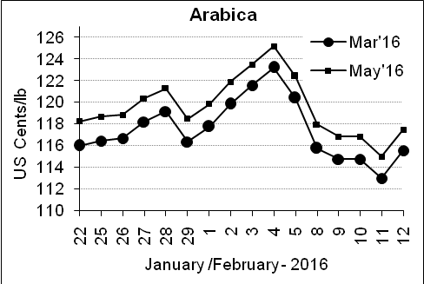
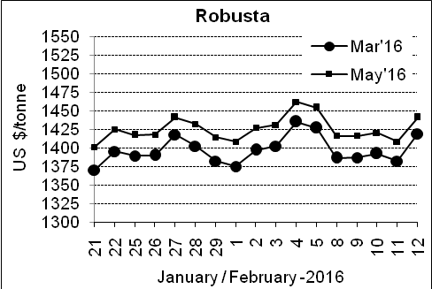

Market Analysis
ICE Arabica coffee futures rallied in heavy volume on Friday. ICE May arabica coffee futures settled up 2.5 cents, or 2.2 percent, at $1.175 per lb, but closed the week down 4 percent. LIFFE March robusta coffee futures settled up $37, or 2.7 percent, at $1,419 per tonne.

.  Differentials: | Ar. Plant. A | Ar.Chy.AB | Rob.Pmt.AB | Rob.Chy.AB
.  Differentials: | NY +35 to +40 | NY –22 to –25 | LIFFE +600 to +650 | LIFFE +200 to +220

ICTA Auction Prices Rs/Kg as on 11.02.2016 (2014-15 season crop)
Grade | MNEB | AA | PB | A | AB | B | C | BBB
Arabica Plantation | --- | 216.90 | 161.00 | --- | --- | --- | --- | ---
Arabica Cherry | --- | --- | 123.00 | --- | --- | --- | --- | ---
 | RKR | A | PB | AA | AB | B | C | BBB
Robusta Parchment | --- | --- | 111.00 | 124.00 | --- | --- | --- | ---
Robusta Cherry | --- | --- | --- | --- | --- | --- | --- | ---

ICTA Auction Prices Rs/Kg as on 11.02.2016 (2015-16 season crop)
Grade | MNEB | AA | PB | A | AB | B | C | BBB
Arabica Plantation | --- | --- | 189.36 | 234.00 | --- | 182.50 | 143.00 | ---
Arabica Cherry | --- | --- | --- | --- | --- | --- | --- | ---

Raw Coffee Price (Karnataka) as on 13.02.2016 in Rs/50 kg
Ar.Pmt |  |  | Ar.Chy |  |  | Rob.Pmt |  |  | Rob.Chy
8150 | - | 8250 | 3300 | - | 3325 | 5400 | - | 5450 | 2700 | - | 2800

Export update: From 1st January 2016 to 12th February 2016 (in metric tonnes)
 | INDIAN COFFEE | Ar.Pmt | Ar.Chy | Rob.Pmt | Rob.Chy | Roasted seeds | R & G | Instant | Total
1 | Provisional exports (Indian coffee) | 6713 | 1579 | 1386 | 15429 | 6 | 22 | 2331 | 27466
2 | Provisional exports corresponding period last year | 4972 | 2262 | 1403 | 11060 | 4 | 24 | 2346 | 22070
3 | Provisional re-exports | 0 | 0 | 0 | 0 | 0 | 5 | 9350 | 9355
4 | Provisional re-exports corresponding period last year | 0 | 0 | 0 | 0 | 6 | 10 | 8011 | 8027
5 | Total provisional exports (1+3) | 6713 | 1579 | 1386 | 15429 | 6 | 22 | 11681 | 36822
6 | Total provisional exports corresponding period last year (2+4) | 4972 | 2262 | 1403 | 11060 | 10 | 34 | 10357 | 30097

Disclaimer: The Board neither guarantees the accuracy of the information nor accept any liability whatsoever for any direct or consequential loss arising from the use of this report

