COFFEE BOARD: BENGALURU
Daily Coffee Market Report Monday, February 22, 2016

Futures Prices 19.02.2016
ICE (New York)- Arabica- US cents / lb |  |  | LIFFE(London) – Robusta -US $ / tonne and cents / lb in brackets (10 MT contract)
Month | Price | Prev. Price | Month | Price | Prev. Price
Mar – 2016 | 115.75 | 114.15 | Mar - 2016 | 1384 (62.78) | 1402 (63.59)
May – 2016 | 116.55 | 116.10 | May – 2016 | 1417 (64.27) | 1428 (64.77)
July – 2016 | 118.40 | 118.00 | July – 2016 | 1442 (65.41) | 1454 (65.95)
ICO Group Indicator price on 18.02.2016 and previous price in brackets
Other Mild Arabica |  | Robusta |  |  | Exchange Rate Rs/ US $
US Cents/lb | Rs/kg | US Cents/lb | Rs/kg
145.10 (145.82) | 219.09 (220.18) | 74.67 (74.87) | 112.75 (113.05) |  | 68.49
Futures Price Trend
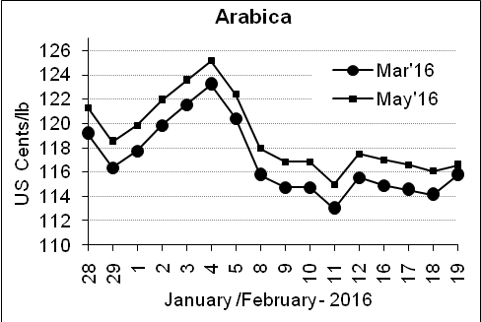
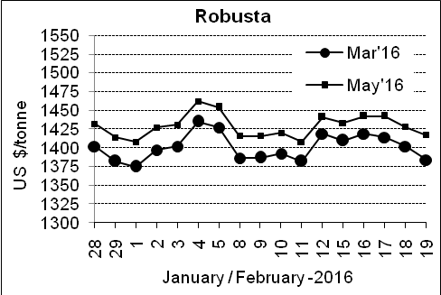

Market Analysis
ICE Arabica coffee eased as dealers awaited new market fundamentals and focused on further expected draw downs of U.S. certified stocks due to high cash premiums in producing countries. ICE May arabica coffee futures settled down 0.45 cent, or 0.4 percent, at $1.1655 per lb. LIFFE May robusta coffee futures settled down $11 at $1,417 per tonne.

.  Differentials: | Ar. Plant. A | Ar.Chy.AB | Rob.Pmt.AB | Rob.Chy.AB
.  Differentials: | NY +35 to +40 | NY –22 to –25 | LIFFE +600 to +650 | LIFFE +200 to +220

ICTA Auction Prices Rs/Kg as on 18.02.2016 (2014-15 season crop)
Grade | MNEB | AA | PB | A | AB | B | C | BBB
Arabica Plantation | --- | 228.10 | --- | --- | --- | --- | --- | ---
Arabica Cherry | --- | --- | --- | 146.00 | --- | --- | --- | 101.50
 | RKR | A | PB | AA | AB | B | C | BBB
Robusta Parchment | --- | --- | --- | 119.00 | 118.00 | --- | 110.00 | ---
Robusta Cherry | --- | --- | --- | --- | --- | --- | --- | ---

ICTA Auction Prices Rs/Kg as on 18.02.2016 (2015-16 season crop)
Grade | MNEB | AA | PB | A | AB | B | C | BBB
Arabica Plantation | --- | --- | 197.40 | 232.00 | --- | 181.00 | 142.00 | 113.00
Arabica Cherry | --- | --- | --- | --- | --- | --- | --- | ---

Raw Coffee Price (Karnataka) as on 19.02.2016 in Rs/50 kg
Ar.Pmt |  |  | Ar.Chy |  |  | Rob.Pmt |  |  | Rob.Chy
8160 | - | 8300 | 3300 | - | 3375 | 5600 | - | 5750 | 2675 | - | 2825

Export update: From 1st January 2016 to 19th February 2016 (in metric tonnes)
 | INDIAN COFFEE | Ar.Pmt | Ar.Chy | Rob.Pmt | Rob.Chy | Roasted seeds | R & G | Instant | Total
1 | Provisional exports (Indian coffee) | 8425 | 1827 | 1755 | 18133 | 6 | 35 | 2683 | 32864
2 | Provisional exports corresponding period last year | 5755 | 2503 | 1800 | 13864 | 4 | 26 | 2740 | 26691
3 | Provisional re-exports | 0 | 0 | 0 | 0 | 0 | 5 | 11246 | 11251
4 | Provisional re-exports corresponding period last year | 0 | 0 | 0 | 0 | 6 | 10 | 9033 | 9048
5 | Total provisional exports (1+3) | 8425 | 1827 | 1755 | 18133 | 6 | 40 | 13930 | 44115
6 | Total provisional exports corresponding period last year (2+4) | 5755 | 2503 | 1800 | 13864 | 10 | 36 | 11773 | 35740

Disclaimer: The Board neither guarantees the accuracy of the information nor accept any liability whatsoever for any direct or consequential loss arising from the use of this report

