COFFEE BOARD: BENGALURU
Daily Coffee Market Report Friday, February 12, 2016

Futures Prices 11.02.2016
ICE (New York)- Arabica- US cents / lb |  |  | LIFFE(London) – Robusta -US $ / tonne and cents / lb in brackets (10 MT contract)
Month | Price | Prev. Price | Month | Price | Prev. Price
Mar – 2016 | 113.00 | 114.75 | Mar - 2016 | 1382 (62.69) | 1392 (63.14)
May – 2016 | 115.00 | 116.85 | May – 2016 | 1408 (63.87) | 1420 (64.41)
July – 2016 | 116.95 | 118.80 | July – 2016 | 1437 (65.18) | 1450 (65.77)
ICO Group Indicator price on 10.02.2016 and previous price in brackets
Other Mild Arabica |  | Robusta |  |  | Exchange Rate Rs/ US $
US Cents/lb | Rs/kg | US Cents/lb | Rs/kg
145.75 (145.88) | 218.56 (218.31) | 73.92 (73.83) | 110.85 (110.49) |  | 68.02
Futures Price Trend
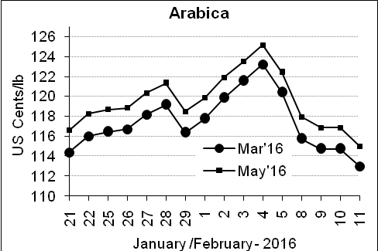
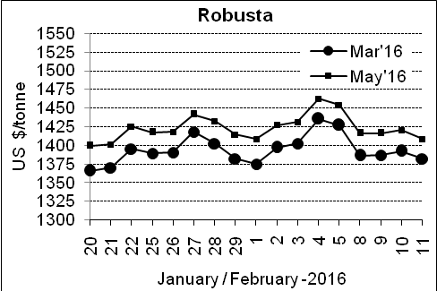

Market Analysis
ICE coffee dropped, with the spot contract returning toward a two-year low reached in January, as prices gravitated to $1.10, a level with the highest open interest in March puts. March options expired at the end of the session. ICE May arabica coffee futures settled down 1.85 cent, or 1.6 percent, at $1.15 per lb. LIFFE March robusta coffee futures settled down $10, or 0.7 percent, at $1,382 per tonne.

.  Differentials: | Ar. Plant. A | Ar.Chy.AB | Rob.Pmt.AB | Rob.Chy.AB
.  Differentials: | NY +35 to +40 | NY –22 to –25 | LIFFE +600 to +650 | LIFFE +200 to +220

ICTA Auction Prices Rs/Kg as on 04.02.2016 (2014-15 season crop)
Grade | MNEB | AA | PB | A | AB | B | C | BBB
Arabica Plantation | --- | 218.50 | 159.06 | 214.00 | --- | 166.10 | 131.00 | 105.00
Arabica Cherry | --- | --- | 123.00 | --- | --- | --- | --- | ---
 | RKR | A | PB | AA | AB | B | C | BBB
Robusta Parchment | 120.00 | --- | --- | --- | 118.00 | --- | --- | ---
Robusta Cherry | --- | --- | 113.00 | 119.00 | --- | --- | --- | ---

ICTA Auction Prices Rs/Kg as on 04.02.2016 (2015-16 season crop)
Grade | MNEB | AA | PB | A | AB | B | C | BBB
Arabica Plantation | --- | 250.00 | 189.50 | 232.50 | --- | 182.26 | 148.00 | ---
Arabica Cherry | --- | --- | --- | --- | --- | --- | --- | ---

Raw Coffee Price (Karnataka) as on 11.02.2016 in Rs/50 kg
Ar.Pmt |  |  | Ar.Chy |  |  | Rob.Pmt |  |  | Rob.Chy
8250 | - | 8300 | 3300 | - | 3325 | 5400 | - | 5450 | 2700 | - | 2830

Export update: From 1st January 2016 to 11th February 2016 (in metric tonnes)
 | INDIAN COFFEE | Ar.Pmt | Ar.Chy | Rob.Pmt | Rob.Chy | Roasted seeds | R & G | Instant | Total
1 | Provisional exports (Indian coffee) | 6471 | 1533 | 1367 | 14650 | 6 | 17 | 2331 | 26373
2 | Provisional exports corresponding period last year | 4807 | 2132 | 1403 | 10788 | 4 | 24 | 2232 | 21390
3 | Provisional re-exports | 0 | 0 | 0 | 0 | 0 | 5 | 9064 | 9069
4 | Provisional re-exports corresponding period last year | 0 | 0 | 0 | 0 | 6 | 10 | 7816 | 7832
5 | Total provisional exports (1+3) | 6471 | 1533 | 1367 | 14650 | 6 | 22 | 11394 | 35442
6 | Total provisional exports corresponding period last year (2+4) | 4807 | 2132 | 1403 | 10788 | 10 | 34 | 10048 | 29221

Disclaimer: The Board neither guarantees the accuracy of the information nor accept any liability whatsoever for any direct or consequential loss arising from the use of this report

