COFFEE BOARD: BENGALURU
Daily Coffee Market Report Monday, March 07, 2016

Futures Prices 04.03.2016
ICE (New York)- Arabica- US cents / lb |  |  | LIFFE(London) – Robusta -US $ / tonne and cents / lb in brackets (10 MT contract)
Month | Price | Prev. Price | Month | Price | Prev. Price
Mar – 2016 | 118.80 | 115.60 | Mar - 2016 | 1363 (61.82) | 1366 (61.96)
May – 2016 | 121.05 | 117.85 | May – 2016 | 1393 (63.19) | 1394 (63.23)
July – 2016 | 122.80 | 119.60 | July – 2016 | 1424 (64.59) | 1424 (64.59)
ICO Group Indicator price on 03.03.2016 and previous price in brackets
Other Mild Arabica |  | Robusta |  |  | Exchange Rate Rs/ US $
US Cents/lb | Rs/kg | US Cents/lb | Rs/kg
149.03 (146.75) | 221.02 (217.99) | 72.81 (72.28) | 107.98 (107.37) |  | 67.27
Futures Price Trend
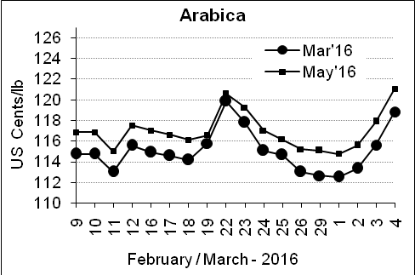
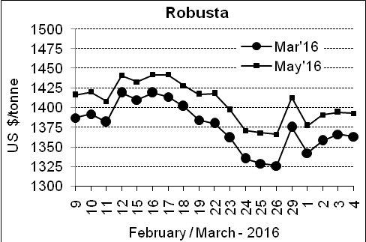

Market Analysis
ICE Arabica coffee futures rose for the third straight day, also buoyed by the stronger real. ICE May arabica coffee futures settled up 3.2 cent, or 2.7 percent, at $1.2105 per lb. LIFFE May robusta coffee futures settled down $1, or 0.1 percent, at $1,393 per tonne.

, .  Differentials: | Ar. Plant. A | Ar.Chy.AB | Rob.Pmt.AB | Rob.Chy.AB
, .  Differentials: | NY +35 to +40 | NY –22 to –25 | LIFFE +600 to +650 | LIFFE +200 to +220

ICTA Auction Prices Rs/Kg as on 03.03.2016 (2014-15 season crop)
Grade | MNEB | AA | PB | A | AB | B | C | BBB
Arabica Plantation | --- | --- | 165.00 | 203.00 | --- | --- | 129.00 | 122.10
Arabica Cherry | --- | --- | 120.00 | --- | --- | --- | --- | ---
 | RKR | A | PB | AA | AB | B | C | BBB
Robusta Parchment | --- | --- | --- | --- | --- | --- | --- | ---
Robusta Cherry | --- | --- | --- | 115.00 | --- | --- | --- | ---

ICTA Auction Prices Rs/Kg as on 03.03.2016 (2015-16 season crop)
Grade | MNEB | AA | PB | A | AB | B | C | BBB
Arabica Plantation | 264.56 | --- | 185.00 | --- | --- | --- | --- | 111.00
Arabica Cherry | --- | --- | --- | --- | --- | --- | --- | ---
 | RKR | A | PB | AA | AB | B | C | BBB
Robusta Parchment | --- | --- | 145.00 | 153.00 | 151.00 | --- | --- | ---
Robusta Cherry | --- | --- | --- | --- | --- | --- | --- | ---

Raw Coffee Price (Karnataka) as on 05.03.2016 in Rs/50 kg
Ar.Pmt |  |  | Ar.Chy |  |  | Rob.Pmt |  |  | Rob.Chy
8250 | - | 8310 | 3300 | - | 3350 | 5800 | - | 5900 | 2600 | - | 2700

Export update: From 1st January 2016 to 04th March 2016 (in metric tonnes)
 | INDIAN COFFEE | Ar.Pmt | Ar.Chy | Rob.Pmt | Rob.Chy | Roasted seeds | R & G | Instant | Total
1 | Provisional exports (Indian coffee) | 10704 | 2325 | 3173 | 26601 | 10 | 43 | 3956 | 46811
2 | Provisional exports corresponding period last year | 8274 | 3141 | 4419 | 19372 | 6 | 41 | 3366 | 38621
3 | Provisional re-exports | 0 | 0 | 0 | 0 | 0 | 5 | 14464 | 14469
4 | Provisional re-exports corresponding period last year | 0 | 0 | 0 | 0 | 7 | 17 | 11998 | 12022
5 | Total provisional exports (1+3) | 10704 | 2325 | 3173 | 26601 | 10 | 48 | 18421 | 61280
6 | Total provisional exports corresponding period last year (2+4) | 8274 | 3141 | 4419 | 19372 | 13 | 58 | 15364 | 50642

Disclaimer: The Board neither guarantees the accuracy of the information nor accept any liability whatsoever for any direct or consequential loss arising from the use of this report

