COFFEE BOARD: BENGALURU
Daily Coffee Market Report Tuesday, March 15, 2016

Futures Prices 14.03.2016
ICE (New York)- Arabica- US cents / lb |  |  | LIFFE(London) – Robusta -US $ / tonne and cents / lb in brackets (10 MT contract)
Month | Price | Prev. Price | Month | Price | Prev. Price
Mar – 2016 | 125.60 | 124.40 | Mar - 2016 | 1411 (64.00) | 1402 (63.59)
May – 2016 | 127.20 | 125.80 | May – 2016 | 1438 (65.23) | 1427 (64.73)
July – 2016 | 128.95 | 127.55 | July – 2016 | 1465 (66.45) | 1454 (65.95)
ICO Group Indicator price on 11.03.2016 and previous price in brackets
Other Mild Arabica |  | Robusta |  |  | Exchange Rate Rs/ US $
US Cents/lb | Rs/kg | US Cents/lb | Rs/kg
156.44 (153.09) | 231.15 (226.43) | 74.40 (73.36) | 109.93 (108.51) |  | 67.02
Futures Price Trend
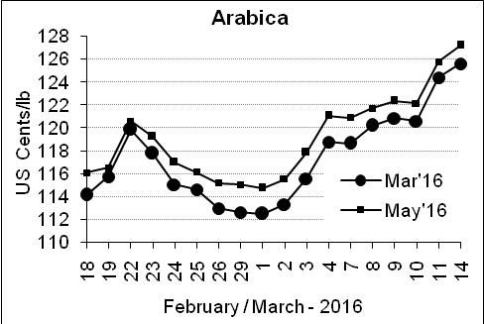
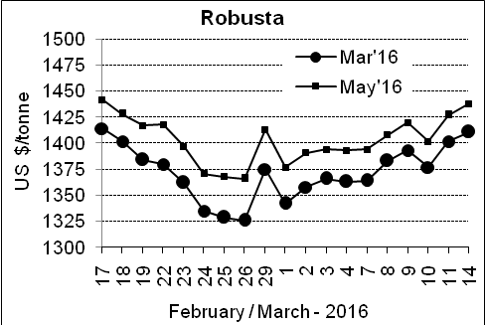

Market Analysis
ICE arabica coffee futures extended gains, with robusta seen supported by prolonged dry weather in Brazil and concerns over drought in Vietnam. ICE May arabica coffee futures settled up 1.4 cent, or 1.1 percent, at $1.272 per lb. It earlier hit $1.277, the highest price since Jan. 4. LIFFE May robusta coffee futures settled up $11, or 0.8 percent, at $1,438 per tonne, after hitting a three-week high of $1,444.

, .  Differentials: | Ar. Plant. A | Ar.Chy.AB | Rob.Pmt.AB | Rob.Chy.AB
, .  Differentials: | NY +35 to +40 | NY –22 to –25 | LIFFE +600 to +650 | LIFFE +200 to +220

ICTA Auction Prices Rs/Kg as on 10.03.2016 (2015-16 season crop)
Grade | MNEB | AA | PB | A | AB | B | C | BBB
Arabica Plantation | --- | --- | 190.50 | --- | --- | 181.00 | 148.00 | ---
Arabica Cherry | --- | --- | --- | --- | --- | --- | --- | ---
 | RKR | A | PB | AA | AB | B | C | BBB
Robusta Parchment | --- | --- | 145.00 | 153.00 | 151.00 | --- | --- | 94.00
Robusta Cherry | --- | --- | --- | --- | --- | --- | --- | ---

Raw Coffee Price (Karnataka) as on 12.03.2016 in Rs/50 kg
Ar.Pmt |  |  | Ar.Chy |  |  | Rob.Pmt |  |  | Rob.Chy
8210 | - | 8350 | 3225 | - | 3400 | 5810 | - | 5850 | 2550 | - | 2725

Export update: From 1st January 2016 to 14th March 2016 (in metric tonnes)
 | INDIAN COFFEE | Ar.Pmt | Ar.Chy | Rob.Pmt | Rob.Chy | Roasted seeds | R & G | Instant | Total
1 | Provisional exports (Indian coffee) | 12407 | 2711 | 4253 | 32800 | 10 | 44 | 4580 | 56805
2 | Provisional exports corresponding period last year | 9602 | 3492 | 5457 | 24650 | 6 | 44 | 3964 | 47216
3 | Provisional re-exports | 0 | 0 | 0 | 0 | 0 | 5 | 16507 | 16512
4 | Provisional re-exports corresponding period last year | 0 | 0 | 0 | 0 | 18 | 22 | 13708 | 13748
5 | Total provisional exports (1+3) | 12407 | 2711 | 4253 | 32800 | 10 | 49 | 21087 | 73316
6 | Total provisional exports corresponding period last year (2+4) | 9602 | 3492 | 5457 | 24650 | 25 | 66 | 17672 | 60964

Disclaimer: The Board neither guarantees the accuracy of the information nor accept any liability whatsoever for any direct or consequential loss arising from the use of this report

