COFFEE BOARD: BENGALURU
Daily Coffee Market Report Friday, March 18, 2016

Futures Prices 17.03.2016
ICE (New York)- Arabica- US cents / lb |  |  | LIFFE(London) – Robusta -US $ / tonne and cents / lb in brackets (10 MT contract)
Month | Price | Prev. Price | Month | Price | Prev. Price
Mar – 2016 | 132.00 | 127.40 | Mar - 2016 | 1428 (64.77) | 1395 (63.28)
May – 2016 | 132.55 | 129.05 | May – 2016 | 1459 (66.18) | 1426 (64.68)
July – 2016 | 134.25 | 130.75 | July – 2016 | 1487 (67.45) | 1456 (66.04)
ICO Group Indicator price on 16.03.2016 and previous price in brackets
Other Mild Arabica |  | Robusta |  |  | Exchange Rate Rs/ US $
US Cents/lb | Rs/kg | US Cents/lb | Rs/kg
161.03 (157.95) | 237.43 (234.60) | 74.46 (74.40) | 109.79 (110.50) |  | 66.88
Futures Price Trend
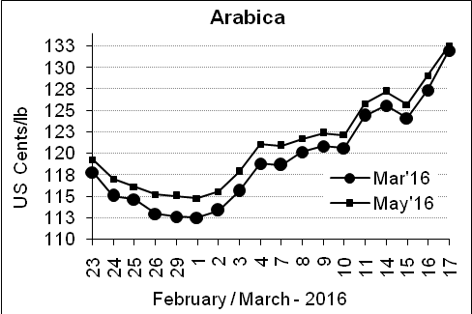
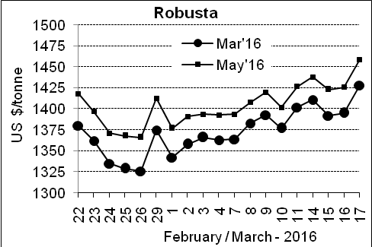

Market Analysis
ICE arabica coffee future prices are hitting a new five-month high on the back of a stronger Brazilian real and other technical factors. ICE May arabica coffee futures price settled up 3.50 cents or 2.7% at $1.3255 per pound. LIFFE May robusta coffee futures climbed $33 or 2.4 percent to $1,459 per tonne.

, .  Differentials: | Ar. Plant. A | Ar.Chy.AB | Rob.Pmt.AB | Rob.Chy.AB
, .  Differentials: | NY +35 to +40 | NY –22 to –25 | LIFFE +600 to +650 | LIFFE +200 to +220

ICTA Auction Prices Rs/Kg as on 10.03.2016 (2015-16 season crop)
Grade | MNEB | AA | PB | A | AB | B | C | BBB
Arabica Plantation | --- | --- | 190.50 | --- | --- | 181.00 | 148.00 | ---
Arabica Cherry | --- | --- | --- | --- | --- | --- | --- | ---
 | RKR | A | PB | AA | AB | B | C | BBB
Robusta Parchment | --- | --- | 145.00 | 153.00 | 151.00 | --- | --- | 94.00
Robusta Cherry | --- | --- | --- | --- | --- | --- | --- | ---

Raw Coffee Price (Karnataka) as on 17.03.2016 in Rs/50 kg
Ar.Pmt |  |  | Ar.Chy |  |  | Rob.Pmt |  |  | Rob.Chy
8260 | - | 8450 | 3300 | - | 3450 | 5725 | - | 5850 | 2525 | - | 2725

Export update: From 1st January 2016 to 17th March 2016 (in metric tonnes)
 | INDIAN COFFEE | Ar.Pmt | Ar.Chy | Rob.Pmt | Rob.Chy | Roasted seeds | R & G | Instant | Total
1 | Provisional exports (Indian coffee) | 13428 | 2980 | 4374 | 34913 | 10 | 45 | 4714 | 60464
2 | Provisional exports corresponding period last year | 10342 | 3546 | 5755 | 26601 | 6 | 48 | 4196 | 50495
3 | Provisional re-exports | 0 | 0 | 0 | 0 | 0 | 5 | 17320 | 17325
4 | Provisional re-exports corresponding period last year | 0 | 0 | 0 | 0 | 18 | 22 | 14838 | 14879
5 | Total provisional exports (1+3) | 13428 | 2980 | 4374 | 34913 | 10 | 50 | 22034 | 77788
6 | Total provisional exports corresponding period last year (2+4) | 10342 | 3546 | 5755 | 26601 | 25 | 70 | 19034 | 65374

Disclaimer: The Board neither guarantees the accuracy of the information nor accept any liability whatsoever for any direct or consequential loss arising from the use of this report

