COFFEE BOARD: BENGALURU
Daily Coffee Market Report Monday, March 21, 2016

Futures Prices 18.03.2016
ICE (New York)- Arabica- US cents / lb |  |  | LIFFE(London) – Robusta -US $ / tonne and cents / lb in brackets (10 MT contract)
Month | Price | Prev. Price | Month | Price | Prev. Price
Mar – 2016 | 133.85 | 132.00 | Mar - 2016 | 1447 (65.63) | 1428 (64.77)
May – 2016 | 134.30 | 132.55 | May – 2016 | 1482 (67.22) | 1459 (66.18)
July – 2016 | 136.15 | 134.25 | July – 2016 | 1511 (68.54) | 1487 (67.45)
ICO Group Indicator price on 17.03.2016 and previous price in brackets
Other Mild Arabica |  | Robusta |  |  | Exchange Rate Rs/ US $
US Cents/lb | Rs/kg | US Cents/lb | Rs/kg
163.97 (161.03) | 240.79 (237.43) | 79.96 (74.46) | 117.42 (109.79) |  | 66.61
Futures Price Trend
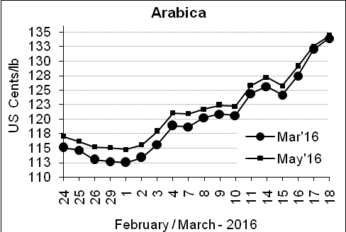
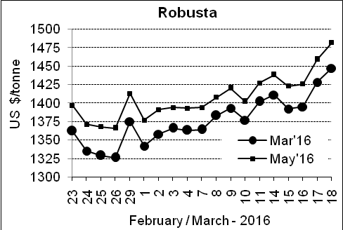

Market Analysis
ICE Arabica coffee futures hit a new five-month high on Friday as political news out of Brazil helped boost the currency of the world's largest coffee producer. The May arabica coffee futures settled up 1.75 cent, or 1.3 percent, at $1.343 per lb, finishing the week up nearly 7 percent in its biggest such gain since November 2015. LIFFE May robusta coffee futures settled up $23, or 1.6 percent, at $1,482 per tonne.

, .  Differentials: | Ar. Plant. A | Ar.Chy.AB | Rob.Pmt.AB | Rob.Chy.AB
, .  Differentials: | NY +35 to +40 | NY –22 to –25 | LIFFE +600 to +650 | LIFFE +200 to +220

ICTA Auction Prices Rs/Kg as on 17.03.2016 (2015-16 season crop)
Grade | MNEB | AA | PB | A | AB | B | C | BBB
Arabica Plantation | --- | --- | --- | 231.00 | --- | 180.50 | 140.00 | ---
Arabica Cherry | --- | --- | --- | --- | 135.00 | --- | --- | 101.00
 | RKR | A | PB | AA | AB | B | C | BBB
Robusta Parchment | --- | --- | --- | --- | --- | --- | --- | 92.50
Robusta Cherry | --- | --- | --- | --- | --- | --- | --- | ---

Raw Coffee Price (Karnataka) as on 17.03.2016 in Rs/50 kg
Ar.Pmt |  |  | Ar.Chy |  |  | Rob.Pmt |  |  | Rob.Chy
8260 | - | 8450 | 3300 | - | 3450 | 5725 | - | 5850 | 2525 | - | 2725

Export update: From 1st January 2016 to 18th March 2016 (in metric tonnes)
 | INDIAN COFFEE | Ar.Pmt | Ar.Chy | Rob.Pmt | Rob.Chy | Roasted seeds | R & G | Instant | Total
1 | Provisional exports (Indian coffee) | 13815 | 3073 | 4797 | 35504 | 10 | 45 | 4765 | 62010
2 | Provisional exports corresponding period last year | 10552 | 3663 | 6220 | 27495 | 6 | 48 | 4196 | 52180
3 | Provisional re-exports | 0 | 0 | 0 | 0 | 0 | 5 | 17703 | 17708
4 | Provisional re-exports corresponding period last year | 0 | 0 | 0 | 0 | 18 | 22 | 14990 | 15030
5 | Total provisional exports (1+3) | 13815 | 3073 | 4797 | 35504 | 10 | 50 | 22469 | 79718
6 | Total provisional exports corresponding period last year (2+4) | 10552 | 3663 | 6220 | 27495 | 25 | 70 | 19186 | 67211

Disclaimer: The Board neither guarantees the accuracy of the information nor accept any liability whatsoever for any direct or consequential loss arising from the use of this report

