COFFEE BOARD: BENGALURU
Daily Coffee Market Report Thursday, March 17, 2016

Futures Prices 16.03.2016
ICE (New York)- Arabica- US cents / lb |  |  | LIFFE(London) – Robusta -US $ / tonne and cents / lb in brackets (10 MT contract)
Month | Price | Prev. Price | Month | Price | Prev. Price
Mar – 2016 | 127.40 | 124.10 | Mar - 2016 | 1395 (63.28) | 1392 (63.14)
May – 2016 | 129.05 | 125.70 | May – 2016 | 1426 (64.68) | 1423 (64.55)
July – 2016 | 130.75 | 127.50 | July – 2016 | 1456 (66.04) | 1451 (65.82)
ICO Group Indicator price on 15.03.2016 and previous price in brackets
Other Mild Arabica |  | Robusta |  |  | Exchange Rate Rs/ US $
US Cents/lb | Rs/kg | US Cents/lb | Rs/kg
157.95 (159.28) | 234.60 (236.08) | 74.40 (74.96) | 110.50 (111.10) |  | 67.37
Futures Price Trend
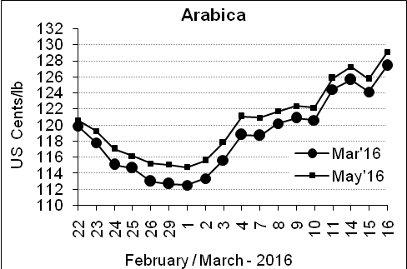
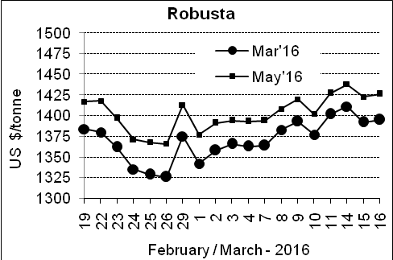

Market Analysis
ICE Arabica coffee futures turned up to reach the highest levels in 2016 so far on Wednesday, on looming supply concerns and as the currency in top grower Brazil sharply pared its losses. ICE May arabica coffee futures settled up 3.35 cents, or 2.7 percent, at $1.2905 per lb, after rising to $1.30, a five-month high on a continuation chart. LIFFE May robusta coffee futures settled up $3, or 0.2 percent, at $1,426 per tonne.

, .  Differentials: | Ar. Plant. A | Ar.Chy.AB | Rob.Pmt.AB | Rob.Chy.AB
, .  Differentials: | NY +35 to +40 | NY –22 to –25 | LIFFE +600 to +650 | LIFFE +200 to +220

ICTA Auction Prices Rs/Kg as on 10.03.2016 (2015-16 season crop)
Grade | MNEB | AA | PB | A | AB | B | C | BBB
Arabica Plantation | --- | --- | 190.50 | --- | --- | 181.00 | 148.00 | ---
Arabica Cherry | --- | --- | --- | --- | --- | --- | --- | ---
 | RKR | A | PB | AA | AB | B | C | BBB
Robusta Parchment | --- | --- | 145.00 | 153.00 | 151.00 | --- | --- | 94.00
Robusta Cherry | --- | --- | --- | --- | --- | --- | --- | ---

Raw Coffee Price (Karnataka) as on 16.03.2016 in Rs/50 kg
Ar.Pmt |  |  | Ar.Chy |  |  | Rob.Pmt |  |  | Rob.Chy
8210 | - | 8300 | 3250 | - | 3400 | 5750 | - | 5810 | 2525 | - | 2725

Export update: From 1st January 2016 to 16th March 2016 (in metric tonnes)
 | INDIAN COFFEE | Ar.Pmt | Ar.Chy | Rob.Pmt | Rob.Chy | Roasted seeds | R & G | Instant | Total
1 | Provisional exports (Indian coffee) | 12954 | 2803 | 4374 | 34062 | 10 | 45 | 4546 | 58794
2 | Provisional exports corresponding period last year | 10025 | 3492 | 5654 | 25672 | 6 | 48 | 4096 | 48993
3 | Provisional re-exports | 0 | 0 | 0 | 0 | 0 | 5 | 16885 | 16890
4 | Provisional re-exports corresponding period last year | 0 | 0 | 0 | 0 | 18 | 22 | 14548 | 14588
5 | Total provisional exports (1+3) | 12954 | 2803 | 4374 | 34062 | 10 | 49 | 21431 | 75683
6 | Total provisional exports corresponding period last year (2+4) | 10025 | 3492 | 5654 | 25672 | 25 | 70 | 18644 | 63581

Disclaimer: The Board neither guarantees the accuracy of the information nor accept any liability whatsoever for any direct or consequential loss arising from the use of this report

