COFFEE BOARD: BENGALURU
Daily Coffee Market Report Thursday, March 03, 2016

Futures Prices 02.03.2016
ICE (New York)- Arabica- US cents / lb |  |  | LIFFE(London) – Robusta -US $ / tonne and cents / lb in brackets (10 MT contract)
Month | Price | Prev. Price | Month | Price | Prev. Price
Mar – 2016 | 113.35 | 112.50 | Mar - 2016 | 1358 (61.60) | 1342 (60.87)
May – 2016 | 115.55 | 114.75 | May – 2016 | 1391 (63.09) | 1377 (62.46)
July – 2016 | 117.40 | 116.70 | July – 2016 | 1420 (64.41) | 1408 (63.78)
ICO Group Indicator price on 01.03.2016 and previous price in brackets
Other Mild Arabica |  | Robusta |  |  | Exchange Rate Rs/ US $
US Cents/lb | Rs/kg | US Cents/lb | Rs/kg
146.09 (146.38) | 218.04 (219.96) | 71.95 (72.96) | 107.39 (109.63) |  | 67.70
Futures Price Trend
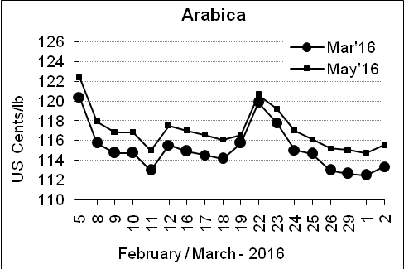
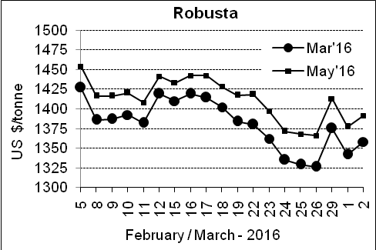

Market Analysis
ICE May arabicas coffee futures settled up 0.80 cent at $1.1555 per lb. LIFFE May robusta coffee futures settled up $14 at $1,391 per tonne.

, .  Differentials: | Ar. Plant. A | Ar.Chy.AB | Rob.Pmt.AB | Rob.Chy.AB
, .  Differentials: | NY +35 to +40 | NY –22 to –25 | LIFFE +600 to +650 | LIFFE +200 to +220

ICTA Auction Prices Rs/Kg as on 25.02.2016 (2014-15 season crop)
Grade | MNEB | AA | PB | A | AB | B | C | BBB
Arabica Plantation | --- | --- | --- | --- | --- | --- | --- | ---
Arabica Cherry | --- | --- | --- | 145.00 | --- | --- | --- | ---
 | RKR | A | PB | AA | AB | B | C | BBB
Robusta Parchment | 125.00 | --- | 122.00 | --- | --- | --- | 107.00 | ---
Robusta Cherry | --- | --- | --- | 116.00 | --- | --- | --- | ---

ICTA Auction Prices Rs/Kg as on 25.02.2016 (2015-16 season crop)
Grade | MNEB | AA | PB | A | AB | B | C | BBB
Arabica Plantation | --- | --- | --- | --- | --- | 180.00 | --- | 108.00
Arabica Cherry | --- | --- | --- | --- | --- | --- | --- | ---

Raw Coffee Price (Karnataka) as on 29.02.2016 in Rs/50 kg
Ar.Pmt |  |  | Ar.Chy |  |  | Rob.Pmt |  |  | Rob.Chy
8250 | - | 8310 | 3250 | - | 3400 | 5700 | - | 5960 | 2600 | - | 2750

Export update: From 1st January 2016 to 02nd March 2016 (in metric tonnes)
 | INDIAN COFFEE | Ar.Pmt | Ar.Chy | Rob.Pmt | Rob.Chy | Roasted seeds | R & G | Instant | Total
1 | Provisional exports (Indian coffee) | 10387 | 2185 | 2762 | 24694 | 10 | 43 | 3596 | 43677
2 | Provisional exports corresponding period last year | 7816 | 2872 | 3801 | 18390 | 6 | 40 | 3177 | 36103
3 | Provisional re-exports | 0 | 0 | 0 | 0 | 0 | 5 | 13321 | 13326
4 | Provisional re-exports corresponding period last year | 0 | 0 | 0 | 0 | 6 | 12 | 11146 | 11164
5 | Total provisional exports (1+3) | 10387 | 2185 | 2762 | 24694 | 10 | 47 | 16917 | 57003
6 | Total provisional exports corresponding period last year (2+4) | 7816 | 2872 | 3801 | 18390 | 12 | 53 | 14322 | 47267

Disclaimer: The Board neither guarantees the accuracy of the information nor accept any liability whatsoever for any direct or consequential loss arising from the use of this report

