COFFEE BOARD: BENGALURU
Daily Coffee Market Report Thursday, March 10, 2016

Futures Prices 09.03.2016
ICE (New York)- Arabica- US cents / lb |  |  | LIFFE(London) – Robusta -US $ / tonne and cents / lb in brackets (10 MT contract)
Month | Price | Prev. Price | Month | Price | Prev. Price
Mar – 2016 | 120.85 | 120.20 | Mar - 2016 | 1393 (63.19) | 1383 (62.73)
May – 2016 | 122.35 | 121.70 | May – 2016 | 1420 (64.41) | 1408 (63.87)
July – 2016 | 124.25 | 123.60 | July – 2016 | 1449 (65.73) | 1437 (65.18)
ICO Group Indicator price on 08.03.2016 and previous price in brackets
Other Mild Arabica |  | Robusta |  |  | Exchange Rate Rs/ US $
US Cents/lb | Rs/kg | US Cents/lb | Rs/kg
152.63 (151.90) | 227.00 (225.51) | 73.56 (72.92) | 109.40 (108.26) |  | 67.46
Futures Price Trend
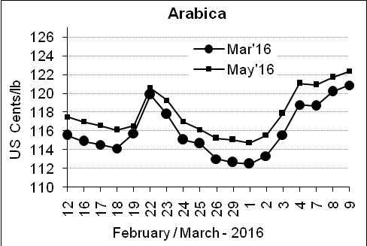
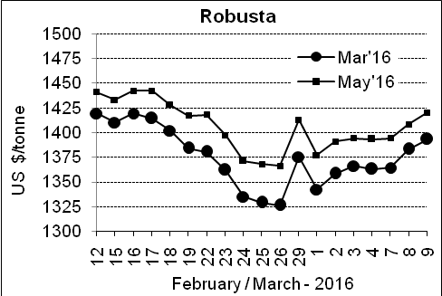

Market Analysis
ICE Arabica coffee futures edged up to a one-month high. ICE May arabica coffee futures settled up 0.65 cent, or 0.5 percent, at $1.2235 per lb after climbing to $1.229, the highest since Feb. 5. LIFFE May robusta coffee futures settled up $12, or 0.9 percent, at $1,420 per tonne.

, .  Differentials: | Ar. Plant. A | Ar.Chy.AB | Rob.Pmt.AB | Rob.Chy.AB
, .  Differentials: | NY +35 to +40 | NY –22 to –25 | LIFFE +600 to +650 | LIFFE +200 to +220

ICTA Auction Prices Rs/Kg as on 03.03.2016 (2014-15 season crop)
Grade | MNEB | AA | PB | A | AB | B | C | BBB
Arabica Plantation | --- | --- | 165.00 | 203.00 | --- | --- | 129.00 | 122.10
Arabica Cherry | --- | --- | 120.00 | --- | --- | --- | --- | ---
 | RKR | A | PB | AA | AB | B | C | BBB
Robusta Parchment | --- | --- | --- | --- | --- | --- | --- | ---
Robusta Cherry | --- | --- | --- | 115.00 | --- | --- | --- | ---

ICTA Auction Prices Rs/Kg as on 03.03.2016 (2015-16 season crop)
Grade | MNEB | AA | PB | A | AB | B | C | BBB
Arabica Plantation | 264.56 | --- | 185.00 | --- | --- | --- | --- | 111.00
Arabica Cherry | --- | --- | --- | --- | --- | --- | --- | ---
 | RKR | A | PB | AA | AB | B | C | BBB
Robusta Parchment | --- | --- | 145.00 | 153.00 | 151.00 | --- | --- | ---
Robusta Cherry | --- | --- | --- | --- | --- | --- | --- | ---

Raw Coffee Price (Karnataka) as on 09.03.2016 in Rs/50 kg
Ar.Pmt |  |  | Ar.Chy |  |  | Rob.Pmt |  |  | Rob.Chy
8250 | - | 8300 | 3350 | - | 3400 | 5800 | - | 5810 | 2600 | - | 2700

Export update: From 1st January 2016 to 09th March 2016 (in metric tonnes)
 | INDIAN COFFEE | Ar.Pmt | Ar.Chy | Rob.Pmt | Rob.Chy | Roasted seeds | R & G | Instant | Total
1 | Provisional exports (Indian coffee) | 11757 | 2621 | 3847 | 29832 | 10 | 43 | 4151 | 52260
2 | Provisional exports corresponding period last year | 8922 | 3185 | 4927 | 21053 | 6 | 43 | 3784 | 41920
3 | Provisional re-exports | 0 | 0 | 0 | 0 | 0 | 5 | 15319 | 15323
4 | Provisional re-exports corresponding period last year | 0 | 0 | 0 | 0 | 7 | 17 | 12999 | 13023
5 | Total provisional exports (1+3) | 11757 | 2621 | 3847 | 29832 | 10 | 48 | 19470 | 67584
6 | Total provisional exports corresponding period last year (2+4) | 8922 | 3185 | 4927 | 21053 | 13 | 60 | 16782 | 54942

Disclaimer: The Board neither guarantees the accuracy of the information nor accept any liability whatsoever for any direct or consequential loss arising from the use of this report

