COFFEE BOARD: BENGALURU
Daily Coffee Market Report Wednesday, March 02, 2016

Futures Prices 01.03.2016
ICE (New York)- Arabica- US cents / lb |  |  | LIFFE(London) – Robusta -US $ / tonne and cents / lb in brackets (10 MT contract)
Month | Price | Prev. Price | Month | Price | Prev. Price
Mar – 2016 | 112.50 | 112.65 | Mar - 2016 | 1342 (60.87) | 1375 (62.37)
May – 2016 | 114.75 | 115.05 | May – 2016 | 1377 (62.46) | 1413 (64.09)
July – 2016 | 116.70 | 117.00 | July – 2016 | 1408 (63.78) | 1441 (65.36)
ICO Group Indicator price on 29.02.2016 and previous price in brackets
Other Mild Arabica |  | Robusta |  |  | Exchange Rate Rs/ US $
US Cents/lb | Rs/kg | US Cents/lb | Rs/kg
146.38 (146.12) | 219.96 (221.05) | 72.96 (71.63) | 109.63 (108.36) |  | 68.16
Futures Price Trend
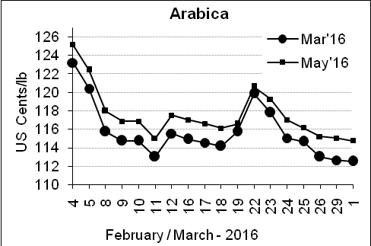
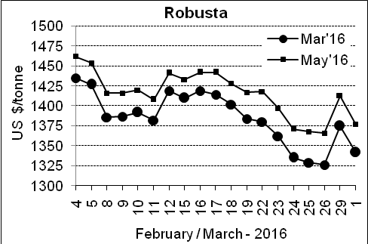

Market Analysis
ICE Arabica coffee futures fell as dealers focused on expectations for an abundant harvest in top grower Brazil, though the firm Brazilian real currency prevented deeper losses. ICE May arabicas coffee futures settled down 0.3 cent, or 0.3 percent, at $1.1475 per lb after falling to a session low at $1.134. LIFFE May robusta coffee futures settled down $36, or 2.6 percent, at $1,377 per tonne.

, .  Differentials: | Ar. Plant. A | Ar.Chy.AB | Rob.Pmt.AB | Rob.Chy.AB
, .  Differentials: | NY +35 to +40 | NY –22 to –25 | LIFFE +600 to +650 | LIFFE +200 to +220

ICTA Auction Prices Rs/Kg as on 25.02.2016 (2014-15 season crop)
Grade | MNEB | AA | PB | A | AB | B | C | BBB
Arabica Plantation | --- | --- | --- | --- | --- | --- | --- | ---
Arabica Cherry | --- | --- | --- | 145.00 | --- | --- | --- | ---
 | RKR | A | PB | AA | AB | B | C | BBB
Robusta Parchment | 125.00 | --- | 122.00 | --- | --- | --- | 107.00 | ---
Robusta Cherry | --- | --- | --- | 116.00 | --- | --- | --- | ---

ICTA Auction Prices Rs/Kg as on 25.02.2016 (2015-16 season crop)
Grade | MNEB | AA | PB | A | AB | B | C | BBB
Arabica Plantation | --- | --- | --- | --- | --- | 180.00 | --- | 108.00
Arabica Cherry | --- | --- | --- | --- | --- | --- | --- | ---

Raw Coffee Price (Karnataka) as on 29.02.2016 in Rs/50 kg
Ar.Pmt |  |  | Ar.Chy |  |  | Rob.Pmt |  |  | Rob.Chy
8250 | - | 8310 | 3250 | - | 3400 | 5700 | - | 5960 | 2600 | - | 2750

Export update: From 1st January 2016 to 01st March 2016 (in metric tonnes)
 | INDIAN COFFEE | Ar.Pmt | Ar.Chy | Rob.Pmt | Rob.Chy | Roasted seeds | R & G | Instant | Total
1 | Provisional exports (Indian coffee) | 10061 | 2172 | 2685 | 23805 | 8 | 43 | 3469 | 42242
2 | Provisional exports corresponding period last year | 7300 | 2872 | 3387 | 17763 | 6 | 39 | 3094 | 34460
3 | Provisional re-exports | 0 | 0 | 0 | 0 | 0 | 5 | 13100 | 13105
4 | Provisional re-exports corresponding period last year | 0 | 0 | 0 | 0 | 6 | 12 | 10984 | 11002
5 | Total provisional exports (1+3) | 10061 | 2172 | 2685 | 23805 | 8 | 47 | 16570 | 55348
6 | Total provisional exports corresponding period last year (2+4) | 7300 | 2872 | 3387 | 17763 | 12 | 51 | 14078 | 45463

Disclaimer: The Board neither guarantees the accuracy of the information nor accept any liability whatsoever for any direct or consequential loss arising from the use of this report

