COFFEE BOARD: BENGALURU
Daily Coffee Market Report Tuesday, March 22, 2016

Futures Prices 21.03.2016
ICE (New York)- Arabica- US cents / lb |  |  | LIFFE(London) – Robusta -US $ / tonne and cents / lb in brackets (10 MT contract)
Month | Price | Prev. Price | Month | Price | Prev. Price
May – 2016 | 131.55 | 134.30 | Mar - 2016 | 1438 (65.23) | 1447 (65.63)
July – 2016 | 133.35 | 136.15 | May – 2016 | 1473 (66.81) | 1482 (67.22)
Sep – 2016 | 134.95 | 137.65 | July – 2016 | 1501 (68.08) | 1511 (68.54)
ICO Group Indicator price on 18.03.2016 and previous price in brackets
Other Mild Arabica |  | Robusta |  |  | Exchange Rate Rs/ US $
US Cents/lb | Rs/kg | US Cents/lb | Rs/kg
165.44 (163.97) | 242.55 (240.79) | 80.11 (79.96) | 117.45 (117.42) |  | 66.50
Futures Price Trend
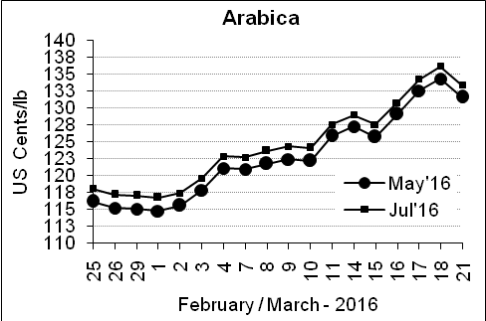
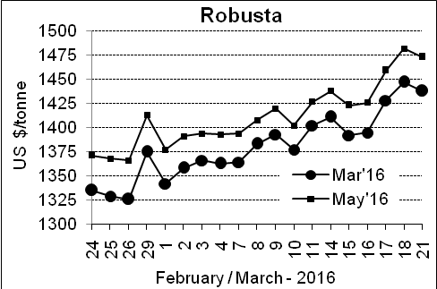

Market Analysis
ICE Arabica coffee futures slid from last week's five-month highs as a short-covering rally ran out of steam. ICE May arabica coffee futures settled down 2.75 cent, or 2.1 percent, at $1.3155 per lb as traders reacted to weekly U.S. government data that showed speculators had switched to a bullish position for the first time since August 2015. LIFFE May robusta coffee futures closed down $9, or 0.61 percent, at $1,473 per tonne.

, .  Differentials: | Ar. Plant. A | Ar.Chy.AB | Rob.Pmt.AB | Rob.Chy.AB
, .  Differentials: | NY +25 to +30 | NY –30 to –35 | LIFFE +800 to +850 | LIFFE +170 to +200

ICTA Auction Prices Rs/Kg as on 17.03.2016 (2015-16 season crop)
Grade | MNEB | AA | PB | A | AB | B | C | BBB
Arabica Plantation | --- | --- | --- | 231.00 | --- | 180.50 | 140.00 | ---
Arabica Cherry | --- | --- | --- | --- | 135.00 | --- | --- | 101.00
 | RKR | A | PB | AA | AB | B | C | BBB
Robusta Parchment | --- | --- | --- | --- | --- | --- | --- | 92.50
Robusta Cherry | --- | --- | --- | --- | --- | --- | --- | ---

Raw Coffee Price (Karnataka) as on 19.03.2016 in Rs/50 kg
Ar.Pmt |  |  | Ar.Chy |  |  | Rob.Pmt |  |  | Rob.Chy
8350 | - | 8550 | 3300 | - | 3500 | 5800 | - | 5900 | 2600 | - | 2700

Export update: From 1st January 2016 to 21st March 2016 (in metric tonnes)
 | INDIAN COFFEE | Ar.Pmt | Ar.Chy | Rob.Pmt | Rob.Chy | Roasted seeds | R & G | Instant | Total
1 | Provisional exports (Indian coffee) | 14029 | 3073 | 4915 | 37502 | 10 | 46 | 4922 | 64496
2 | Provisional exports corresponding period last year | 11243 | 3752 | 7032 | 29383 | 7 | 52 | 4337 | 55805
3 | Provisional re-exports | 0 | 0 | 0 | 0 | 0 | 5 | 17889 | 17893
4 | Provisional re-exports corresponding period last year | 0 | 0 | 0 | 0 | 36 | 22 | 16371 | 16429
5 | Total provisional exports (1+3) | 14029 | 3073 | 4915 | 37502 | 10 | 51 | 22811 | 82390
6 | Total provisional exports corresponding period last year (2+4) | 11243 | 3752 | 7032 | 29383 | 43 | 74 | 20708 | 72234

Disclaimer: The Board neither guarantees the accuracy of the information nor accept any liability whatsoever for any direct or consequential loss arising from the use of this report

