COFFEE BOARD: BENGALURU
Daily Coffee Market Report Friday, April 15, 2016

Futures Prices 14.04.2016
ICE (New York)- Arabica- US cents / lb |  |  | LIFFE(London) – Robusta -US $ / tonne and cents / lb in brackets (10 MT contract)
Month | Price | Prev. Price | Month | Price | Prev. Price
May – 2016 | 123.15 | 121.75 | May – 2016 | 1523 (69.08) | 1515 (68.72)
July – 2016 | 125.10 | 123.60 | July – 2016 | 1552 (70.40) | 1546 (70.13)
Sep – 2016 | 126.85 | 125.35 | Sep – 2016 | 1570 (71.21) | 1565 (70.99)
ICO Group Indicator price on 13.04.2016 and previous price in brackets
Other Mild Arabica |  | Robusta |  |  | Exchange Rate Rs/ US $
US Cents/lb | Rs/kg | US Cents/lb | Rs/kg
153.25 (155.64) | 224.44 (227.94) | 80.03 (81.55) | 117.21 (119.43) |  | 66.43
Futures Price Trend

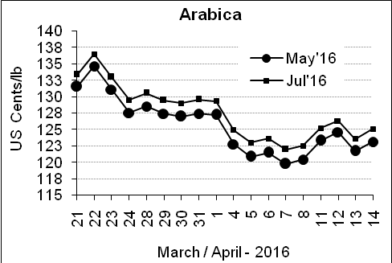
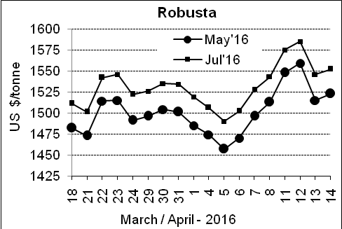

Market Analysis
ICE Arabica coffee prices corrected higher after the prior session's fall. ICE July arabica coffee futures settled up 1.5 cent, or 1.2 percent, at $1.251 per lb. Robusta coffee futures also regained ground after a setback on Wednesday, with May finishing up $8, or 0.5 percent, at $1,523 per tonne.

Differentials: | Ar. Plant. A | Ar.Chy.AB | Rob.Pmt.AB | Rob.Chy.AB
Differentials: | NY +25 to +30 | NY –30 to –35 | LIFFE +800 to +850 | LIFFE +170 to +200

ICTA Auction Prices Rs/Kg as on 06.04.2016 (2015-16 season crop)
Grade | MNEB | AA | PB | A | AB | B | C | BBB
Arabica Plantation | --- | 250.00 | 190.00 | 232.00 | --- | 183.00 | 146.00 | 112.00
Arabica Cherry | --- | --- | --- | --- | 136.00 | --- | --- | 100.00
 | RKR | A | PB | AA | AB | B | C | BBB
Robusta Parchment | --- | --- | 136.00 | --- | --- | --- | --- | ---
Robusta Cherry | --- | --- | 105.00 | --- | 108.00 | --- | 102.00 | 96.00

Raw Coffee Price (Karnataka) as on 13.04.2016 in Rs/50 kg
Ar.Pmt |  |  | Ar.Chy |  |  | Rob.Pmt |  |  | Rob.Chy
8000 | - | 8050 | 3275 | - | 3450 | 5700 | - | 5800 | 2700 | - | 2725

Export update: From 1st January 2016 to 13th April 2016 (in metric tonnes)
 | INDIAN COFFEE | Ar.Pmt | Ar.Chy | Rob.Pmt | Rob.Chy | Roasted seeds | R & G | Instant | Total
1 | Provisional exports (Indian coffee) | 18175 | 4474 | 7526 | 53896 | 14 | 57 | 6346 | 90488
2 | Provisional exports corresponding period last year | 13702 | 4679 | 10354 | 39192 | 10 | 99 | 6062 | 74099
3 | Provisional re-exports | 0 | 0 | 0 | 0 | 0 | 5 | 23107 | 23112
4 | Provisional re-exports corresponding period last year | 0 | 0 | 0 | 0 | 36 | 27 | 20858 | 20922
5 | Total provisional exports (1+3) | 18175 | 4474 | 7526 | 53896 | 14 | 62 | 29453 | 113600
6 | Total provisional exports corresponding period last year (2+4) | 13702 | 4679 | 10354 | 39192 | 47 | 126 | 26921 | 95020

Disclaimer: The Board neither guarantees the accuracy of the information nor accept any liability whatsoever for any direct or consequential loss arising from the use of this report

