COFFEE BOARD: BENGALURU
Daily Coffee Market Report Friday, April 22, 2016

Futures Prices 21.04.2016
ICE (New York)- Arabica- US cents / lb |  |  | LIFFE(London) – Robusta -US $ / tonne and cents / lb in brackets (10 MT contract)
Month | Price | Prev. Price | Month | Price | Prev. Price
May – 2016 | 123.55 | 127.15 | May – 2016 | 1534 (69.58) | 1547 (70.17)
July – 2016 | 124.10 | 128.70 | July – 2016 | 1567 (71.08) | 1578 (71.58)
Sep – 2016 | 125.85 | 130.45 | Sep – 2016 | 1587 (71.99) | 1598 (72.48)
ICO Group Indicator price on 20.04.2016 and previous price in brackets
Other Mild Arabica |  | Robusta |  |  | Exchange Rate Rs/ US $
US Cents/lb | Rs/kg | US Cents/lb | Rs/kg
158.73 (157.98) | 231.97 (230.70) | 80.97 (81.38) | 118.33 (118.84) |  | 66.29
Futures Price Trend

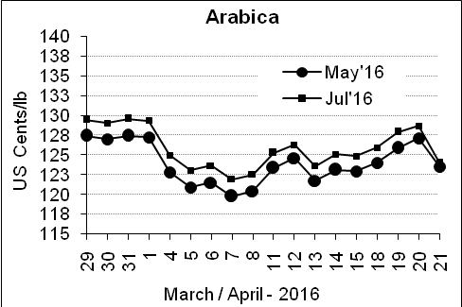
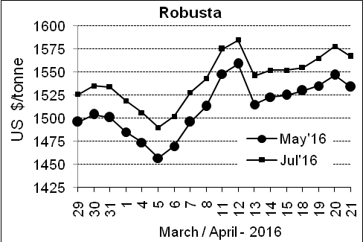

Market Analysis
ICE Arabica coffee futures formed an outside reversal lower, a potentially bearish flag marked by a move well above the prior session's high and settlement below its low. ICE July arabica coffee futures settled down 4.6 cent, or 3.6 percent, at $1.241 per lb, their biggest drop in 2-1/2 months after trading in a wide 7.35 cent range. July robusta coffee futures settled down $11, or 0.7 percent, at $1,567 per tonne.

Differentials: | Ar. Plant. A | Ar.Chy.AB | Rob.Pmt.AB | Rob.Chy.AB
Differentials: | NY +25 to +30 | NY –30 to –35 | LIFFE +800 to +850 | LIFFE +170 to +200

ICTA Auction Prices Rs/Kg as on 06.04.2016 (2015-16 season crop)
Grade | MNEB | AA | PB | A | AB | B | C | BBB
Arabica Plantation | --- | 250.00 | 190.00 | 232.00 | --- | 183.00 | 146.00 | 112.00
Arabica Cherry | --- | --- | --- | --- | 136.00 | --- | --- | 100.00
 | RKR | A | PB | AA | AB | B | C | BBB
Robusta Parchment | --- | --- | 136.00 | --- | --- | --- | --- | ---
Robusta Cherry | --- | --- | 105.00 | --- | 108.00 | --- | 102.00 | 96.00

Raw Coffee Price (Karnataka) as on 19.04.2016 in Rs/50 kg
Ar.Pmt |  |  | Ar.Chy |  |  | Rob.Pmt |  |  | Rob.Chy
8010 | - | 8200 | 3200 | - | 3500 | 5750 | - | 5900 | 2600 | - | 2750

Export update: From 1st January 2016 to 21st April 2016 (in metric tonnes)
 | INDIAN COFFEE | Ar.Pmt | Ar.Chy | Rob.Pmt | Rob.Chy | Roasted seeds | R & G | Instant | Total
1 | Provisional exports (Indian coffee) | 19993 | 4842 | 8034 | 59349 | 14 | 59 | 6896 | 99186
2 | Provisional exports corresponding period last year | 15098 | 5230 | 11158 | 44411 | 12 | 104 | 6465 | 82477
3 | Provisional re-exports | 0 | 0 | 0 | 0 | 0 | 5 | 25555 | 25560
4 | Provisional re-exports corresponding period last year | 0 | 0 | 0 | 0 | 36 | 27 | 21728 | 21791
5 | Total provisional exports (1+3) | 19993 | 4842 | 8034 | 59349 | 14 | 64 | 32450 | 124746
6 | Total provisional exports corresponding period last year (2+4) | 15098 | 5230 | 11158 | 44411 | 48 | 130 | 28193 | 104267

Disclaimer: The Board neither guarantees the accuracy of the information nor accept any liability whatsoever for any direct or consequential loss arising from the use of this report

