COFFEE BOARD: BENGALURU
Daily Coffee Market Report Monday, April 11, 2016

Futures Prices 08.04.2016
ICE (New York)- Arabica- US cents / lb |  |  | LIFFE(London) – Robusta -US $ / tonne and cents / lb in brackets (10 MT contract)
Month | Price | Prev. Price | Month | Price | Prev. Price
May – 2016 | 120.45 | 119.80 | May – 2016 | 1513 (68.63) | 1496 (67.86)
July – 2016 | 122.55 | 121.95 | July – 2016 | 1543 (69.99) | 1528 (69.31)
Sep – 2016 | 124.30 | 123.75 | Sep – 2016 | 1559 (70.72) | 1548 (70.22)
ICO Group Indicator price on 07.04.2016 and previous price in brackets
Other Mild Arabica |  | Robusta |  |  | Exchange Rate Rs/ US $
US Cents/lb | Rs/kg | US Cents/lb | Rs/kg
151.17 (152.20) | 221.53 (223.04) | 81.08 (77.83) | 118.82 (114.05) |  | 66.47
Futures Price Trend

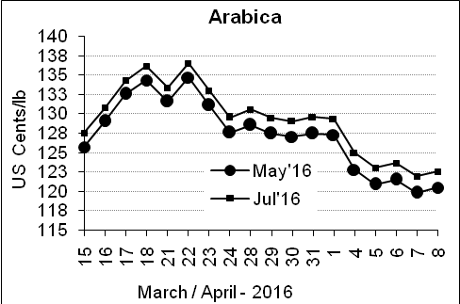
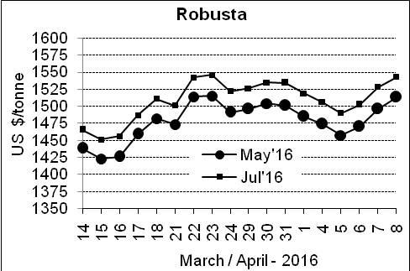

Market Analysis
ICE Arabica coffee futures steadied as the Brazilian real firmed against the U.S. dollar. ICE May arabica coffee futures settled up 0.65 cent, or 0.5 percent, at $1.2045 per lb after touching $1.1905, the lowest since March 10. May robusta coffee futures settled up $17, or 1.1 percent, at $1,513 per tonne.

Differentials: | Ar. Plant. A | Ar.Chy.AB | Rob.Pmt.AB | Rob.Chy.AB
Differentials: | NY +25 to +30 | NY –30 to –35 | LIFFE +800 to +850 | LIFFE +170 to +200

ICTA Auction Prices Rs/Kg as on 06.04.2016 (2015-16 season crop)
Grade | MNEB | AA | PB | A | AB | B | C | BBB
Arabica Plantation | --- | 250.00 | 190.00 | 232.00 | --- | 183.00 | 146.00 | 112.00
Arabica Cherry | --- | --- | --- | --- | 136.00 | --- | --- | 100.00
 | RKR | A | PB | AA | AB | B | C | BBB
Robusta Parchment | --- | --- | 136.00 | --- | --- | --- | --- | ---
Robusta Cherry | --- | --- | 105.00 | --- | 108.00 | --- | 102.00 | 96.00

Raw Coffee Price (Karnataka) as on 06.04.2016 in Rs/50 kg
Ar.Pmt |  |  | Ar.Chy |  |  | Rob.Pmt |  |  | Rob.Chy
8100 | - | 8200 | 3150 | - | 3375 | 5700 | - | 5810 | 2600 | - | 2750

Export update: From 1st January 2016 to 07th April 2016 (in metric tonnes)
 | INDIAN COFFEE | Ar.Pmt | Ar.Chy | Rob.Pmt | Rob.Chy | Roasted seeds | R & G | Instant | Total
1 | Provisional exports (Indian coffee) | 17147 | 4150 | 7052 | 50505 | 14 | 56 | 5832 | 84756
2 | Provisional exports corresponding period last year | 12921 | 4278 | 9315 | 35985 | 8 | 93 | 5880 | 68480
3 | Provisional re-exports | 0 | 0 | 0 | 0 | 0 | 5 | 22382 | 22387
4 | Provisional re-exports corresponding period last year | 0 | 0 | 0 | 0 | 36 | 27 | 19760 | 19823
5 | Total provisional exports (1+3) | 17147 | 4150 | 7052 | 50505 | 14 | 61 | 28213 | 107142
6 | Total provisional exports corresponding period last year (2+4) | 12921 | 4278 | 9315 | 35985 | 44 | 120 | 25640 | 88303

Disclaimer: The Board neither guarantees the accuracy of the information nor accept any liability whatsoever for any direct or consequential loss arising from the use of this report

