COFFEE BOARD: BENGALURU
Daily Coffee Market Report Tuesday, April 05, 2016

Futures Prices 04.04.2016
ICE (New York)- Arabica- US cents / lb |  |  | LIFFE(London) – Robusta -US $ / tonne and cents / lb in brackets (10 MT contract)
Month | Price | Prev. Price | Month | Price | Prev. Price
May – 2016 | 122.80 | 127.25 | May – 2016 | 1474 (66.86) | 1485 (67.36)
July – 2016 | 124.95 | 129.35 | July – 2016 | 1506 (68.31) | 1519 (68.90)
Sep – 2016 | 126.75 | 131.05 | Sep – 2016 | 1528 (69.31) | 1538 (69.76)
ICO Group Indicator price on 01.04.2016 and previous price in brackets
Other Mild Arabica |  | Robusta |  |  | Exchange Rate Rs/ US $
US Cents/lb | Rs/kg | US Cents/lb | Rs/kg
159.30 (159.65) | 232.63 (233.46) | 77.93 (77.75) | 113.80 (113.70) |  | 66.24
Futures Price Trend

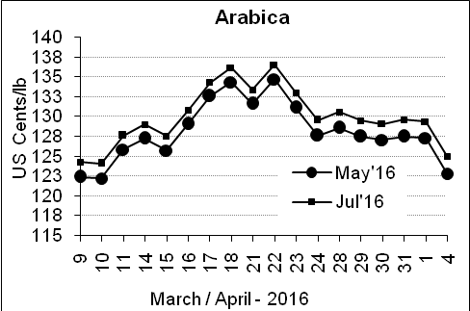
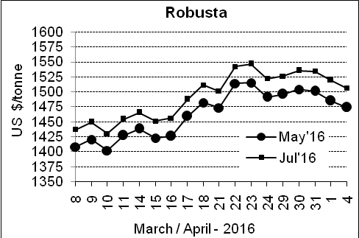

Market Analysis
ICE arabica coffee prices took their biggest tumble in two months. ICE May arabica coffee futures settled down 4.45 cent, or 3.5 percent, at $1.228 per lb, after falling to $1.223, the lowest since March 19. Robusta coffee prices fell on spillover pressure from arabica but losses were limited as brokers focused on the impact of prolonged dry weather on the upcoming Brazilian robusta harvest. May robusta coffee futures settled down $11, or 0.7 percent, at $1,474 per tonne.

Differentials: | Ar. Plant. A | Ar.Chy.AB | Rob.Pmt.AB | Rob.Chy.AB
Differentials: | NY +25 to +30 | NY –30 to –35 | LIFFE +800 to +850 | LIFFE +170 to +200

ICTA Auction Prices Rs/Kg as on 30.03.2016 (2015-16 season crop)
Grade | MNEB | AA | PB | A | AB | B | C | BBB
Arabica Plantation | 256.00 | --- | --- | --- | --- | 183.00 | 146.00 | ---
Arabica Cherry | --- | --- | --- | --- | --- | --- | --- | 93.00
 | RKR | A | PB | AA | AB | B | C | BBB
Robusta Parchment | --- | --- | --- | --- | --- | --- | --- | ---
Robusta Cherry | --- | --- | --- | --- | --- | --- | --- | ---

Raw Coffee Price (Karnataka) as on 04.04.2016 in Rs/50 kg
Ar.Pmt |  |  | Ar.Chy |  |  | Rob.Pmt |  |  | Rob.Chy
8250 | - | 8375 | 3300 | - | 3425 | 5750 | - | 5825 | 2600 | - | 2775

Export update: From 1st January 2016 to 04th April 2016 (in metric tonnes)
 | INDIAN COFFEE | Ar.Pmt | Ar.Chy | Rob.Pmt | Rob.Chy | Roasted seeds | R & G | Instant | Total
1 | Provisional exports (Indian coffee) | 16361 | 4000 | 6638 | 46100 | 14 | 54 | 5735 | 78901
2 | Provisional exports corresponding period last year | 12521 | 4103 | 8645 | 33690 | 8 | 89 | 5590 | 64645
3 | Provisional re-exports | 0 | 0 | 0 | 0 | 0 | 5 | 21610 | 21615
4 | Provisional re-exports corresponding period last year | 0 | 0 | 0 | 0 | 36 | 27 | 19399 | 19462
5 | Total provisional exports (1+3) | 16361 | 4000 | 6638 | 46100 | 14 | 58 | 27345 | 100517
6 | Total provisional exports corresponding period last year (2+4) | 12521 | 4103 | 8645 | 33690 | 44 | 115 | 24989 | 84107

Disclaimer: The Board neither guarantees the accuracy of the information nor accept any liability whatsoever for any direct or consequential loss arising from the use of this report

