COFFEE BOARD: BENGALURU
Daily Coffee Market Report Tuesday, April 12, 2016

Futures Prices 11.04.2016
ICE (New York)- Arabica- US cents / lb |  |  | LIFFE(London) – Robusta -US $ / tonne and cents / lb in brackets (10 MT contract)
Month | Price | Prev. Price | Month | Price | Prev. Price
May – 2016 | 123.35 | 120.45 | May – 2016 | 1548 (70.22) | 1513 (68.63)
July – 2016 | 125.25 | 122.55 | July – 2016 | 1575 (71.44) | 1543 (69.99)
Sep – 2016 | 126.90 | 124.30 | Sep – 2016 | 1590 (72.12) | 1559 (70.72)
ICO Group Indicator price on 08.04.2016 and previous price in brackets
Other Mild Arabica |  | Robusta |  |  | Exchange Rate Rs/ US $
US Cents/lb | Rs/kg | US Cents/lb | Rs/kg
151.28 (151.17) | 221.42 (221.53) | 79.75 (81.08) | 116.73 (118.82) |  | 66.39
Futures Price Trend

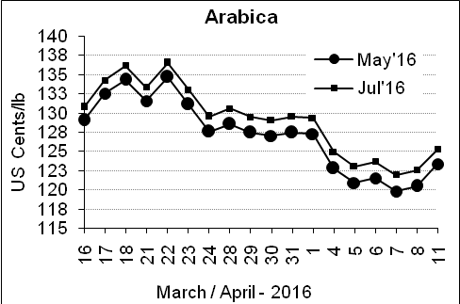
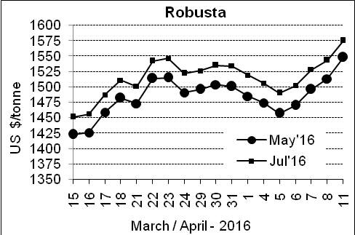

Market Analysis
ICE Arabica coffee futures turned slightly higher, as the Brazilian real firmed. ICE July arabica coffee futures settled up 2.7 cent, or 2.2 percent, at $1.2525 per lb, quickly extending gains above the 100-day moving average. May robusta coffee futures settled up $35, or 2.3 percent, at $1,548 per tonne, with dealers focused on erosion of yields at the start of robusta harvesting in Brazil after prolonged dry weather.

Differentials: | Ar. Plant. A | Ar.Chy.AB | Rob.Pmt.AB | Rob.Chy.AB
Differentials: | NY +25 to +30 | NY –30 to –35 | LIFFE +800 to +850 | LIFFE +170 to +200

ICTA Auction Prices Rs/Kg as on 06.04.2016 (2015-16 season crop)
Grade | MNEB | AA | PB | A | AB | B | C | BBB
Arabica Plantation | --- | 250.00 | 190.00 | 232.00 | --- | 183.00 | 146.00 | 112.00
Arabica Cherry | --- | --- | --- | --- | 136.00 | --- | --- | 100.00
 | RKR | A | PB | AA | AB | B | C | BBB
Robusta Parchment | --- | --- | 136.00 | --- | --- | --- | --- | ---
Robusta Cherry | --- | --- | 105.00 | --- | 108.00 | --- | 102.00 | 96.00

Raw Coffee Price (Karnataka) as on 11.04.2016 in Rs/50 kg
Ar.Pmt |  |  | Ar.Chy |  |  | Rob.Pmt |  |  | Rob.Chy
7950 | - | 8000 | 3275 | - | 3300 | 5700 | - | 5800 | 2675 | - | 2725

Export update: From 1st January 2016 to 11th April 2016 (in metric tonnes)
 | INDIAN COFFEE | Ar.Pmt | Ar.Chy | Rob.Pmt | Rob.Chy | Roasted seeds | R & G | Instant | Total
1 | Provisional exports (Indian coffee) | 17440 | 4312 | 7138 | 51580 | 14 | 56 | 6196 | 86737
2 | Provisional exports corresponding period last year | 13466 | 4587 | 9938 | 38274 | 8 | 98 | 6001 | 72372
3 | Provisional re-exports | 0 | 0 | 0 | 0 | 0 | 5 | 22832 | 22837
4 | Provisional re-exports corresponding period last year | 0 | 0 | 0 | 0 | 36 | 27 | 20659 | 20722
5 | Total provisional exports (1+3) | 17440 | 4312 | 7138 | 51580 | 14 | 61 | 29029 | 109574
6 | Total provisional exports corresponding period last year (2+4) | 13466 | 4587 | 9938 | 38274 | 44 | 125 | 26661 | 93095

Disclaimer: The Board neither guarantees the accuracy of the information nor accept any liability whatsoever for any direct or consequential loss arising from the use of this report

