COFFEE BOARD: BENGALURU
Daily Coffee Market Report Wednesday, April 06, 2016

Futures Prices 05.04.2016
ICE (New York)- Arabica- US cents / lb |  |  | LIFFE(London) – Robusta -US $ / tonne and cents / lb in brackets (10 MT contract)
Month | Price | Prev. Price | Month | Price | Prev. Price
May – 2016 | 120.90 | 122.80 | May – 2016 | 1457 (66.09) | 1474 (66.86)
July – 2016 | 123.05 | 124.95 | July – 2016 | 1490 (67.59) | 1506 (68.31)
Sep – 2016 | 124.85 | 126.75 | Sep – 2016 | 1513 (68.63) | 1528 (69.31)
ICO Group Indicator price on 04.04.2016 and previous price in brackets
Other Mild Arabica |  | Robusta |  |  | Exchange Rate Rs/ US $
US Cents/lb | Rs/kg | US Cents/lb | Rs/kg
153.75 (159.30) | 224.80 (232.63) | 77.93 (77.93) | 113.94 (113.80) |  | 66.32
Futures Price Trend

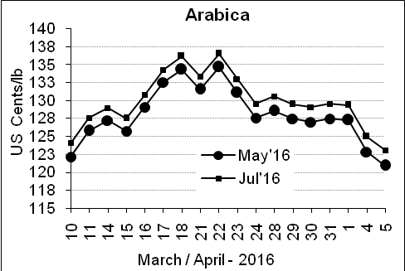
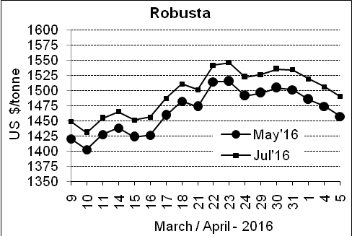

Market Analysis
ICE Arabica coffee futures fell to a four-week low on Tuesday, dropping for the third straight session on fund and chart-based selling, and pressure from the weak currency in top grower Brazil. ICE May arabica coffee futures settled down 1.9 cent, or 1.6 percent, at $1.209 per lb, after falling to $1.2055, the lowest since March 10. May robusta coffee futures settled down $17, or 1.2 percent, at $1,457 per tonne.

Differentials: | Ar. Plant. A | Ar.Chy.AB | Rob.Pmt.AB | Rob.Chy.AB
Differentials: | NY +25 to +30 | NY –30 to –35 | LIFFE +800 to +850 | LIFFE +170 to +200

ICTA Auction Prices Rs/Kg as on 30.03.2016 (2015-16 season crop)
Grade | MNEB | AA | PB | A | AB | B | C | BBB
Arabica Plantation | 256.00 | --- | --- | --- | --- | 183.00 | 146.00 | ---
Arabica Cherry | --- | --- | --- | --- | --- | --- | --- | 93.00
 | RKR | A | PB | AA | AB | B | C | BBB
Robusta Parchment | --- | --- | --- | --- | --- | --- | --- | ---
Robusta Cherry | --- | --- | --- | --- | --- | --- | --- | ---

Raw Coffee Price (Karnataka) as on 05.04.2016 in Rs/50 kg
Ar.Pmt |  |  | Ar.Chy |  |  | Rob.Pmt |  |  | Rob.Chy
8100 | - | 8250 | 3250 | - | 3400 | 5750 | - | 5810 | 2600 | - | 2750

Export update: From 1st January 2016 to 05th April 2016 (in metric tonnes)
 | INDIAN COFFEE | Ar.Pmt | Ar.Chy | Rob.Pmt | Rob.Chy | Roasted seeds | R & G | Instant | Total
1 | Provisional exports (Indian coffee) | 16549 | 4020 | 6892 | 47521 | 14 | 54 | 5735 | 80785
2 | Provisional exports corresponding period last year | 12521 | 4103 | 8645 | 33690 | 8 | 89 | 5590 | 64645
3 | Provisional re-exports | 0 | 0 | 0 | 0 | 0 | 5 | 21821 | 21826
4 | Provisional re-exports corresponding period last year | 0 | 0 | 0 | 0 | 36 | 27 | 19399 | 19462
5 | Total provisional exports (1+3) | 16549 | 4020 | 6892 | 47521 | 14 | 59 | 27556 | 102612
6 | Total provisional exports corresponding period last year (2+4) | 12521 | 4103 | 8645 | 33690 | 44 | 115 | 24989 | 84107

Disclaimer: The Board neither guarantees the accuracy of the information nor accept any liability whatsoever for any direct or consequential loss arising from the use of this report

