COFFEE BOARD: BENGALURU
Daily Coffee Market Report Wednesday, April 13, 2016

Futures Prices 12.04.2016
ICE (New York)- Arabica- US cents / lb |  |  | LIFFE(London) – Robusta -US $ / tonne and cents / lb in brackets (10 MT contract)
Month | Price | Prev. Price | Month | Price | Prev. Price
May – 2016 | 124.60 | 123.35 | May – 2016 | 1559 (70.72) | 1548 (70.22)
July – 2016 | 126.30 | 125.25 | July – 2016 | 1585 (71.89) | 1575 (71.44)
Sep – 2016 | 127.95 | 126.90 | Sep – 2016 | 1600 (72.57) | 1590 (72.12)
ICO Group Indicator price on 11.04.2016 and previous price in brackets
Other Mild Arabica |  | Robusta |  |  | Exchange Rate Rs/ US $
US Cents/lb | Rs/kg | US Cents/lb | Rs/kg
153.57 (151.28) | 225.14 (221.42) | 81.25 (79.75) | 119.12 (116.73) |  | 66.50
Futures Price Trend

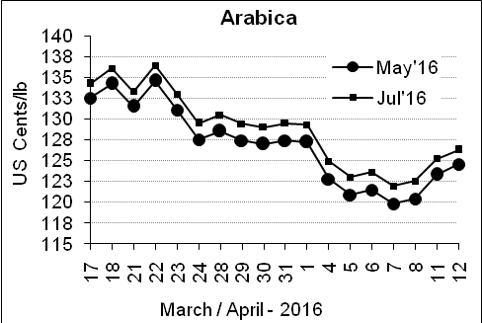
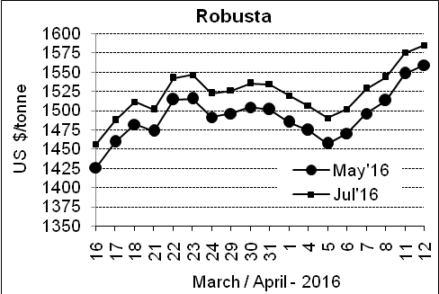

Market Analysis
ICE Arabica coffee futures rose for the third straight day, extending gains above their 100-day moving average. ICE July arabica coffee futures settled up 1.05 cent, or 0.8 percent, at $1.263 per lb. May robusta coffee futures settled up $11, or 0.7 percent, at $1,559 per tonne, with attention centered on erosion of yields at the start of the robusta harvest in Brazil after prolonged dry weather.

Differentials: | Ar. Plant. A | Ar.Chy.AB | Rob.Pmt.AB | Rob.Chy.AB
Differentials: | NY +25 to +30 | NY –30 to –35 | LIFFE +800 to +850 | LIFFE +170 to +200

ICTA Auction Prices Rs/Kg as on 06.04.2016 (2015-16 season crop)
Grade | MNEB | AA | PB | A | AB | B | C | BBB
Arabica Plantation | --- | 250.00 | 190.00 | 232.00 | --- | 183.00 | 146.00 | 112.00
Arabica Cherry | --- | --- | --- | --- | 136.00 | --- | --- | 100.00
 | RKR | A | PB | AA | AB | B | C | BBB
Robusta Parchment | --- | --- | 136.00 | --- | --- | --- | --- | ---
Robusta Cherry | --- | --- | 105.00 | --- | 108.00 | --- | 102.00 | 96.00

Raw Coffee Price (Karnataka) as on 12.04.2016 in Rs/50 kg
Ar.Pmt |  |  | Ar.Chy |  |  | Rob.Pmt |  |  | Rob.Chy
8060 | - | 8250 | 3300 | - | 3450 | 5800 | - | 5900 | 2650 | - | 2775

Export update: From 1st January 2016 to 12th April 2016 (in metric tonnes)
 | INDIAN COFFEE | Ar.Pmt | Ar.Chy | Rob.Pmt | Rob.Chy | Roasted seeds | R & G | Instant | Total
1 | Provisional exports (Indian coffee) | 17675 | 4428 | 7344 | 52578 | 14 | 57 | 6302 | 88398
2 | Provisional exports corresponding period last year | 13466 | 4587 | 9938 | 38274 | 8 | 98 | 6001 | 72372
3 | Provisional re-exports | 0 | 0 | 0 | 0 | 0 | 5 | 22933 | 22938
4 | Provisional re-exports corresponding period last year | 0 | 0 | 0 | 0 | 36 | 27 | 20659 | 20722
5 | Total provisional exports (1+3) | 17675 | 4428 | 7344 | 52578 | 14 | 62 | 29235 | 111336
6 | Total provisional exports corresponding period last year (2+4) | 13466 | 4587 | 9938 | 38274 | 44 | 125 | 26661 | 93095

Disclaimer: The Board neither guarantees the accuracy of the information nor accept any liability whatsoever for any direct or consequential loss arising from the use of this report

