COFFEE BOARD: BENGALURU
Daily Coffee Market Report Friday, May 06, 2016

Futures Prices 05.05.2016
ICE (New York)- Arabica- US cents / lb |  |  | LIFFE(London) – Robusta -US $ / tonne and cents / lb in brackets (10 MT contract)
Month | Price | Prev. Price | Month | Price | Prev. Price
May – 2016 | 120.90 | 119.10 | May – 2016 | 1584 (71.85) | 1552 (70.40)
July – 2016 | 121.50 | 119.70 | July – 2016 | 1617 (73.35) | 1585 (71.85)
Sep – 2016 | 123.25 | 121.55 | Sep – 2016 | 1626 (73.75) | 1603 (72.71)
ICO Group Indicator price on 04.05.2016 and previous price in brackets
Other Mild Arabica |  | Robusta |  |  | Exchange Rate Rs/ US $
US Cents/lb | Rs/kg | US Cents/lb | Rs/kg
150.30 (150.00) | 220.38 (220.04) | 81.24 (81.27) | 119.12 (119.22) |  | 66.54
Futures Price Trend

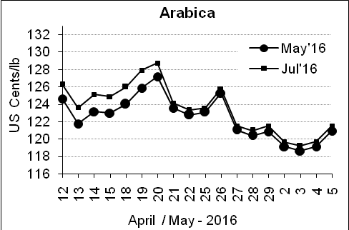
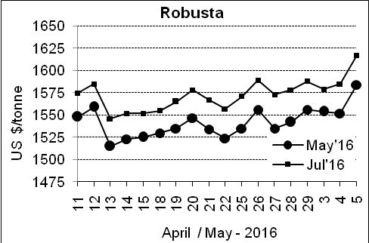

Market Analysis
ICE July arabica coffee futures settled up 1.8 cent, or 1.5 percent, at $1.215 per lb, bouncing up from Wednesday's two-month low. Robusta coffee hit a six-month high, surging above the 200-day moving average at $1,588 for the contract's first time, basis July. ICE July robusta coffee futures settled up $32, or 2 percent, at $1,617 per tonne, after touching $1,625, the highest since November on a continuation chart.

Differentials: | Ar. Plant. A | Ar.Chy.AB | Rob.Pmt.AB | Rob.Chy.AB
Differentials: | NY +25 to +30 | NY –25 to –30 | LIFFE +650 to +700 | LIFFE +170 to +180

ICTA Auction Prices Rs/Kg as on 28.04.2016 (2015-16 season crop)
Grade | MNEB | AA | PB | A | AB | B | C | BBB
Arabica Plantation | --- | 252.00 | 185.00 | 223.00 | --- | --- | 150.00 | ---
Arabica Cherry | --- | --- | 134.00 | --- | --- | --- | --- | ---
 | RKR | A | PB | AA | AB | B | C | BBB
Robusta Parchment | --- | --- | --- | --- | --- | --- | --- | ---
Robusta Cherry | --- | --- | --- | --- | --- | --- | --- | ---

Raw Coffee Price (Karnataka) as on 04.05.2016 in Rs/50 kg
Ar.Pmt |  |  | Ar.Chy |  |  | Rob.Pmt |  |  | Rob.Chy
7900 | - | 8000 | 3250 | - | 3425 | 5700 | - | 5750 | 2675 | - | 2700

Export update: From 1st January 2016 to 05th May 2016 (in metric tonnes)
 | INDIAN COFFEE | Ar.Pmt | Ar.Chy | Rob.Pmt | Rob.Chy | Roasted seeds | R & G | Instant | Total
1 | Provisional exports (Indian coffee) | 21926 | 5769 | 9525 | 68379 | 17 | 75 | 7865 | 113555
2 | Provisional exports corresponding period last year | 16626 | 5852 | 12655 | 51126 | 12 | 114 | 6975 | 93361
3 | Provisional re-exports | 0 | 0 | 0 | 0 | 0 | 5 | 28292 | 28296
4 | Provisional re-exports corresponding period last year | 0 | 0 | 0 | 0 | 42 | 57 | 23575 | 23674
5 | Total provisional exports (1+3) | 21926 | 5769 | 9525 | 68379 | 17 | 80 | 36156 | 141851
6 | Total provisional exports corresponding period last year (2+4) | 16626 | 5852 | 12655 | 51126 | 54 | 170 | 30550 | 117035

Disclaimer: The Board neither guarantees the accuracy of the information nor accept any liability whatsoever for any direct or consequential loss arising from the use of this report

