COFFEE BOARD: BENGALURU
Daily Coffee Market Report Friday, May 13, 2016

Futures Prices 12.05.2016
ICE (New York)- Arabica- US cents / lb |  |  | LIFFE(London) – Robusta -US $ / tonne and cents / lb in brackets (10 MT contract)
Month | Price | Prev. Price | Month | Price | Prev. Price
May – 2016 | 128.20 | 127.90 | May – 2016 | 1649 (74.48) | 1642 (74.48)
July – 2016 | 130.05 | 129.75 | July – 2016 | 1678 (76.11) | 1671 (75.80)
Sep – 2016 | 131.90 | 131.50 | Sep – 2016 | 1690 (76.66) | 1685 (76.43)
ICO Group Indicator price on 11.05.2016 and previous price in brackets
Other Mild Arabica |  | Robusta |  |  | Exchange Rate Rs/ US $
US Cents/lb | Rs/kg | US Cents/lb | Rs/kg
160.48 (159.67) | 235.63 (234.79) | 85.02 (84.60) | 124.83 (124.40) |  | 66.60
Futures Price Trend
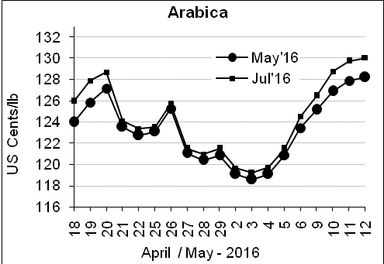
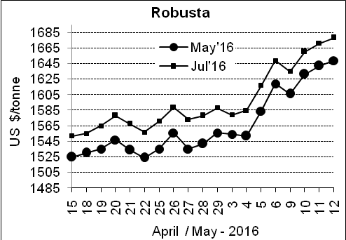

Market Analysis
ICE Arabica coffee prices extended their steady rise. ICE July arabica coffee futures settled up 0.3 cent, or 0.2 percent, at $1.3005 per lb, up for the seventh straight day, after touching a three-week high of $1.307. July robusta coffee futures settled up $7, or 0.4 percent, at $1,678 per tonne, after touching a six-month high of $1,684, matching the high reached on Nov. 5 on a continuation chart.

Differentials: | Ar. Plant. A | Ar.Chy.AB | Rob.Pmt.AB | Rob.Chy.AB
Differentials: | NY +25 to +30 | NY –25 to –30 | LIFFE +650 to +700 | LIFFE +170 to +180

ICTA Auction Prices Rs/Kg as on 05.05.2016 (2015-16 season crop)
Grade | MNEB | AA | PB | A | AB | B | C | BBB
Arabica Plantation | --- | 244.00 | 191.00 | --- | --- | 176.00 | 140.00 | ---
Arabica Cherry | --- | --- | 128.00 | --- | 140.00 | --- | 120.5 | 107.00
 | RKR | A | PB | AA | AB | B | C | BBB
Robusta Parchment | --- | --- | 140.00 | --- | 147.00 | --- | 130.00 | ---
Robusta Cherry | --- | --- | --- | --- | --- | --- | --- | ---

Raw Coffee Price (Karnataka) as on 12.05.2016 in Rs/50 kg
Ar.Pmt |  |  | Ar.Chy |  |  | Rob.Pmt |  |  | Rob.Chy
7850 | - | 8000 | 3400 | - | 3450 | 5750 | - | 5800 | 2750 | - | 2775

Export update: From 1st January 2016 to 12th May 2016 (in metric tonnes)
 | INDIAN COFFEE | Ar.Pmt | Ar.Chy | Rob.Pmt | Rob.Chy | Roasted seeds | R & G | Instant | Total
1 | Provisional exports (Indian coffee) | 22795 | 6101 | 10399 | 71506 | 17 | 77 | 8315 | 119211
2 | Provisional exports corresponding period last year | 17947 | 6337 | 13722 | 54382 | 12 | 118 | 7142 | 99661
3 | Provisional re-exports | 0 | 0 | 0 | 0 | 0 | 5 | 30010 | 30014
4 | Provisional re-exports corresponding period last year | 0 | 0 | 0 | 0 | 42 | 63 | 24735 | 24840
5 | Total provisional exports (1+3) | 22795 | 6101 | 10399 | 71506 | 17 | 81 | 38325 | 149225
6 | Total provisional exports corresponding period last year (2+4) | 17947 | 6337 | 13722 | 54382 | 54 | 181 | 31877 | 124501

Disclaimer: The Board neither guarantees the accuracy of the information nor accept any liability whatsoever for any direct or consequential loss arising from the use of this report

