COFFEE BOARD: BENGALURU
Daily Coffee Market Report Thursday, May 05, 2016

Futures Prices 04.05.2016
ICE (New York)- Arabica- US cents / lb |  |  | LIFFE(London) – Robusta -US $ / tonne and cents / lb in brackets (10 MT contract)
Month | Price | Prev. Price | Month | Price | Prev. Price
May – 2016 | 119.10 | 118.60 | May – 2016 | 1552 (70.40) | 1554 (70.49)
July – 2016 | 119.70 | 119.25 | July – 2016 | 1585 (71.85) | 1579 (71.62)
Sep – 2016 | 121.55 | 121.15 | Sep – 2016 | 1603 (72.71) | 1599 (72.53)
ICO Group Indicator price on 03.05.2016 and previous price in brackets
Other Mild Arabica |  | Robusta |  |  | Exchange Rate Rs/ US $
US Cents/lb | Rs/kg | US Cents/lb | Rs/kg
150.00 (150.49) | 220.04 (219.87) | 81.27 (81.53) | 119.22 (119.12) |  | 66.54
Futures Price Trend

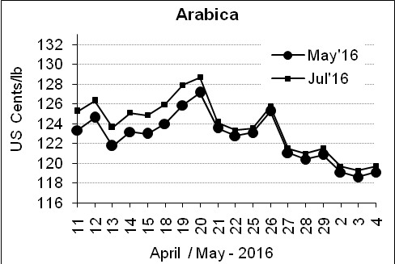
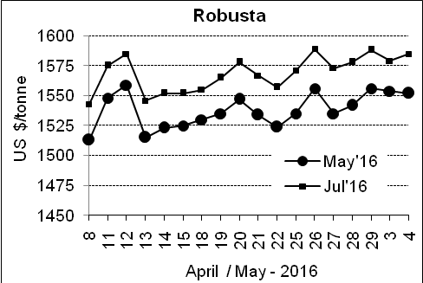

Market Analysis
ICE Arabica coffee futures bounced higher on Wednesday for the first time in three sessions as the Brazilian real strengthened against the dollar, removing a recent source of pressure on coffee bean prices. ICE July arabica coffee futures settled up 0.45 cent, or 0.4 percent, at $1.197 per lb. Robusta coffee consolidated just below last month's five-month high, underpinned by concerns that drought is likely to curb production in Vietnam. July robusta coffee futures settled up $6, or 0.4 percent, at $1,585 per tonne.

Differentials: | Ar. Plant. A | Ar.Chy.AB | Rob.Pmt.AB | Rob.Chy.AB
Differentials: | NY +25 to +30 | NY –25 to –30 | LIFFE +650 to +700 | LIFFE +170 to +180

ICTA Auction Prices Rs/Kg as on 28.04.2016 (2015-16 season crop)
Grade | MNEB | AA | PB | A | AB | B | C | BBB
Arabica Plantation | --- | 252.00 | 185.00 | 223.00 | --- | --- | 150.00 | ---
Arabica Cherry | --- | --- | 134.00 | --- | --- | --- | --- | ---
 | RKR | A | PB | AA | AB | B | C | BBB
Robusta Parchment | --- | --- | --- | --- | --- | --- | --- | ---
Robusta Cherry | --- | --- | --- | --- | --- | --- | --- | ---

Raw Coffee Price (Karnataka) as on 04.05.2016 in Rs/50 kg
Ar.Pmt |  |  | Ar.Chy |  |  | Rob.Pmt |  |  | Rob.Chy
7900 | - | 8000 | 3250 | - | 3425 | 5700 | - | 5750 | 2675 | - | 2700

Export update: From 1st January 2016 to 04th May 2016 (in metric tonnes)
 | INDIAN COFFEE | Ar.Pmt | Ar.Chy | Rob.Pmt | Rob.Chy | Roasted seeds | R & G | Instant | Total
1 | Provisional exports (Indian coffee) | 21804 | 5673 | 9400 | 67600 | 17 | 75 | 7865 | 112433
2 | Provisional exports corresponding period last year | 16401 | 5567 | 12498 | 49518 | 12 | 111 | 6878 | 90985
3 | Provisional re-exports | 0 | 0 | 0 | 0 | 0 | 5 | 27687 | 27692
4 | Provisional re-exports corresponding period last year | 0 | 0 | 0 | 0 | 40 | 47 | 23383 | 23470
5 | Total provisional exports (1+3) | 21804 | 5673 | 9400 | 67600 | 17 | 79 | 35552 | 140125
6 | Total provisional exports corresponding period last year (2+4) | 16401 | 5567 | 12498 | 49518 | 52 | 158 | 30261 | 114455

Disclaimer: The Board neither guarantees the accuracy of the information nor accept any liability whatsoever for any direct or consequential loss arising from the use of this report

