COFFEE BOARD: BENGALURU
Daily Coffee Market Report Thursday, May 12, 2016

Futures Prices 11.05.2016
ICE (New York)- Arabica- US cents / lb |  |  | LIFFE(London) – Robusta -US $ / tonne and cents / lb in brackets (10 MT contract)
Month | Price | Prev. Price | Month | Price | Prev. Price
May – 2016 | 127.90 | 126.90 | May – 2016 | 1642 (74.48) | 1631 (73.98)
July – 2016 | 129.75 | 128.75 | July – 2016 | 1671 (75.80) | 1660 (75.30)
Sep – 2016 | 131.50 | 130.45 | Sep – 2016 | 1685 (76.43) | 1675 (75.98)
ICO Group Indicator price on 10.05.2016 and previous price in brackets
Other Mild Arabica |  | Robusta |  |  | Exchange Rate Rs/ US $
US Cents/lb | Rs/kg | US Cents/lb | Rs/kg
159.67 (157.40) | 234.79 (231.52) | 84.60 (83.50) | 124.40 (122.82) |  | 66.70
Futures Price Trend
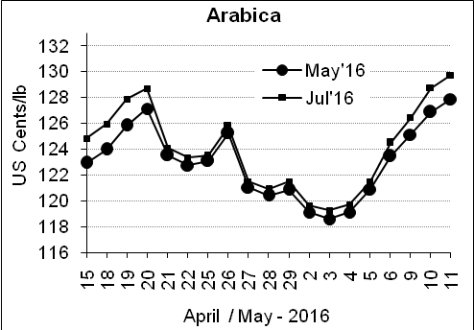
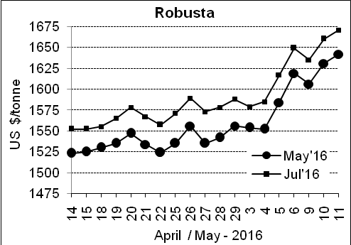

Market Analysis
ICE Arabica coffee futures extended gains above the 200-day moving average. ICE July arabica coffee futures settled up 1 cent, or 0.8 percent, at $1.2975 per lb, up for the sixth straight day to a three-week high $1.298. July robusta coffee futures settled up $11, or 0.7 percent, at $1,671 per tonne after touching a six-month peak of $1,672 on dry weather Southeast Asia.

Differentials: | Ar. Plant. A | Ar.Chy.AB | Rob.Pmt.AB | Rob.Chy.AB
Differentials: | NY +25 to +30 | NY –25 to –30 | LIFFE +650 to +700 | LIFFE +170 to +180

ICTA Auction Prices Rs/Kg as on 05.05.2016 (2015-16 season crop)
Grade | MNEB | AA | PB | A | AB | B | C | BBB
Arabica Plantation | --- | 244.00 | 191.00 | --- | --- | 176.00 | 140.00 | ---
Arabica Cherry | --- | --- | 128.00 | --- | 140.00 | --- | 120.5 | 107.00
 | RKR | A | PB | AA | AB | B | C | BBB
Robusta Parchment | --- | --- | 140.00 | --- | 147.00 | --- | 130.00 | ---
Robusta Cherry | --- | --- | --- | --- | --- | --- | --- | ---

Raw Coffee Price (Karnataka) as on 11.05.2016 in Rs/50 kg
Ar.Pmt |  |  | Ar.Chy |  |  | Rob.Pmt |  |  | Rob.Chy
7910 | - | 8150 | 3400 | - | 3600 | 5810 | - | 6000 | 2750 | - | 2825

Export update: From 1st January 2016 to 11th May 2016 (in metric tonnes)
 | INDIAN COFFEE | Ar.Pmt | Ar.Chy | Rob.Pmt | Rob.Chy | Roasted seeds | R & G | Instant | Total
1 | Provisional exports (Indian coffee) | 22581 | 6096 | 10270 | 71150 | 17 | 77 | 8195 | 118386
2 | Provisional exports corresponding period last year | 17792 | 6310 | 13407 | 53960 | 12 | 117 | 7119 | 98717
3 | Provisional re-exports | 0 | 0 | 0 | 0 | 0 | 5 | 29887 | 29892
4 | Provisional re-exports corresponding period last year | 0 | 0 | 0 | 0 | 42 | 63 | 24562 | 24668
5 | Total provisional exports (1+3) | 22581 | 6096 | 10270 | 71150 | 17 | 81 | 38082 | 148278
6 | Total provisional exports corresponding period last year (2+4) | 17792 | 6310 | 13407 | 53960 | 54 | 180 | 31681 | 123385

Disclaimer: The Board neither guarantees the accuracy of the information nor accept any liability whatsoever for any direct or consequential loss arising from the use of this report

