COFFEE BOARD: BENGALURU
Daily Coffee Market Report Tuesday, May 10, 2016

Futures Prices 09.05.2016
ICE (New York)- Arabica- US cents / lb |  |  | LIFFE(London) – Robusta -US $ / tonne and cents / lb in brackets (10 MT contract)
Month | Price | Prev. Price | Month | Price | Prev. Price
May – 2016 | 125.15 | 123.45 | May – 2016 | 1606 (72.85) | 1619 (73.44)
July – 2016 | 126.45 | 124.50 | July – 2016 | 1635 (74.16) | 1649 (74.80)
Sep – 2016 | 128.10 | 126.25 | Sep – 2016 | 1650 (74.84) | 1658 (75.21)
ICO Group Indicator price on 06.05.2016 and previous price in brackets
Other Mild Arabica |  | Robusta |  |  | Exchange Rate Rs/ US $
US Cents/lb | Rs/kg | US Cents/lb | Rs/kg
154.62 (152.05) | 226.48 (223.18) | 84.09 (81.77) | 123.17 (120.02) |  | 66.44
Futures Price Trend
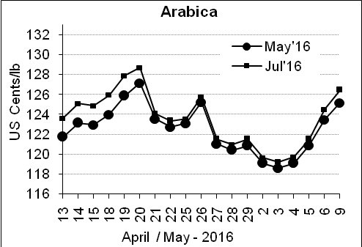
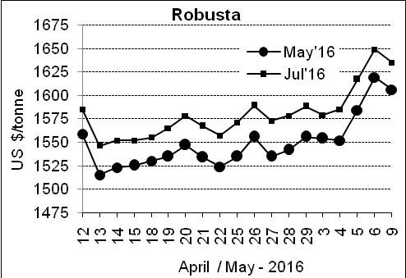

Market Analysis
ICE Arabica coffee prices rose on chart-based strength, after closing above the 100-day moving average on Friday but failing just short of the 200-day moving average on Monday. ICE July arabica coffee futures settled up 1.95 cent, or 1.6 percent, at $1.2645 per lb. Robusta ran out of upward momentum at $1,665 per tonne, the highest on a continuation chart since early November, and sell stops were triggered below the prior session's low. July robusta coffee futures settled down $14, or 0.9 percent, at $1,635 per tonne.

Differentials: | Ar. Plant. A | Ar.Chy.AB | Rob.Pmt.AB | Rob.Chy.AB
Differentials: | NY +25 to +30 | NY –25 to –30 | LIFFE +650 to +700 | LIFFE +170 to +180

ICTA Auction Prices Rs/Kg as on 05.05.2016 (2015-16 season crop)
Grade | MNEB | AA | PB | A | AB | B | C | BBB
Arabica Plantation | --- | 224.00 | 191.00 | --- | --- | 176.00 | 140.00 | ---
Arabica Cherry | --- | --- | 128.00 | --- | 140.00 | --- | 120.5 | 107.00
 | RKR | A | PB | AA | AB | B | C | BBB
Robusta Parchment | --- | --- | 140.00 | --- | 147.00 | --- | 130.00 | ---
Robusta Cherry | --- | --- | --- | --- | --- | --- | --- | ---

Raw Coffee Price (Karnataka) as on 07.05.2016 in Rs/50 kg
Ar.Pmt |  |  | Ar.Chy |  |  | Rob.Pmt |  |  | Rob.Chy
7900 | - | 8100 | 3400 | - | 3550 | 5800 | - | 6000 | 2700 | - | 2825

Export update: From 1st January 2016 to 09th May 2016 (in metric tonnes)
 | INDIAN COFFEE | Ar.Pmt | Ar.Chy | Rob.Pmt | Rob.Chy | Roasted seeds | R & G | Instant | Total
1 | Provisional exports (Indian coffee) | 22474 | 5808 | 10035 | 69512 | 17 | 76 | 7914 | 115836
2 | Provisional exports corresponding period last year | 17576 | 5920 | 13053 | 52858 | 12 | 117 | 7036 | 96571
3 | Provisional re-exports | 0 | 0 | 0 | 0 | 0 | 5 | 29373 | 29378
4 | Provisional re-exports corresponding period last year | 0 | 0 | 0 | 0 | 42 | 63 | 24202 | 24308
5 | Total provisional exports (1+3) | 22474 | 5808 | 10035 | 69512 | 17 | 81 | 37287 | 145214
6 | Total provisional exports corresponding period last year (2+4) | 17576 | 5920 | 13053 | 52858 | 54 | 180 | 31238 | 120879

Disclaimer: The Board neither guarantees the accuracy of the information nor accept any liability whatsoever for any direct or consequential loss arising from the use of this report

