COFFEE BOARD: BENGALURU
Daily Coffee Market Report Friday, June 03, 2016

Futures Prices 02.06.2016
ICE (New York)- Arabica- US cents / lb |  |  | LIFFE(London) – Robusta -US $ / tonne and cents / lb in brackets (10 MT contract)
Month | Price | Prev. Price | Month | Price | Prev. Price
July – 2016 | 123.00 | 121.90 | July – 2016 | 1632 (74.03) | 1646 (74.66)
Sep – 2016 | 125.00 | 123.85 | Sep – 2016 | 1656 (75.11) | 1667 (75.61)
Dec – 2016 | 127.55 | 126.45 | Nov – 2016 | 1668 (75.66) | 1679 (76.16)
ICO Group Indicator price on 01.06.2016 and previous price in brackets
Other Mild Arabica |  | Robusta |  |  | Exchange Rate Rs/ US $
US Cents/lb | Rs/kg | US Cents/lb | Rs/kg
152.49 (152.16) | 226.08 (225.93) | 84.88 (84.17) | 125.84 (124.98) |  | 67.25
Futures Price Trend
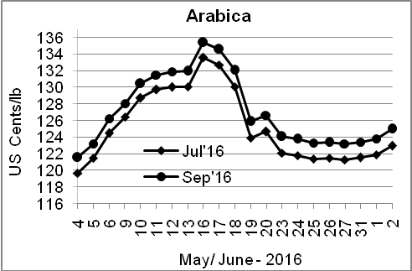
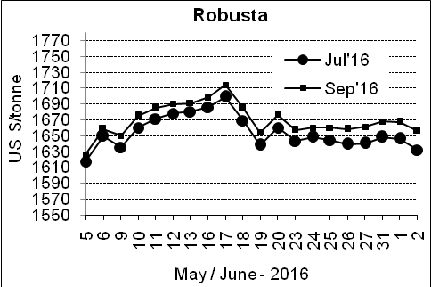

Market Analysis
ICE Arabica coffee futures edged up, with July closing up 1.1 cent, or 0.90 percent, at $1.23 per lb. July robusta coffee futures settled down $14, or 0.9 percent, at $1,632 per tonne.

Differentials: | Ar. Plant. A | Ar.Chy.AB | Rob.Pmt.AB | Rob.Chy.AB
Differentials: | NY +18 to +20 | NY –25 to –30 | LIFFE +650 to +700 | LIFFE +160 to +180

ICTA Auction Prices Rs/Kg as on 26.05.2016 (2015-16 season crop)
Grade | MNEB | AA | PB | A | AB | B | C | BBB
Arabica Plantation | --- | --- | --- | --- | --- | 193.00 | 150.00 | ---
Arabica Cherry | --- | 147.00 | 137.00 | 146.00 | --- | 144.00 | 128.00 | 103.50
 | RKR | A | PB | AA | AB | B | C | BBB
Robusta Parchment | --- | --- | 130.00 | 164.36 | 136.00 | --- | 112.00 | 103.00
Robusta Cherry | --- | 120.50 | 115.00 | 124.00 | 116.50 | --- | 114.00 | 103.00

Raw Coffee Price (Karnataka) as on 02.06.2016 in Rs/50 kg
Ar.Pmt |  |  | Ar.Chy |  |  | Rob.Pmt |  |  | Rob.Chy
7450 | - | 7500 | 3275 | - | 3375 | 5600 | - | 5660 | 2725 | - | 2800

Export update: From 1st January 2016 to 02nd June 2016 (in metric tonnes)
 | INDIAN COFFEE | Ar.Pmt | Ar.Chy | Rob.Pmt | Rob.Chy | Roasted seeds | R & G | Instant | Total
1 | Provisional exports (Indian coffee) | 26075 | 7113 | 12922 | 84374 | 18 | 81 | 10092 | 140675
2 | Provisional exports corresponding period last year | 20541 | 7060 | 17216 | 62802 | 12 | 127 | 8143 | 115901
3 | Provisional re-exports | 0 | 0 | 0 | 0 | 0 | 48 | 34666 | 34714
4 | Provisional re-exports corresponding period last year | 0 | 0 | 0 | 0 | 85 | 84 | 29801 | 29971
5 | Total provisional exports (1+3) | 26075 | 7113 | 12922 | 84374 | 18 | 128 | 44758 | 175388
6 | Total provisional exports corresponding period last year (2+4) | 20541 | 7060 | 17216 | 62802 | 97 | 211 | 37944 | 145871

Disclaimer: The Board neither guarantees the accuracy of the information nor accept any liability whatsoever for any direct or consequential loss arising from the use of this report

