COFFEE BOARD: BENGALURU
Daily Coffee Market Report Monday, June 13, 2016

Futures Prices 10.06.2016
ICE (New York)- Arabica- US cents / lb |  |  | LIFFE(London) – Robusta -US $ / tonne and cents / lb in brackets (10 MT contract)
Month | Price | Prev. Price | Month | Price | Prev. Price
July – 2016 | 136.95 | 133.95 | July – 2016 | 1643 (74.53) | 1685 (76.43)
Sep – 2016 | 138.85 | 135.85 | Sep – 2016 | 1674 (75.93) | 1714 (77.75)
Dec – 2016 | 141.25 | 138.40 | Nov – 2016 | 1691 (76.70) | 1730 (78.47)
ICO Group Indicator price on 09.06.2016 and previous price in brackets
Other Mild Arabica |  | Robusta |  |  | Exchange Rate Rs/ US $
US Cents/lb | Rs/kg | US Cents/lb | Rs/kg
163.75 (169.23) | 241.12 (248.59) | 87.31 (87.63) | 128.56 (128.72) |  | 66.79
Futures Price Trend
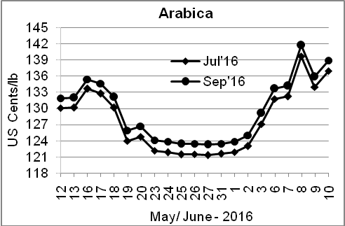
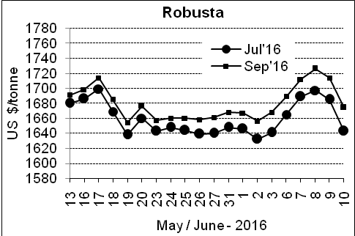

Market Analysis
ICE July arabica coffee futures prices pushed higher on Friday, up 3.00 cents or 2.2% to settle at $1.3695 a pound. July robusta coffee futures settled down $42 at $1,643 per tonne.

Differentials: | Ar. Plant. A | Ar.Chy.AB | Rob.Pmt.AB | Rob.Chy.AB
Differentials: | NY +18 to +20 | NY –25 to –30 | LIFFE +650 to +700 | LIFFE +160 to +180

ICTA Auction Prices Rs/Kg as on 09.06.2016 (2015-16 season crop)
Grade | MNEB | AA | PB | A | AB | B | C | BBB
Arabica Plantation | 245.00 | 245.40 | 209.96 | 211.10 | --- | 191.00 | 150.50 | 120.00
Arabica Cherry | --- | --- | --- | --- | --- | --- | --- | ---
 | RKR | A | PB | AA | AB | B | C | BBB
Robusta Parchment | 144.50 |  | 137.50 | 148.50 | 143.50 | --- | 127.50 | 100.50
Robusta Cherry | --- | 124.00 | --- | 125.00 | --- | --- | --- | 106.00

Raw Coffee Price (Karnataka) as on 09.06.2016 in Rs/50 kg
Ar.Pmt |  |  | Ar.Chy |  |  | Rob.Pmt |  |  | Rob.Chy
7710 | - | 8100 | 3350 | - | 3700 | 5675 | - | 5925 | 2750 | - | 2950

Export update: From 1st January 2016 to 10th June 2016 (in metric tonnes)
 | INDIAN COFFEE | Ar.Pmt | Ar.Chy | Rob.Pmt | Rob.Chy | Roasted seeds | R & G | Instant | Total
1 | Provisional exports (Indian coffee) | 27272 | 7453 | 14318 | 88712 | 18 | 83 | 10413 | 148269
2 | Provisional exports corresponding period last year | 21451 | 7525 | 18537 | 65678 | 12 | 136 | 9022 | 122360
3 | Provisional re-exports | 0 | 0 | 0 | 0 | 0 | 48 | 36529 | 36576
4 | Provisional re-exports corresponding period last year | 0 | 0 | 0 | 0 | 119 | 91 | 30539 | 30749
5 | Total provisional exports (1+3) | 27272 | 7453 | 14318 | 88712 | 18 | 131 | 46942 | 184845
6 | Total provisional exports corresponding period last year (2+4) | 21451 | 7525 | 18537 | 65678 | 131 | 226 | 39562 | 153109

Disclaimer: The Board neither guarantees the accuracy of the information nor accept any liability whatsoever for any direct or consequential loss arising from the use of this report

