COFFEE BOARD: BENGALURU
Daily Coffee Market Report Thursday, June 02, 2016

Futures Prices 01.06.2016
ICE (New York)- Arabica- US cents / lb |  |  | LIFFE(London) – Robusta -US $ / tonne and cents / lb in brackets (10 MT contract)
Month | Price | Prev. Price | Month | Price | Prev. Price
July – 2016 | 121.90 | 121.55 | July – 2016 | 1646 (74.66) | 1648 (74.75)
Sep – 2016 | 123.85 | 123.45 | Sep – 2016 | 1667 (75.61) | 1668 (75.66)
Dec – 2016 | 126.45 | 126.15 | Nov – 2016 | 1679 (76.16) | 1681 (76.25)
ICO Group Indicator price on 31.05.2016 and previous price in brackets
Other Mild Arabica |  | Robusta |  |  | Exchange Rate Rs/ US $
US Cents/lb | Rs/kg | US Cents/lb | Rs/kg
152.16 (151.56) | 225.93 (224.54) | 84.17 (83.80) | 124.98 (124.15) |  | 67.35
Futures Price Trend
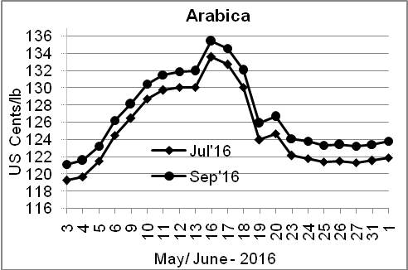
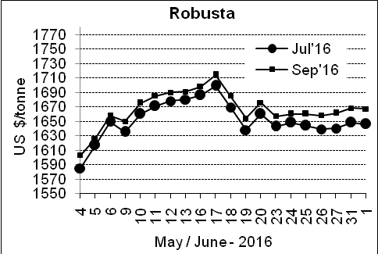

Market Analysis
ICE July arabica coffee futures settled up 0.35 cent, or 0.3 percent, at $1.219 per lb. July robusta coffee futures settled down $2, or 0.1 percent, at $1,646 per tonne.

Differentials: | Ar. Plant. A | Ar.Chy.AB | Rob.Pmt.AB | Rob.Chy.AB
Differentials: | NY +18 to +20 | NY –25 to –30 | LIFFE +650 to +700 | LIFFE +160 to +180

ICTA Auction Prices Rs/Kg as on 26.05.2016 (2015-16 season crop)
Grade | MNEB | AA | PB | A | AB | B | C | BBB
Arabica Plantation | --- | --- | --- | --- | --- | 193.00 | 150.00 | ---
Arabica Cherry | --- | 147.00 | 137.00 | 146.00 | --- | 144.00 | 128.00 | 103.50
 | RKR | A | PB | AA | AB | B | C | BBB
Robusta Parchment | --- | --- | 130.00 | 164.36 | 136.00 | --- | 112.00 | 103.00
Robusta Cherry | --- | 120.50 | 115.00 | 124.00 | 116.50 | --- | 114.00 | 103.00

Raw Coffee Price (Karnataka) as on 01.06.2016 in Rs/50 kg
Ar.Pmt |  |  | Ar.Chy |  |  | Rob.Pmt |  |  | Rob.Chy
7650 | - | 7700 | 3275 | - | 3375 | 5600 | - | 5660 | 2725 | - | 2800

Export update: From 1st January 2016 to 01st June 2016 (in metric tonnes)
 | INDIAN COFFEE | Ar.Pmt | Ar.Chy | Rob.Pmt | Rob.Chy | Roasted seeds | R & G | Instant | Total
1 | Provisional exports (Indian coffee) | 25753 | 6933 | 12881 | 83391 | 18 | 80 | 9921 | 138977
2 | Provisional exports corresponding period last year | 20351 | 7000 | 17069 | 62228 | 12 | 127 | 8074 | 114861
3 | Provisional re-exports | 0 | 0 | 0 | 0 | 0 | 48 | 34426 | 34474
4 | Provisional re-exports corresponding period last year | 0 | 0 | 0 | 0 | 85 | 84 | 29753 | 29923
5 | Total provisional exports (1+3) | 25753 | 6933 | 12881 | 83391 | 18 | 128 | 44347 | 173450
6 | Total provisional exports corresponding period last year (2+4) | 20351 | 7000 | 17069 | 62228 | 97 | 211 | 37827 | 144784

Disclaimer: The Board neither guarantees the accuracy of the information nor accept any liability whatsoever for any direct or consequential loss arising from the use of this report

