COFFEE BOARD: BENGALURU
Daily Coffee Market Report Thursday, June 09, 2016

Futures Prices 08.06.2016
ICE (New York)- Arabica- US cents / lb |  |  | LIFFE(London) – Robusta -US $ / tonne and cents / lb in brackets (10 MT contract)
Month | Price | Prev. Price | Month | Price | Prev. Price
July – 2016 | 139.65 | 132.20 | July – 2016 | 1697 (76.97) | 1689 (76.61)
Sep – 2016 | 141.65 | 134.15 | Sep – 2016 | 1726 (78.29) | 1712 (77.66)
Dec – 2016 | 144.20 | 136.80 | Nov – 2016 | 1740 (78.93) | 1726 (78.29)
ICO Group Indicator price on 07.06.2016 and previous price in brackets
Other Mild Arabica |  | Robusta |  |  | Exchange Rate Rs/ US $
US Cents/lb | Rs/kg | US Cents/lb | Rs/kg
162.21 (161.75) | 238.67 (238.31) | 87.03 (86.11) | 128.05 (126.87) |  | 66.74
Futures Price Trend
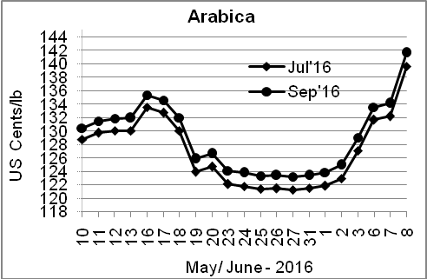
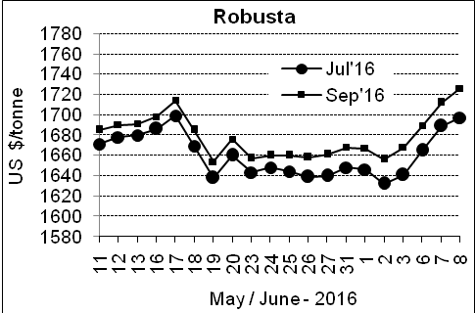

Market Analysis
ICE Arabica coffee futures jumped more than 5 percent to a one-year high on Wednesday, after weather service Somar forecast a risk of isolated frost in Brazil. ICE July arabica coffee futures settled up 7.45 cent, or 5.6 percent, at $1.3965 per lb, the highest since May 2015 and biggest one-day jump since November. July robusta coffee futures settled up $8, or 0.5 percent, at $1,697 per tonne after touching the highest in nearly 10 months at $1,709.

Differentials: | Ar. Plant. A | Ar.Chy.AB | Rob.Pmt.AB | Rob.Chy.AB
Differentials: | NY +18 to +20 | NY –25 to –30 | LIFFE +650 to +700 | LIFFE +160 to +180

ICTA Auction Prices Rs/Kg as on 02.06.2016 (2015-16 season crop)
Grade | MNEB | AA | PB | A | AB | B | C | BBB
Arabica Plantation | --- | --- | --- | --- | --- | --- | --- | 119.00
Arabica Cherry | --- | --- | --- | --- | --- | --- | --- | ---
 | RKR | A | PB | AA | AB | B | C | BBB
Robusta Parchment | --- | --- | --- | --- | --- | --- | --- | ---
Robusta Cherry | --- | --- | 116.00 | --- | 116.00 | --- | 113.00 | 108.00

Raw Coffee Price (Karnataka) as on 08.06.2016 in Rs/50 kg
Ar.Pmt |  |  | Ar.Chy |  |  | Rob.Pmt |  |  | Rob.Chy
7610 | - | 7850 | 3400 | - | 3600 | 5685 | - | 5925 | 2750 | - | 2950

Export update: From 1st January 2016 to 08th June 2016 (in metric tonnes)
 | INDIAN COFFEE | Ar.Pmt | Ar.Chy | Rob.Pmt | Rob.Chy | Roasted seeds | R & G | Instant | Total
1 | Provisional exports (Indian coffee) | 26862 | 7352 | 13551 | 87469 | 18 | 82 | 10329 | 145663
2 | Provisional exports corresponding period last year | 21181 | 7399 | 18087 | 64966 | 12 | 134 | 8874 | 120653
3 | Provisional re-exports | 0 | 0 | 0 | 0 | 0 | 48 | 35802 | 35850
4 | Provisional re-exports corresponding period last year | 0 | 0 | 0 | 0 | 119 | 91 | 30335 | 30545
5 | Total provisional exports (1+3) | 26862 | 7352 | 13551 | 87469 | 18 | 130 | 46131 | 181512
6 | Total provisional exports corresponding period last year (2+4) | 21181 | 7399 | 18087 | 64966 | 131 | 225 | 39209 | 151198

Disclaimer: The Board neither guarantees the accuracy of the information nor accept any liability whatsoever for any direct or consequential loss arising from the use of this report

