COFFEE BOARD: BENGALURU
Daily Coffee Market Report Tuesday, June 07, 2016

Futures Prices 06.06.2016
ICE (New York)- Arabica- US cents / lb |  |  | LIFFE(London) – Robusta -US $ / tonne and cents / lb in brackets (10 MT contract)
Month | Price | Prev. Price | Month | Price | Prev. Price
July – 2016 | 131.70 | 127.10 | July – 2016 | 1665 (75.52) | 1641 (74.43)
Sep – 2016 | 133.60 | 129.05 | Sep – 2016 | 1689 (76.61) | 1668 (75.66)
Dec – 2016 | 136.15 | 131.55 | Nov – 2016 | 1702 (77.20) | 1682 (76.29)
ICO Group Indicator price on 03.06.2016 and previous price in brackets
Other Mild Arabica |  | Robusta |  |  | Exchange Rate Rs/ US $
US Cents/lb | Rs/kg | US Cents/lb | Rs/kg
157.16 (153.29) | 232.00 (227.24) | 85.01 (84.46) | 125.49 (125.20) |  | 66.96
Futures Price Trend
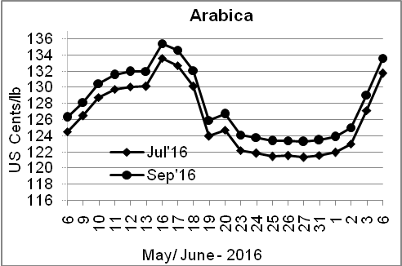
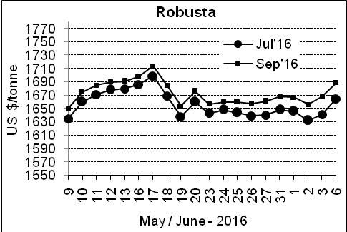

Market Analysis
ICE Arabica coffee futures extended gains above the 200-day moving average and on harvest-hampering rain in Brazil. ICE July arabica coffee futures settled up 4.6 cent, or 3.6 percent, at $1.317 per lb while July robusta coffee futures settled up $24, or 1.5 percent, at $1,665 per tonne.

Differentials: | Ar. Plant. A | Ar.Chy.AB | Rob.Pmt.AB | Rob.Chy.AB
Differentials: | NY +18 to +20 | NY –25 to –30 | LIFFE +650 to +700 | LIFFE +160 to +180

ICTA Auction Prices Rs/Kg as on 02.06.2016 (2015-16 season crop)
Grade | MNEB | AA | PB | A | AB | B | C | BBB
Arabica Plantation | --- | --- | --- | --- | --- | --- | --- | 119.00
Arabica Cherry | --- | --- | --- | --- | --- | --- | --- | ---
 | RKR | A | PB | AA | AB | B | C | BBB
Robusta Parchment | --- | --- | --- | --- | --- | --- | --- | ---
Robusta Cherry | --- | --- | 116.00 | --- | 116.00 | --- | 113.00 | 108.00

Raw Coffee Price (Karnataka) as on 05.06.2016 in Rs/50 kg
Ar.Pmt |  |  | Ar.Chy |  |  | Rob.Pmt |  |  | Rob.Chy
7450 | - | 7500 | 3275 | - | 3375 | 5600 | - | 5660 | 2780 | - | 2800

Export update: From 1st January 2016 to 07th June 2016 (in metric tonnes)
 | INDIAN COFFEE | Ar.Pmt | Ar.Chy | Rob.Pmt | Rob.Chy | Roasted seeds | R & G | Instant | Total
1 | Provisional exports (Indian coffee) | 26393 | 7232 | 13334 | 86079 | 18 | 81 | 10225 | 143363
2 | Provisional exports corresponding period last year | 21123 | 7187 | 17953 | 64405 | 12 | 131 | 8829 | 119641
3 | Provisional re-exports | 0 | 0 | 0 | 0 | 0 | 48 | 35290 | 35337
4 | Provisional re-exports corresponding period last year | 0 | 0 | 0 | 0 | 85 | 91 | 30287 | 30464
5 | Total provisional exports (1+3) | 26393 | 7232 | 13334 | 86079 | 18 | 129 | 45515 | 178700
6 | Total provisional exports corresponding period last year (2+4) | 21123 | 7187 | 17953 | 64405 | 97 | 222 | 39117 | 150104

Disclaimer: The Board neither guarantees the accuracy of the information nor accept any liability whatsoever for any direct or consequential loss arising from the use of this report

