COFFEE BOARD: BENGALURU
Daily Coffee Market Report Wednesday, June 01, 2016

Futures Prices 31.05.2016
ICE (New York)- Arabica- US cents / lb |  |  | LIFFE(London) – Robusta -US $ / tonne and cents / lb in brackets (10 MT contract)
Month | Price | Prev. Price | Month | Price | Prev. Price
July – 2016 | 121.55 | 121.30 | May – 2016 | 1642 (74.48) | 1630 (73.94)
Sep – 2016 | 123.45 | 123.25 | July – 2016 | 1648 (74.75) | 1640 (74.39)
Dec – 2016 | 126.15 | 126.00 | Sep – 2016 | 1668 (75.66) | 1661 (75.34)
ICO Group Indicator price on 30.05.2016 and previous price in brackets
Other Mild Arabica |  | Robusta |  |  | Exchange Rate Rs/ US $
US Cents/lb | Rs/kg | US Cents/lb | Rs/kg
151.56 (151.56) | 224.54 (225.00) | 83.80 (83.68) | 124.15 (124.23) |  | 67.20
Futures Price Trend
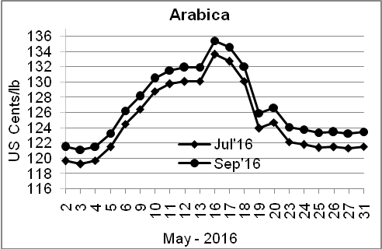
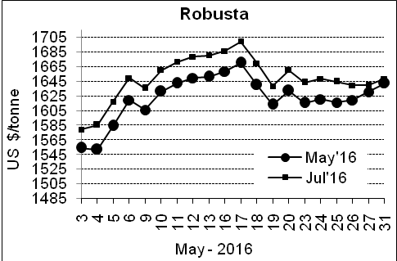

Market Analysis
ICE July arabica coffee futures settled up 0.25 cent, or 0.2 percent, at $1.2155 per lb. In coffee, a potentially disastrous Brazilian harvest has whetted investors' appetite for robusta, causing speculators to ditch well-established short positions and go long. July robusta coffee futures settled up $8, or 0.5 percent, at $1,648 per tonne.

Differentials: | Ar. Plant. A | Ar.Chy.AB | Rob.Pmt.AB | Rob.Chy.AB
Differentials: | NY +18 to +20 | NY –25 to –30 | LIFFE +650 to +700 | LIFFE +160 to +180

ICTA Auction Prices Rs/Kg as on 26.05.2016 (2015-16 season crop)
Grade | MNEB | AA | PB | A | AB | B | C | BBB
Arabica Plantation | --- | --- | --- | --- | --- | 193.00 | 150.00 | ---
Arabica Cherry | --- | 147.00 | 137.00 | 146.00 | --- | 144.00 | 128.00 | 103.50
 | RKR | A | PB | AA | AB | B | C | BBB
Robusta Parchment | --- | --- | 130.00 | 164.36 | 136.00 | --- | 112.00 | 103.00
Robusta Cherry | --- | 120.50 | 115.00 | 124.00 | 116.50 | --- | 114.00 | 103.00

Raw Coffee Price (Karnataka) as on 31.05.2016 in Rs/50 kg
Ar.Pmt |  |  | Ar.Chy |  |  | Rob.Pmt |  |  | Rob.Chy
7650 | - | 7700 | 3275 | - | 3375 | 5600 | - | 5660 | 2725 | - | 2850

Export update: From 1st January 2016 to 31st May 2016 (in metric tonnes)
 | INDIAN COFFEE | Ar.Pmt | Ar.Chy | Rob.Pmt | Rob.Chy | Roasted seeds | R & G | Instant | Total
1 | Provisional exports (Indian coffee) | 25643 | 6933 | 12348 | 82553 | 18 | 79 | 9913 | 137487
2 | Provisional exports corresponding period last year | 20146 | 6980 | 16861 | 61529 | 12 | 126 | 7891 | 113544
3 | Provisional re-exports | 0 | 0 | 0 | 0 | 0 | 48 | 34232 | 34280
4 | Provisional re-exports corresponding period last year | 0 | 0 | 0 | 0 | 48 | 84 | 29710 | 29842
5 | Total provisional exports (1+3) | 25643 | 6933 | 12348 | 82553 | 18 | 127 | 44145 | 171766
6 | Total provisional exports corresponding period last year (2+4) | 20146 | 6980 | 16861 | 61529 | 60 | 211 | 37600 | 143386

Disclaimer: The Board neither guarantees the accuracy of the information nor accept any liability whatsoever for any direct or consequential loss arising from the use of this report

