COFFEE BOARD: BENGALURU
Daily Coffee Market Report Friday, July 01, 2016

Futures Prices 30.06.2016
ICE (New York)- Arabica- US cents / lb |  |  | LIFFE(London) – Robusta -US $ / tonne and cents / lb in brackets (10 MT contract)
Month | Price | Prev. Price | Month | Price | Prev. Price
July – 2016 | 144.10 | 142.85 | July – 2016 | 1688 (76.57) | 1696 (76.93)
Sep – 2016 | 145.65 | 144.45 | Sep – 2016 | 1717 (77.88) | 1722 (78.11)
Dec – 2016 | 148.30 | 147.20 | Nov – 2016 | 1731 (78.52) | 1736 (78.74)
ICO Group Indicator price on 29.06.2016 and previous price in brackets
Other Mild Arabica |  | Robusta |  |  | Exchange Rate Rs/ US $
US Cents/lb | Rs/kg | US Cents/lb | Rs/kg
171.62 (168.12) | 255.84 (251.09) | 87.75 (86.73) | 130.81 (129.53) |  | 67.62

Futures Price Trend
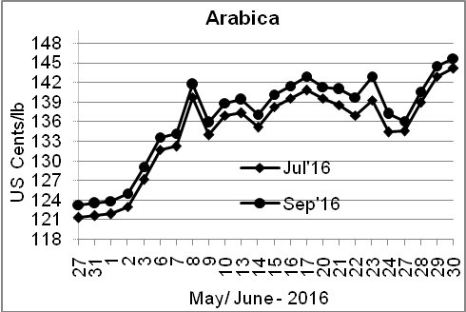
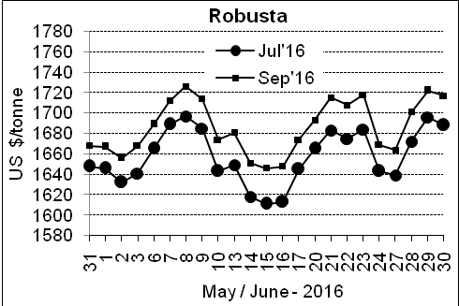

Market Analysis
ICE Arabica coffee futures reversed earlier gains that had been underpinned by a firm Brazilian currency. ICE September arabica coffee futures settled up 1.2 cent, or 0.8 percent, at $1.4565 per lb, after touching $1.4790, the highest since April 2015. It closed the quarter up 12 percent, its strongest since the third quarter of 2014. September robusta coffee futures settled down $5, or 0.29 percent, at $1,717 per tonne, having hit $1,740, the highest since June 9.

Differentials: | Ar. Plant. A | Ar.Chy.AB | Rob.Pmt.AB | Rob.Chy.AB
Differentials: | NY +18 to +20 | NY –25 to –30 | LIFFE +650 to +700 | LIFFE +160 to +180

ICTA Auction Prices Rs/Kg as on 23.06.2016 (2015-16 season crop)
Grade | MNEB | AA | PB | A | AB | B | C | BBB
Arabica Plantation | --- | 248.00 | --- | --- | --- | --- | --- | ---
Arabica Cherry | --- | --- | --- | --- | --- | --- | --- | ---
 | RKR | A | PB | AA | AB | B | C | BBB
Robusta Parchment | --- | --- | 139.00 | --- | 146.00 | --- | 130.00 | 106.00
Robusta Cherry | --- | --- | 117.76 | --- | 118.00 | --- | 115.00 | 103.00

Raw Coffee Price (Karnataka) as on 30.06.2016 in Rs/50 kg
Ar.Pmt |  |  | Ar.Chy |  |  | Rob.Pmt |  |  | Rob.Chy
7825 | - | 8000 | 3525 | - | 3600 | 5625 | - | 5750 | 2750 | - | 2900

Export update: From 1st January 2016 to 30th June 2016 (in metric tonnes)
 | INDIAN COFFEE | Ar.Pmt | Ar.Chy | Rob.Pmt | Rob.Chy | Roasted seeds | R & G | Instant | Total
1 | Provisional exports (Indian coffee) | 29592 | 8029 | 16310 | 99675 | 20 | 97 | 12578 | 166302
2 | Provisional exports corresponding period last year | 23319 | 7907 | 21170 | 73727 | 15 | 148 | 13181 | 139468
3 | Provisional re-exports | 0 | 0 | 0 | 0 | 0 | 48 | 42137 | 42185
4 | Provisional re-exports corresponding period last year | 0 | 0 | 0 | 0 | 119 | 114 | 33431 | 33665
5 | Total provisional exports (1+3) | 29592 | 8029 | 16310 | 99675 | 20 | 144 | 54716 | 208487
6 | Total provisional exports corresponding period last year (2+4) | 23319 | 7907 | 21170 | 73727 | 134 | 262 | 46612 | 173132

Disclaimer: The Board neither guarantees the accuracy of the information nor accept any liability whatsoever for any direct or consequential loss arising from the use of this report

