COFFEE BOARD: BENGALURU
Daily Coffee Market Report Friday, July 08, 2016

Futures Prices 07.07.2016
ICE (New York)- Arabica- US cents / lb |  |  | LIFFE(London) – Robusta -US $ / tonne and cents / lb in brackets (10 MT contract)
Month | Price | Prev. Price | Month | Price | Prev. Price
July – 2016 | 140.45 | 141.95 | July – 2016 | 1760 (79.83) | 1748 (79.29)
Sep – 2016 | 141.80 | 143.30 | Sep – 2016 | 1762 (79.92) | 1749 (79.33)
Dec – 2016 | 144.80 | 146.30 | Nov – 2016 | 1776 (80.56) | 1764 (80.01)
ICO Group Indicator price on 06.07.2016 and previous price in brackets
Other Mild Arabica |  | Robusta |  |  | Exchange Rate Rs/ US $
US Cents/lb | Rs/kg | US Cents/lb | Rs/kg
169.86 (171.74) | 252.77 (255.19) | 88.69 (89.17) | 131.98 (132.50) |  | 67.50

Futures Price Trend
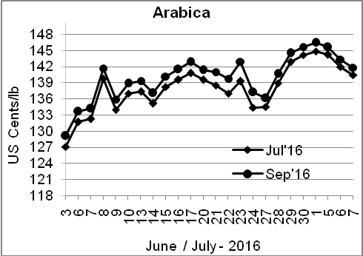
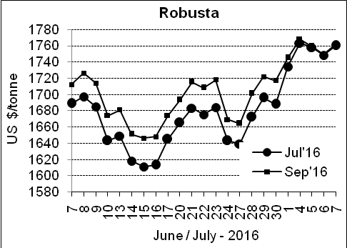

Market Analysis
ICE September arabica coffee futures settled down 1.5 cent, or 1.1 percent, at $1.418 per lb. Robusta coffee hovered near a one-year high, underpinned by tight stocks, while arabica turned lower. September robusta coffee futures settled up $13, or 0.7 percent, at $1,762 per tonne.

Differentials: | Ar. Plant. A | Ar.Chy.AB | Rob.Pmt.AB | Rob.Chy.AB
Differentials: | NY +18 to +20 | NY –25 to –30 | LIFFE +650 to +700 | LIFFE +160 to +180

ICTA Auction Prices Rs/Kg as on 30.06.2016 (2015-16 season crop)
Grade | MNEB | AA | PB | A | AB | B | C | BBB
Arabica Plantation | --- | --- | 213.10 | 215.30 | --- | 191.50 | 167.00 | 120.35
Arabica Cherry | --- | --- | 144.00 | --- | --- | --- | --- | 108.00
 | RKR | A | PB | AA | AB | B | C | BBB
Robusta Parchment | --- | --- | 138.50 | --- | 144.00 | --- | 130.00 | 108.00
Robusta Cherry | --- | --- | 118.80 | 124.10 | 120.10 | --- | 114.50 | 103.00

Raw Coffee Price (Karnataka) as on 07.07.2016 in Rs/50 kg
Ar.Pmt |  |  | Ar.Chy |  |  | Rob.Pmt |  |  | Rob.Chy
7950 | - | 8200 | 3550 | - | 3700 | 5700 | - | 6000 | 2800 | - | 3000

Export update: From 1st January 2016 to 06th July 2016 (in metric tonnes)
 | INDIAN COFFEE | Ar.Pmt | Ar.Chy | Rob.Pmt | Rob.Chy | Roasted seeds | R & G | Instant | Total
1 | Provisional exports (Indian coffee) | 29933 | 8050 | 17107 | 101487 | 23 | 118 | 12731 | 169449
2 | Provisional exports corresponding period last year | 23733 | 7986 | 21971 | 77069 | 15 | 150 | 13465 | 144388
3 | Provisional re-exports | 0 | 0 | 0 | 0 | 0 | 48 | 41819 | 41866
4 | Provisional re-exports corresponding period last year | 0 | 0 | 0 | 0 | 119 | 131 | 34148 | 34398
5 | Total provisional exports (1+3) | 29933 | 8050 | 17107 | 101487 | 23 | 166 | 54550 | 211315
6 | Total provisional exports corresponding period last year (2+4) | 23733 | 7986 | 21971 | 77069 | 134 | 280 | 47613 | 178786

Disclaimer: The Board neither guarantees the accuracy of the information nor accept any liability whatsoever for any direct or consequential loss arising from the use of this report

