COFFEE BOARD: BENGALURU
Daily Coffee Market Report Friday, July 15, 2016

Futures Prices 14.07.2016
ICE (New York)- Arabica- US cents / lb |  |  | LIFFE(London) – Robusta -US $ / tonne and cents / lb in brackets (10 MT contract)
Month | Price | Prev. Price | Month | Price | Prev. Price
July – 2016 | 150.30 | 146.20 | July – 2016 | 1836 (83.28) | 1810 (82.10)
Sep – 2016 | 152.15 | 147.65 | Sep – 2016 | 1842 (83.55) | 1816 (82.37)
Dec – 2016 | 155.10 | 150.55 | Nov – 2016 | 1860 (84.37) | 1834 (83.19)
ICO Group Indicator price on 13.07.2016 and previous price in brackets
Other Mild Arabica |  | Robusta |  |  | Exchange Rate Rs/ US $
US Cents/lb | Rs/kg | US Cents/lb | Rs/kg
173.97 (173.99) | 256.63 (257.77) | 91.40 (91.13) | 134.83 (135.01) |  | 66.91

Futures Price Trend
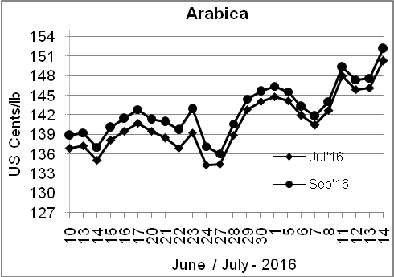
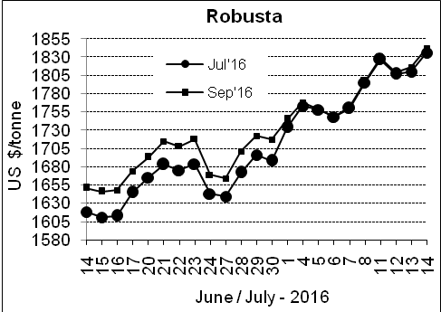

Market Analysis
ICE arabica coffee futures rose amid forecasts for cold weather in top grower Brazil, nearing this week's 1-1/2-year high. ICE September arabica coffee futures settled up 4.5 cent, or 3.1percent, at $1.5215 per lb. September robusta coffee futures settled up $26, or 1.4 percent, at $1,842 per tonne.

Differentials: | Ar. Plant. A | Ar.Chy.AB | Rob.Pmt.AB | Rob.Chy.AB
Differentials: | NY +0 to +2 | NY –25 to –30 | LIFFE +500 to +550 | LIFFE +100 to +120

ICTA Auction Prices Rs/Kg as on 07.07.2016 (2015-16 season crop)
Grade | MNEB | AA | PB | A | AB | B | C | BBB
Arabica Plantation | 248.00 | 242.00 | 211.00 | 220.00 | --- | --- | --- | 118.00
Arabica Cherry | --- | --- | --- | --- | --- | --- | --- | ---
 | RKR | A | PB | AA | AB | B | C | BBB
Robusta Parchment | --- | --- | --- | --- | --- | --- | --- | 106.50
Robusta Cherry | --- | --- | 120.70 | 127.50 | 124.50 | --- | 118.50 | 104.50

Raw Coffee Price (Karnataka) as on 14.07.2016 in Rs/50 kg
Ar.Pmt |  |  | Ar.Chy |  |  | Rob.Pmt |  |  | Rob.Chy
8000 | - | 8250 | 3550 | - | 3700 | 5700 | - | 5800 | 2800 | - | 3150

Export update: From 1st January 2016 to 14th July 2016 (in metric tonnes)
 | INDIAN COFFEE | Ar.Pmt | Ar.Chy | Rob.Pmt | Rob.Chy | Roasted seeds | R & G | Instant | Total
1 | Provisional exports (Indian coffee) | 30711 | 8159 | 17456 | 104952 | 23 | 122 | 13813 | 175236
2 | Provisional exports corresponding period last year | 24154 | 8017 | 22661 | 80529 | 15 | 169 | 14081 | 149626
3 | Provisional re-exports | 0 | 0 | 0 | 0 | 0 | 48 | 43837 | 43885
4 | Provisional re-exports corresponding period last year | 0 | 0 | 0 | 0 | 119 | 131 | 35040 | 35289
5 | Total provisional exports (1+3) | 30711 | 8159 | 17456 | 104952 | 23 | 170 | 57650 | 219121
6 | Total provisional exports corresponding period last year (2+4) | 24154 | 8017 | 22661 | 80529 | 134 | 299 | 49121 | 184916

Disclaimer: The Board neither guarantees the accuracy of the information nor accept any liability whatsoever for any direct or consequential loss arising from the use of this report

