COFFEE BOARD: BENGALURU
Daily Coffee Market Report Friday, July 22, 2016

Futures Prices 21.07.2016
ICE (New York)- Arabica- US cents / lb |  |  | LIFFE(London) – Robusta -US $ / tonne and cents / lb in brackets (10 MT contract)
Month | Price | Prev. Price | Month | Price | Prev. Price
Sep – 2016 | 146.85 | 147.00 | July – 2016 | 1810 (82.10) | 1808 (82.01)
Dec – 2016 | 149.90 | 149.95 | Sep – 2016 | 1818 (82.46) | 1816 (82.37)
Mar – 2017 | 152.70 | 152.75 | Nov – 2016 | 1841 (83.51) | 1838 (83.37)
ICO Group Indicator price on 20.07.2016 and previous price in brackets
Other Mild Arabica |  | Robusta |  |  | Exchange Rate Rs/ US $
US Cents/lb | Rs/kg | US Cents/lb | Rs/kg
173.60 (172.90) | 257.20 (256.04) | 91.78 (91.73) | 135.98 (135.84) |  | 67.20

Futures Price Trend
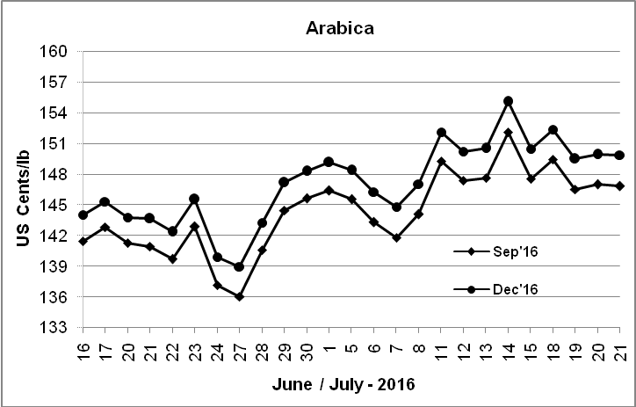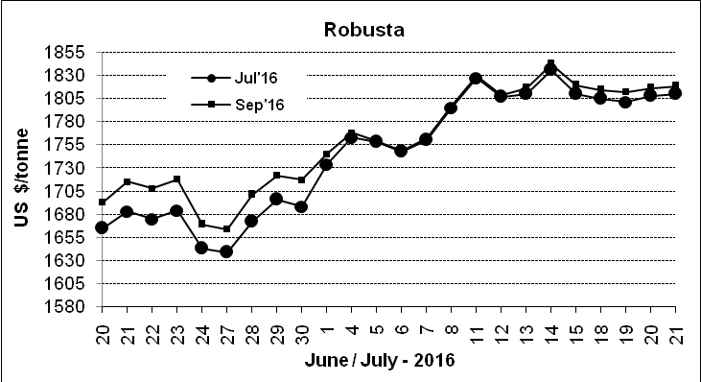

Market Analysis
ICE arabica coffee futures turned slightly lower after rising for most of the session, with traders cautious about forecasts for cool weather in Brazil's growing region on Friday.ICE arabica coffee futures for September was down 0.1% to settle at $1.4685 a pound. September robusta coffee futures settled up $2, or 0.1 percent, at $1,818 per tonne.

Differentials: | Ar. Plant. A | Ar.Chy.AB | Rob.Pmt.AB | Rob.Chy.AB
Differentials: | NY +0 to +2 | NY –25 to –30 | LIFFE +500 to +550 | LIFFE +100 to +120

ICTA Auction Prices Rs/Kg as on 14.07.2016 (2015-16 season crop)
Grade | MNEB | AA | PB | A | AB | B | C | BBB
Arabica Plantation | --- | 233.06 | 220.00 | 214.00 | --- | 200.00 | 176.00 | 115.50
Arabica Cherry | --- | 163.00 | 140.50 | --- | 143.56 | --- | 118.50 | 101.00
 | RKR | A | PB | AA | AB | B | C | BBB
Robusta Parchment | --- | --- | 140.00 | --- | 146.00 | --- | 130.00 | 112.00
Robusta Cherry | --- | --- | 124.00 | 127.00 | 127.00 | --- | 120.00 | 112.00

Raw Coffee Price (Karnataka) as on 21.07.2016 in Rs/50 kg
Ar.Pmt |  |  | Ar.Chy |  |  | Rob.Pmt |  |  | Rob.Chy
8000 | - | 8200 | 3585 | - | 3725 | 5700 | - | 5800 | 2800 | - | 3015

Export update: From 1st January 2016 to 21st July 2016 (in metric tonnes)
 | INDIAN COFFEE | Ar.Pmt | Ar.Chy | Rob.Pmt | Rob.Chy | Roasted seeds | R & G | Instant | Total
1 | Provisional exports (Indian coffee) | 31162 | 8353 | 18254 | 107789 | 25 | 127 | 14269 | 179979
2 | Provisional exports corresponding period last year | 24598 | 8118 | 23340 | 82567 | 15 | 173 | 15497 | 154309
3 | Provisional re-exports | 0 | 0 | 0 | 0 | 0 | 62 | 44967 | 45029
4 | Provisional re-exports corresponding period last year | 0 | 0 | 0 | 0 | 119 | 150 | 35949 | 36218
5 | Total provisional exports (1+3) | 31162 | 8353 | 18254 | 107789 | 25 | 189 | 59236 | 225008
6 | Total provisional exports corresponding period last year (2+4) | 24598 | 8118 | 23340 | 82567 | 134 | 324 | 51446 | 190527

Disclaimer: The Board neither guarantees the accuracy of the information nor accept any liability whatsoever for any direct or consequential loss arising from the use of this report

