COFFEE BOARD: BENGALURU
Daily Coffee Market Report Monday, July 04, 2016

Futures Prices 01.07.2016
ICE (New York)- Arabica- US cents / lb |  |  | LIFFE(London) – Robusta -US $ / tonne and cents / lb in brackets (10 MT contract)
Month | Price | Prev. Price | Month | Price | Prev. Price
July – 2016 | 144.85 | 144.10 | July – 2016 | 1734 (78.65) | 1688 (76.57)
Sep – 2016 | 146.40 | 145.65 | Sep – 2016 | 1745 (79.15) | 1717 (77.88)
Dec – 2016 | 149.15 | 148.30 | Nov – 2016 | 1758 (79.74) | 1731 (78.52)
ICO Group Indicator price on 01.07.2016 and previous price in brackets
Other Mild Arabica |  | Robusta |  |  | Exchange Rate Rs/ US $
US Cents/lb | Rs/kg | US Cents/lb | Rs/kg
173.48 (172.68) | 256.95 (256.74) | 88.29 (87.58) | 130.77 (130.21) |  | 67.18

Futures Price Trend
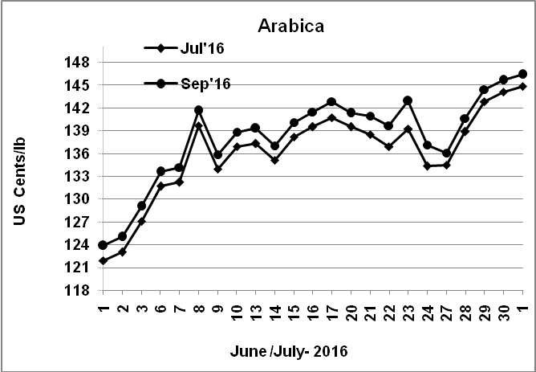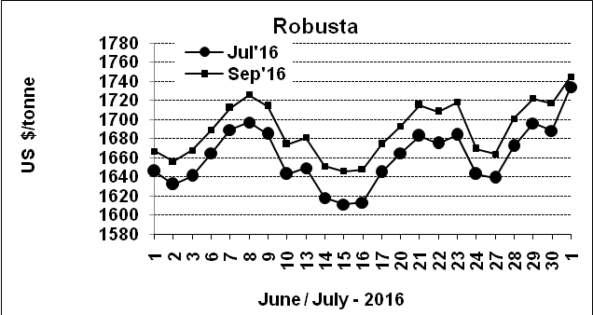

Market Analysis
ICE September arabica coffee futures settled up 0.75 cent at $1.464 per lb. September robusta coffee futures settled up $28 at $1,745 per tonne.

Differentials: | Ar. Plant. A | Ar.Chy.AB | Rob.Pmt.AB | Rob.Chy.AB
Differentials: | NY +18 to +20 | NY –25 to –30 | LIFFE +650 to +700 | LIFFE +160 to +180

ICTA Auction Prices Rs/Kg as on 30.06.2016 (2015-16 season crop)
Grade | MNEB | AA | PB | A | AB | B | C | BBB
Arabica Plantation | --- | --- | 213.10 | 215.30 | --- | 191.50 | 167.00 | 120.35
Arabica Cherry | --- | --- | 144.00 | --- | --- | --- | --- | 108.00
 | RKR | A | PB | AA | AB | B | C | BBB
Robusta Parchment | --- | --- | 138.50 | --- | 144.00 | --- | 130.00 | 108.00
Robusta Cherry | --- | --- | 118.80 | 124.10 | 120.10 | --- | 114.50 | 103.00

Raw Coffee Price (Karnataka) as on 30.06.2016 in Rs/50 kg
Ar.Pmt |  |  | Ar.Chy |  |  | Rob.Pmt |  |  | Rob.Chy
7825 | - | 8000 | 3525 | - | 3600 | 5625 | - | 5750 | 2750 | - | 2900

Export update: From 1st January 2016 to 01 July 2016 (in metric tonnes)
 | INDIAN COFFEE | Ar.Pmt | Ar.Chy | Rob.Pmt | Rob.Chy | Roasted seeds | R & G | Instant | Total
1 | Provisional exports (Indian coffee) | 29615 | 8029 | 16693 | 100171 | 23 | 105 | 12619 | 167255
2 | Provisional exports corresponding period last year | 23454 | 7907 | 21428 | 74519 | 15 | 148 | 13267 | 140739
3 | Provisional re-exports | 0 | 0 | 0 | 0 | 0 | 48 | 42288 | 42335
4 | Provisional re-exports corresponding period last year | 0 | 0 | 0 | 0 | 119 | 114 | 33522 | 33756
5 | Total provisional exports (1+3) | 29615 | 8029 | 16693 | 100171 | 23 | 152 | 54907 | 209590
6 | Total provisional exports corresponding period last year (2+4) | 23454 | 7907 | 21428 | 74519 | 134 | 263 | 46789 | 174494

Disclaimer: The Board neither guarantees the accuracy of the information nor accept any liability whatsoever for any direct or consequential loss arising from the use of this report

