COFFEE BOARD: BENGALURU
Daily Coffee Market Report Monday, July 11, 2016

Futures Prices 08.07.2016
ICE (New York)- Arabica- US cents / lb |  |  | LIFFE(London) – Robusta -US $ / tonne and cents / lb in brackets (10 MT contract)
Month | Price | Prev. Price | Month | Price | Prev. Price
July – 2016 | 142.75 | 140.45 | July – 2016 | 1795 (81.42) | 1760 (79.83)
Sep – 2016 | 144.10 | 141.80 | Sep – 2016 | 1797 (81.51) | 1762 (79.92)
Dec – 2016 | 147.05 | 144.80 | Nov – 2016 | 1810 (82.10) | 1776 (80.56)
ICO Group Indicator price on 07.07.2016 and previous price in brackets
Other Mild Arabica |  | Robusta |  |  | Exchange Rate Rs/ US $
US Cents/lb | Rs/kg | US Cents/lb | Rs/kg
168.40 (169.86) | 250.45 (252.77) | 89.43 (88.69) | 133.00 (131.98) |  | 67.46

Futures Price Trend
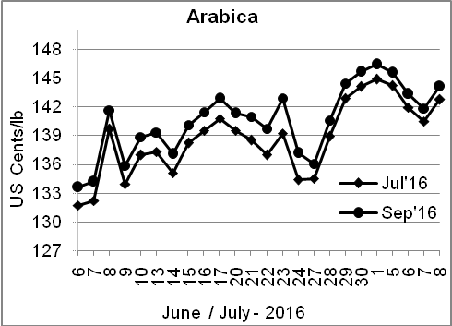
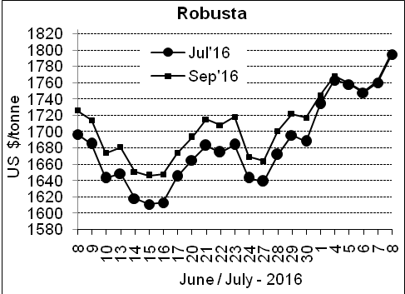

Market Analysis
ICE arabica coffee prices ended higher on Friday, as the currency of Brazil, the world's largest growing region, rose against the dollar for the first time in six sessions. ICE Arabica coffee for September delivery rose 1.6% to close at $1.441 a pound. Robusta coffee prices also rose, with traders noting a slow flow of exports from Indonesia after the El Nino weather pattern eroded production there. A very poor robusta harvest in Brazil underpinned a 2 percent gain for September robusta coffee, which closed up $35 at $1,797 per tonne.

Differentials: | Ar. Plant. A | Ar.Chy.AB | Rob.Pmt.AB | Rob.Chy.AB
Differentials: | NY +18 to +20 | NY –25 to –30 | LIFFE +650 to +700 | LIFFE +160 to +180

ICTA Auction Prices Rs/Kg as on 07.07.2016 (2015-16 season crop)
Grade | MNEB | AA | PB | A | AB | B | C | BBB
Arabica Plantation | 248.00 | 242.00 | 211.00 | 220.00 | --- | --- | --- | 118.00
Arabica Cherry | --- | --- | --- | --- | --- | --- | --- | ---
 | RKR | A | PB | AA | AB | B | C | BBB
Robusta Parchment | --- | --- | --- | --- | --- | --- | --- | 106.50
Robusta Cherry | --- | --- | 120.70 | 127.50 | 124.50 | --- | 118.50 | 104.50

Raw Coffee Price (Karnataka) as on 07.07.2016 in Rs/50 kg
Ar.Pmt |  |  | Ar.Chy |  |  | Rob.Pmt |  |  | Rob.Chy
7950 | - | 8200 | 3550 | - | 3700 | 5700 | - | 6000 | 2800 | - | 3000

Export update: From 1st January 2016 to 08th July 2016 (in metric tonnes)
 | INDIAN COFFEE | Ar.Pmt | Ar.Chy | Rob.Pmt | Rob.Chy | Roasted seeds | R & G | Instant | Total
1 | Provisional exports (Indian coffee) | 30168 | 8050 | 17177 | 102893 | 23 | 118 | 13014 | 171444
2 | Provisional exports corresponding period last year | 23913 | 7986 | 22072 | 77651 | 15 | 151 | 13557 | 145345
3 | Provisional re-exports | 0 | 0 | 0 | 0 | 0 | 48 | 42703 | 42751
4 | Provisional re-exports corresponding period last year | 0 | 0 | 0 | 0 | 119 | 131 | 34214 | 34463
5 | Total provisional exports (1+3) | 30168 | 8050 | 17177 | 102893 | 23 | 166 | 55717 | 214195
6 | Total provisional exports corresponding period last year (2+4) | 23913 | 7986 | 22072 | 77651 | 134 | 282 | 47771 | 179809

Disclaimer: The Board neither guarantees the accuracy of the information nor accept any liability whatsoever for any direct or consequential loss arising from the use of this report

