COFFEE BOARD: BENGALURU
Daily Coffee Market Report Monday, July 18, 2016

Futures Prices 15.07.2016
ICE (New York)- Arabica- US cents / lb |  |  | LIFFE(London) – Robusta -US $ / tonne and cents / lb in brackets (10 MT contract)
Month | Price | Prev. Price | Month | Price | Prev. Price
July – 2016 | 145.70 | 150.30 | July – 2016 | 1810 (82.10) | 1836 (83.28)
Sep – 2016 | 147.55 | 152.15 | Sep – 2016 | 1819 (82.51) | 1842 (83.55)
Dec – 2016 | 150.50 | 155.10 | Nov – 2016 | 1841 (83.51) | 1860 (84.37)
ICO Group Indicator price on 14.07.2016 and previous price in brackets
Other Mild Arabica |  | Robusta |  |  | Exchange Rate Rs/ US $
US Cents/lb | Rs/kg | US Cents/lb | Rs/kg
178.13 (173.97) | 263.39 (256.63) | 92.62 (91.40) | 136.95 (134.83) |  | 67.07

Futures Price Trend
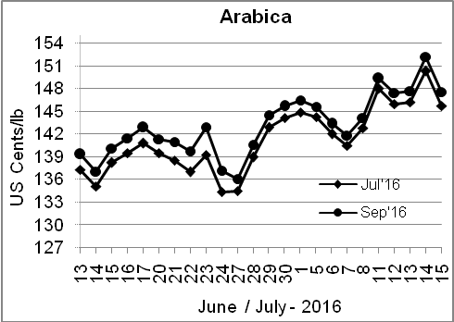
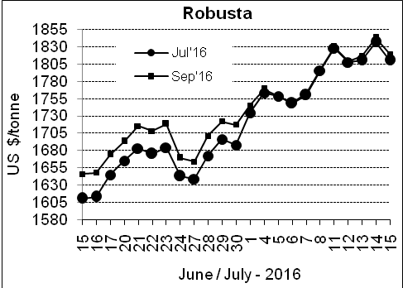

Market Analysis
Arabica coffee futures fell after rallying to the highest levels in nearly 1-1/2 years, pressured by the by the firm U.S. dollar and the weakness in larger commodity markets. ICE September arabica settled down 4.6 cent, or 3 percent, at $1.4755 per lb, after touching a 17-month peak of $1.548 per lb amid concerns over the quality of new crop Brazilian arabica beans. Upward momentum waned, however, and prices turned sharply lower. September robusta coffee futures settled down $23, or 1.3 percent, at $1,819 per tonne, after touching a 16-month high of $1,866.

Differentials: | Ar. Plant. A | Ar.Chy.AB | Rob.Pmt.AB | Rob.Chy.AB
Differentials: | NY +0 to +2 | NY –25 to –30 | LIFFE +500 to +550 | LIFFE +100 to +120

ICTA Auction Prices Rs/Kg as on 14.07.2016 (2015-16 season crop)
Grade | MNEB | AA | PB | A | AB | B | C | BBB
Arabica Plantation | --- | 233.06 | 220.00 | 214.00 | --- | 200.00 | 176.00 | 115.50
Arabica Cherry | --- | 163.00 | 140.50 | --- | 143.56 | --- | 118.50 | 101.00
 | RKR | A | PB | AA | AB | B | C | BBB
Robusta Parchment | --- | --- | 140.00 | --- | 146.00 | --- | 130.00 | 112.00
Robusta Cherry | --- | --- | 124.00 | 127.00 | 127.00 | --- | 120.00 | 112.00

Raw Coffee Price (Karnataka) as on 15.07.2016 in Rs/50 kg
Ar.Pmt |  |  | Ar.Chy |  |  | Rob.Pmt |  |  | Rob.Chy
8000 | - | 8250 | 3550 | - | 3700 | 5700 | - | 5800 | 2800 | - | 3150

Export update: From 1st January 2016 to 15th July 2016 (in metric tonnes)
 | INDIAN COFFEE | Ar.Pmt | Ar.Chy | Rob.Pmt | Rob.Chy | Roasted seeds | R & G | Instant | Total
1 | Provisional exports (Indian coffee) | 30733 | 8159 | 17612 | 105375 | 23 | 122 | 13835 | 175860
2 | Provisional exports corresponding period last year | 24248 | 8037 | 22795 | 81019 | 15 | 170 | 14084 | 150367
3 | Provisional re-exports | 0 | 0 | 0 | 0 | 0 | 48 | 43910 | 43957
4 | Provisional re-exports corresponding period last year | 0 | 0 | 0 | 0 | 119 | 131 | 35247 | 35497
5 | Total provisional exports (1+3) | 30733 | 8159 | 17612 | 105375 | 23 | 170 | 57745 | 219817
6 | Total provisional exports corresponding period last year (2+4) | 24248 | 8037 | 22795 | 81019 | 134 | 300 | 49331 | 185864

Disclaimer: The Board neither guarantees the accuracy of the information nor accept any liability whatsoever for any direct or consequential loss arising from the use of this report

