COFFEE BOARD: BENGALURU
Daily Coffee Market Report Monday, July 25, 2016

Futures Prices 22.07.2016
ICE (New York)- Arabica- US cents / lb |  |  | LIFFE(London) – Robusta -US $ / tonne and cents / lb in brackets (10 MT contract)
Month | Price | Prev. Price | Month | Price | Prev. Price
Sep – 2016 | 141.90 | 146.85 | July – 2016 | 1780 (80.74) | 1810 (82.10)
Dec – 2016 | 145.00 | 149.90 | Sep – 2016 | 1788 (81.10) | 1818 (82.46)
Mar – 2017 | 147.80 | 152.70 | Nov – 2016 | 1813 (82.24) | 1841 (83.51)
ICO Group Indicator price on 21.07.2016 and previous price in brackets
Other Mild Arabica |  | Robusta |  |  | Exchange Rate Rs/ US $
US Cents/lb | Rs/kg | US Cents/lb | Rs/kg
173.31 (173.60) | 256.53 (257.20) | 91.33 (91.78) | 135.19 (135.98) |  | 67.14

Futures Price Trend
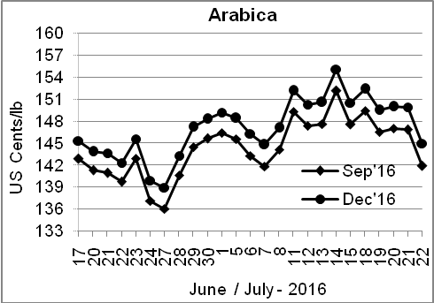
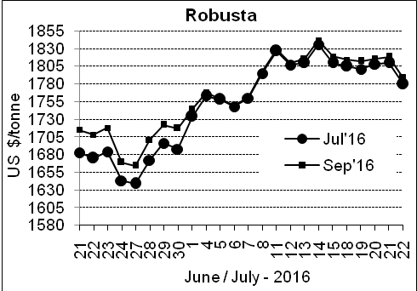

Market Analysis
ICE Arabica coffee futures look their biggest one-day tumble in a month on Friday, falling on the expectation that exports from Colombia will normalize after a truckers strike ended and as automatic sell orders were triggered. ICE September arabica coffee futures settled down 4.95 cents, or 3.37 percent, at $1.419 per lb, after falling 4.4 percent to $1.4035, the lowest since July 6. September robusta settled down $30, or 1.7 percent, at $1,788 per tonne.

Differentials: | Ar. Plant. A | Ar.Chy.AB | Rob.Pmt.AB | Rob.Chy.AB
Differentials: | NY +0 to +2 | NY –25 to –30 | LIFFE +500 to +550 | LIFFE +100 to +120

ICTA Auction Prices Rs/Kg as on 21.07.2016 (2015-16 season crop)
Grade | MNEB | AA | PB | A | AB | B | C | BBB
Arabica Plantation | --- | 241.00 | --- | --- | --- | --- | --- | 121.00
Arabica Cherry | --- | 178.00 | 148.00 | --- | 163.50 | --- | 124.00 | 116.30
 | RKR | A | PB | AA | AB | B | C | BBB
Robusta Parchment | --- | --- | --- | --- | --- | --- | --- | ---
Robusta Cherry | --- | --- | 127.00 | --- | 130.00 | --- | 123.00 | 113.00

Raw Coffee Price (Karnataka) as on 21.07.2016 in Rs/50 kg
Ar.Pmt |  |  | Ar.Chy |  |  | Rob.Pmt |  |  | Rob.Chy
8000 | - | 8200 | 3585 | - | 3725 | 5700 | - | 5800 | 2800 | - | 3015

Export update: From 1st January 2016 to 22nd July 2016 (in metric tonnes)
 | INDIAN COFFEE | Ar.Pmt | Ar.Chy | Rob.Pmt | Rob.Chy | Roasted seeds | R & G | Instant | Total
1 | Provisional exports (Indian coffee) | 31262 | 8353 | 18436 | 108212 | 25 | 127 | 14309 | 180725
2 | Provisional exports corresponding period last year | 24693 | 8118 | 23494 | 82821 | 15 | 176 | 15566 | 154883
3 | Provisional re-exports | 0 | 0 | 0 | 0 | 0 | 62 | 45205 | 45267
4 | Provisional re-exports corresponding period last year | 0 | 0 | 0 | 0 | 119 | 150 | 36048 | 36318
5 | Total provisional exports (1+3) | 31262 | 8353 | 18436 | 108212 | 25 | 189 | 59514 | 225992
6 | Total provisional exports corresponding period last year (2+4) | 24693 | 8118 | 23494 | 82821 | 134 | 326 | 51614 | 191201

Disclaimer: The Board neither guarantees the accuracy of the information nor accept any liability whatsoever for any direct or consequential loss arising from the use of this report

