COFFEE BOARD: BENGALURU
Daily Coffee Market Report Tuesday, July 12, 2016

Futures Prices 11.07.2016
ICE (New York)- Arabica- US cents / lb |  |  | LIFFE(London) – Robusta -US $ / tonne and cents / lb in brackets (10 MT contract)
Month | Price | Prev. Price | Month | Price | Prev. Price
July – 2016 | 147.95 | 142.75 | July – 2016 | 1827 (82.87) | 1795 (81.42)
Sep – 2016 | 149.30 | 144.10 | Sep – 2016 | 1829 (82.96) | 1797 (81.51)
Dec – 2016 | 152.15 | 147.05 | Nov – 2016 | 1843 (83.60) | 1810 (82.10)
ICO Group Indicator price on 08.07.2016 and previous price in brackets
Other Mild Arabica |  | Robusta |  |  | Exchange Rate Rs/ US $
US Cents/lb | Rs/kg | US Cents/lb | Rs/kg
170.49 (168.40) | 252.36 (250.45) | 90.65 (89.43) | 134.18 (133.00) |  | 67.14

Futures Price Trend
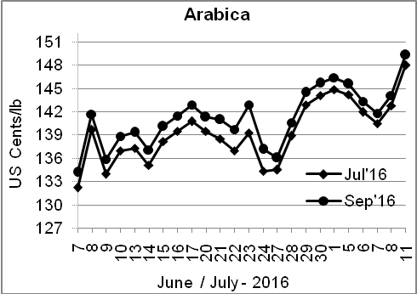
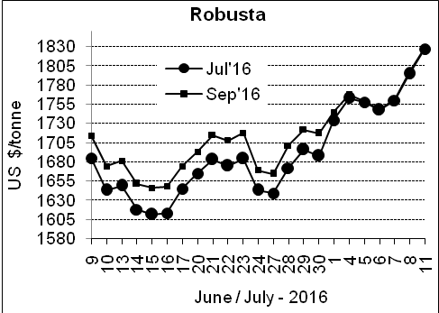

Market Analysis
ICE arabica coffee futures rallied to the highest in more than a year on Monday lifted by chart-based buying and concerns over the quality of new crop Brazilian beans. ICE September arabica coffee futures settled up 5.2 cent, or 3.6 percent, at $1.493 per lb, after reaching $1.4995, the highest since February 2015. September robusta coffee futures settled up $32, or 1.8 percent, at $1,829 per tonne, the highest since April 2015.

Differentials: | Ar. Plant. A | Ar.Chy.AB | Rob.Pmt.AB | Rob.Chy.AB
Differentials: | NY +18 to +20 | NY –25 to –30 | LIFFE +650 to +700 | LIFFE +160 to +180

ICTA Auction Prices Rs/Kg as on 07.07.2016 (2015-16 season crop)
Grade | MNEB | AA | PB | A | AB | B | C | BBB
Arabica Plantation | 248.00 | 242.00 | 211.00 | 220.00 | --- | --- | --- | 118.00
Arabica Cherry | --- | --- | --- | --- | --- | --- | --- | ---
 | RKR | A | PB | AA | AB | B | C | BBB
Robusta Parchment | --- | --- | --- | --- | --- | --- | --- | 106.50
Robusta Cherry | --- | --- | 120.70 | 127.50 | 124.50 | --- | 118.50 | 104.50

Raw Coffee Price (Karnataka) as on 11.07.2016 in Rs/50 kg
Ar.Pmt |  |  | Ar.Chy |  |  | Rob.Pmt |  |  | Rob.Chy
8000 | - | 8100 | 3550 | - | 3675 | 5700 | - | 5750 | 2800 | - | 2975

Export update: From 1st January 2016 to 11th July 2016 (in metric tonnes)
 | INDIAN COFFEE | Ar.Pmt | Ar.Chy | Rob.Pmt | Rob.Chy | Roasted seeds | R & G | Instant | Total
1 | Provisional exports (Indian coffee) | 30389 | 8070 | 17370 | 103719 | 23 | 120 | 13297 | 172988
2 | Provisional exports corresponding period last year | 24072 | 7995 | 22132 | 78471 | 15 | 152 | 13835 | 146672
3 | Provisional re-exports | 0 | 0 | 0 | 0 | 0 | 48 | 43122 | 43170
4 | Provisional re-exports corresponding period last year | 0 | 0 | 0 | 0 | 119 | 131 | 34447 | 34696
5 | Total provisional exports (1+3) | 30389 | 8070 | 17370 | 103719 | 23 | 168 | 56419 | 216157
6 | Total provisional exports corresponding period last year (2+4) | 24072 | 7995 | 22132 | 78471 | 134 | 283 | 48281 | 181368

Disclaimer: The Board neither guarantees the accuracy of the information nor accept any liability whatsoever for any direct or consequential loss arising from the use of this report

