COFFEE BOARD: BENGALURU
Daily Coffee Market Report Tuesday, July 19, 2016

Futures Prices 18.07.2016
ICE (New York)- Arabica- US cents / lb |  |  | LIFFE(London) – Robusta -US $ / tonne and cents / lb in brackets (10 MT contract)
Month | Price | Prev. Price | Month | Price | Prev. Price
July – 2016 | 147.80 | 145.70 | July – 2016 | 1805 (81.87) | 1810 (82.10)
Sep – 2016 | 149.45 | 147.55 | Sep – 2016 | 1814 (82.28) | 1819 (82.51)
Dec – 2016 | 152.40 | 150.50 | Nov – 2016 | 1836 (83.28) | 1841 (83.51)
ICO Group Indicator price on 15.07.2016 and previous price in brackets
Other Mild Arabica |  | Robusta |  |  | Exchange Rate Rs/ US $
US Cents/lb | Rs/kg | US Cents/lb | Rs/kg
173.99 (178.13) | 257.38 (263.39) | 92.23 (92.62) | 136.44 (136.95) |  | 67.10

Futures Price Trend
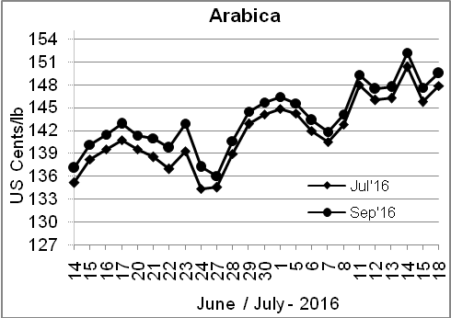
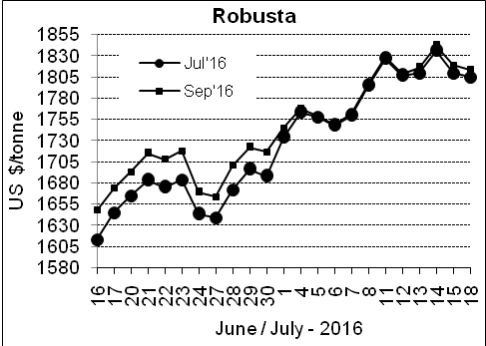

Market Analysis
ICE Arabica coffee futures turned higher on Monday, after an unexpected moderate frost hit parts of Brazil's main coffee region, but gains were limited as traders waited to learn the extent of the damage. ICE September arabica coffee futures settled up 1.9 cent, or 1.3 percent, at $1.4945 per lb. Robusta coffee futures turned lower after finding early support from a poor harvest in Brazil, a late start to harvesting in Indonesia, and concerns over the impact of adverse weather on output in top grower Vietnam. September robusta coffee futures settled down $5, or 0.3 percent, at $1,814 per tonne, having touched a 16-month high of $1,866 on Friday, supported by tight global supplies.

Differentials: | Ar. Plant. A | Ar.Chy.AB | Rob.Pmt.AB | Rob.Chy.AB
Differentials: | NY +0 to +2 | NY –25 to –30 | LIFFE +500 to +550 | LIFFE +100 to +120

ICTA Auction Prices Rs/Kg as on 14.07.2016 (2015-16 season crop)
Grade | MNEB | AA | PB | A | AB | B | C | BBB
Arabica Plantation | --- | 233.06 | 220.00 | 214.00 | --- | 200.00 | 176.00 | 115.50
Arabica Cherry | --- | 163.00 | 140.50 | --- | 143.56 | --- | 118.50 | 101.00
 | RKR | A | PB | AA | AB | B | C | BBB
Robusta Parchment | --- | --- | 140.00 | --- | 146.00 | --- | 130.00 | 112.00
Robusta Cherry | --- | --- | 124.00 | 127.00 | 127.00 | --- | 120.00 | 112.00

Raw Coffee Price (Karnataka) as on 15.07.2016 in Rs/50 kg
Ar.Pmt |  |  | Ar.Chy |  |  | Rob.Pmt |  |  | Rob.Chy
8000 | - | 8250 | 3550 | - | 3700 | 5700 | - | 5800 | 2800 | - | 3150

Export update: From 1st January 2016 to 18th July 2016 (in metric tonnes)
 | INDIAN COFFEE | Ar.Pmt | Ar.Chy | Rob.Pmt | Rob.Chy | Roasted seeds | R & G | Instant | Total
1 | Provisional exports (Indian coffee) | 30958 | 8185 | 17995 | 106403 | 24 | 123 | 13858 | 177546
2 | Provisional exports corresponding period last year | 24360 | 8037 | 23080 | 81603 | 15 | 170 | 14623 | 151889
3 | Provisional re-exports | 0 | 0 | 0 | 0 | 0 | 62 | 44209 | 44271
4 | Provisional re-exports corresponding period last year | 0 | 0 | 0 | 0 | 119 | 131 | 35528 | 35778
5 | Total provisional exports (1+3) | 30958 | 8185 | 17995 | 106403 | 24 | 185 | 58066 | 221816
6 | Total provisional exports corresponding period last year (2+4) | 24360 | 8037 | 23080 | 81603 | 134 | 300 | 50152 | 187666

Disclaimer: The Board neither guarantees the accuracy of the information nor accept any liability whatsoever for any direct or consequential loss arising from the use of this report

