COFFEE BOARD: BENGALURU
Daily Coffee Market Report Wednesday, July 06, 2016

Futures Prices 05.07.2016
ICE (New York)- Arabica- US cents / lb |  |  | LIFFE(London) – Robusta -US $ / tonne and cents / lb in brackets (10 MT contract)
Month | Price | Prev. Price | Month | Price | Prev. Price
July – 2016 | 144.20 | 144.85 | July – 2016 | 1758 (79.74) | 1763 (79.97)
Sep – 2016 | 145.55 | 146.40 | Sep – 2016 | 1759 (79.79) | 1768 (80.20)
Dec – 2016 | 148.40 | 149.15 | Nov – 2016 | 1774 (80.47) | 1781 (80.78)
ICO Group Indicator price on 04.07.2016 and previous price in brackets
Other Mild Arabica |  | Robusta |  |  | Exchange Rate Rs/ US $
US Cents/lb | Rs/kg | US Cents/lb | Rs/kg
173.57 (173.48) | 257.91 (256.95) | 89.70 (88.29) | 133.29 (130.77) |  | 67.40

Futures Price Trend
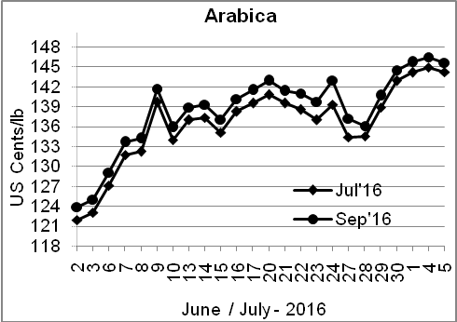
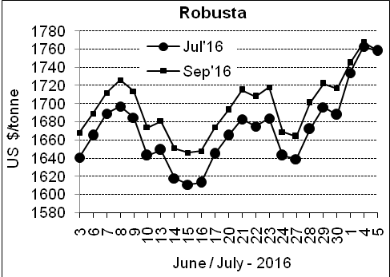

Market Analysis
ICE September arabica coffee futures fell 0.85 cents or 0.6% to $1.4555 a pound. September robusta coffee futures settled down $9 at $1,759 per tonne.

Differentials: | Ar. Plant. A | Ar.Chy.AB | Rob.Pmt.AB | Rob.Chy.AB
Differentials: | NY +18 to +20 | NY –25 to –30 | LIFFE +650 to +700 | LIFFE +160 to +180

ICTA Auction Prices Rs/Kg as on 30.06.2016 (2015-16 season crop)
Grade | MNEB | AA | PB | A | AB | B | C | BBB
Arabica Plantation | --- | --- | 213.10 | 215.30 | --- | 191.50 | 167.00 | 120.35
Arabica Cherry | --- | --- | 144.00 | --- | --- | --- | --- | 108.00
 | RKR | A | PB | AA | AB | B | C | BBB
Robusta Parchment | --- | --- | 138.50 | --- | 144.00 | --- | 130.00 | 108.00
Robusta Cherry | --- | --- | 118.80 | 124.10 | 120.10 | --- | 114.50 | 103.00

Raw Coffee Price (Karnataka) as on 05.07.2016 in Rs/50 kg
Ar.Pmt |  |  | Ar.Chy |  |  | Rob.Pmt |  |  | Rob.Chy
8000 | - | 8250 | 3550 | - | 3700 | 5725 | - | 6000 | 2800 | - | 3000

Export update: From 1st January 2016 to 05th July 2016 (in metric tonnes)
 | INDIAN COFFEE | Ar.Pmt | Ar.Chy | Rob.Pmt | Rob.Chy | Roasted seeds | R & G | Instant | Total
1 | Provisional exports (Indian coffee) | 29776 | 8050 | 17010 | 100984 | 23 | 118 | 12731 | 168692
2 | Provisional exports corresponding period last year | 23580 | 7966 | 21839 | 75556 | 15 | 149 | 13328 | 142433
3 | Provisional re-exports | 0 | 0 | 0 | 0 | 0 | 48 | 41641 | 41688
4 | Provisional re-exports corresponding period last year | 0 | 0 | 0 | 0 | 119 | 131 | 33954 | 34203
5 | Total provisional exports (1+3) | 29776 | 8050 | 17010 | 100984 | 23 | 166 | 54372 | 210380
6 | Total provisional exports corresponding period last year (2+4) | 23580 | 7966 | 21839 | 75556 | 134 | 279 | 47282 | 176636

Disclaimer: The Board neither guarantees the accuracy of the information nor accept any liability whatsoever for any direct or consequential loss arising from the use of this report

