COFFEE BOARD: BENGALURU
Daily Coffee Market Report Wednesday, July 13, 2016

Futures Prices 12.07.2016
ICE (New York)- Arabica- US cents / lb |  |  | LIFFE(London) – Robusta -US $ / tonne and cents / lb in brackets (10 MT contract)
Month | Price | Prev. Price | Month | Price | Prev. Price
July – 2016 | 145.95 | 147.95 | July – 2016 | 1807 (81.96) | 1827 (82.87)
Sep – 2016 | 147.40 | 149.30 | Sep – 2016 | 1809 (82.05) | 1829 (82.96)
Dec – 2016 | 150.25 | 152.15 | Nov – 2016 | 1827 (82.87) | 1843 (83.60)
ICO Group Indicator price on 11.07.2016 and previous price in brackets
Other Mild Arabica |  | Robusta |  |  | Exchange Rate Rs/ US $
US Cents/lb | Rs/kg | US Cents/lb | Rs/kg
176.03 (170.49) | 260.60 (252.36) | 92.38 (90.65) | 136.76 (134.18) |  | 67.15

Futures Price Trend
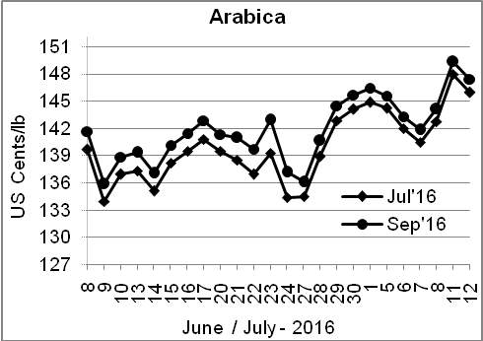
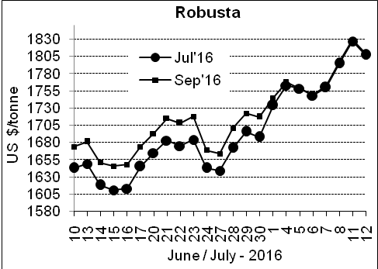

Market Analysis
ICE arabica coffee futures turned lower after extending the prior session's gains to the highest levels in more than a year. ICE September arabica coffee futures settled down 1.9 cent, or 1.3 percent, at $1.474 per lb, after reaching $1.514, the highest since February 2015. September robusta coffee futures settled down $20, or 1.1 percent, at $1,809 per tonne.

Differentials: | Ar. Plant. A | Ar.Chy.AB | Rob.Pmt.AB | Rob.Chy.AB
Differentials: | NY +18 to +20 | NY –25 to –30 | LIFFE +650 to +700 | LIFFE +160 to +180

ICTA Auction Prices Rs/Kg as on 07.07.2016 (2015-16 season crop)
Grade | MNEB | AA | PB | A | AB | B | C | BBB
Arabica Plantation | 248.00 | 242.00 | 211.00 | 220.00 | --- | --- | --- | 118.00
Arabica Cherry | --- | --- | --- | --- | --- | --- | --- | ---
 | RKR | A | PB | AA | AB | B | C | BBB
Robusta Parchment | --- | --- | --- | --- | --- | --- | --- | 106.50
Robusta Cherry | --- | --- | 120.70 | 127.50 | 124.50 | --- | 118.50 | 104.50

Raw Coffee Price (Karnataka) as on 12.07.2016 in Rs/50 kg
Ar.Pmt |  |  | Ar.Chy |  |  | Rob.Pmt |  |  | Rob.Chy
8000 | - | 8100 | 3550 | - | 3675 | 5700 | - | 5750 | 2800 | - | 2975

Export update: From 1st January 2016 to 12th July 2016 (in metric tonnes)
 | INDIAN COFFEE | Ar.Pmt | Ar.Chy | Rob.Pmt | Rob.Chy | Roasted seeds | R & G | Instant | Total
1 | Provisional exports (Indian coffee) | 30539 | 8089 | 17456 | 104204 | 23 | 122 | 13473 | 173905
2 | Provisional exports corresponding period last year | 24072 | 7995 | 22132 | 78471 | 15 | 152 | 13835 | 146672
3 | Provisional re-exports | 0 | 0 | 0 | 0 | 0 | 48 | 43275 | 43323
4 | Provisional re-exports corresponding period last year | 0 | 0 | 0 | 0 | 119 | 131 | 34447 | 34696
5 | Total provisional exports (1+3) | 30539 | 8089 | 17456 | 104204 | 23 | 169 | 56748 | 217228
6 | Total provisional exports corresponding period last year (2+4) | 24072 | 7995 | 22132 | 78471 | 134 | 283 | 48281 | 181368

Disclaimer: The Board neither guarantees the accuracy of the information nor accept any liability whatsoever for any direct or consequential loss arising from the use of this report

