COFFEE BOARD: BENGALURU
Daily Coffee Market Report Monday, August 01, 2016

Futures Prices 29.07.2016
ICE (New York)- Arabica- US cents / lb |  |  | LIFFE(London) – Robusta -US $ / tonne and cents / lb in brackets (10 MT contract)
Month | Price | Prev. Price | Month | Price | Prev. Price
Sep – 2016 | 146.20 | 142.15 | July – 2016 | 1805 (81.87) | 1805 (81.87)
Dec – 2016 | 149.50 | 145.35 | Sep – 2016 | 1848 (83.82) | 1813 (82.24)
Mar – 2017 | 152.40 | 148.30 | Nov – 2016 | 1871 (84.87) | 1837 (83.33)
ICO Group Indicator price on 28.07.2016 and previous price in brackets
Other Mild Arabica |  | Robusta |  |  | Exchange Rate Rs/ US $
US Cents/lb | Rs/kg | US Cents/lb | Rs/kg
167.67 (166.80) | 247.78 (246.60) | 91.18 (91.91) | 134.74 (134.40) |  | 67.03

Futures Price Trend
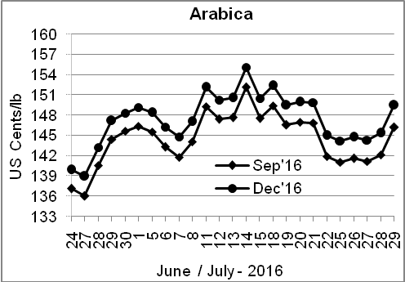
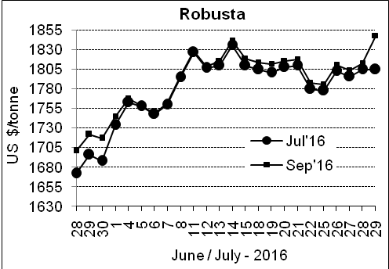

Market Analysis
ICE Arabica coffee futures for September closed up 4.05 cents, or 2.6% to settle at $1.462 a pound. September robusta coffee futures settled up $35 at $1,848 per tonne,

Differentials: | Ar. Plant. A | Ar.Chy.AB | Rob.Pmt.AB | Rob.Chy.AB
Differentials: | NY +2 to +5 | NY –30 to –35 | LIFFE +500 to +550 | LIFFE +170 to +180

ICTA Auction Prices Rs/Kg as on 28.07.2016 (2015-16 season crop)
Grade | MNEB | AA | PB | A | AB | B | C | BBB
Arabica Plantation | --- | --- | 218.00 | 217.00 | --- | --- | --- | ---
Arabica Cherry | --- | --- | --- | --- | --- | --- | --- | 115.00
 | RKR | A | PB | AA | AB | B | C | BBB
Robusta Parchment | 147.00 | --- | 137.00 | 149.00 | 146.00 | --- | --- | 113.26
Robusta Cherry | --- | --- | --- | --- | --- | --- | --- | 113.00

Raw Coffee Price (Karnataka) as on 28.07.2016 in Rs/50 kg
Ar.Pmt |  |  | Ar.Chy |  |  | Rob.Pmt |  |  | Rob.Chy
8100 | - | 8150 | 3625 | - | 3750 | 5700 | - | 5810 | 2900 | - | 3200

Export update: From 1st January 2016 to 29th July 2016 (in metric tonnes)
 | INDIAN COFFEE | Ar.Pmt | Ar.Chy | Rob.Pmt | Rob.Chy | Roasted seeds | R & G | Instant | Total
1 | Provisional exports (Indian coffee) | 32086 | 8407 | 19051 | 111766 | 25 | 131 | 14604 | 186069
2 | Provisional exports corresponding period last year | 24933 | 8133 | 24136 | 84929 | 24 | 185 | 17059 | 159397
3 | Provisional re-exports | 0 | 0 | 0 | 0 | 0 | 91 | 45751 | 45842
4 | Provisional re-exports corresponding period last year | 0 | 0 | 0 | 0 | 119 | 156 | 36935 | 37210
5 | Total provisional exports (1+3) | 32086 | 8407 | 19051 | 111766 | 25 | 221 | 60355 | 231910
6 | Total provisional exports corresponding period last year (2+4) | 24933 | 8133 | 24136 | 84929 | 143 | 341 | 53993 | 196607

Disclaimer: The Board neither guarantees the accuracy of the information nor accept any liability whatsoever for any direct or consequential loss arising from the use of this report

