COFFEE BOARD: BENGALURU
Daily Coffee Market Report Thursday, August 04, 2016

Futures Prices 03.08.2016
ICE (New York)- Arabica- US cents / lb |  |  | LIFFE(London) – Robusta -US $ / tonne and cents / lb in brackets (10 MT contract)
Month | Price | Prev. Price | Month | Price | Prev. Price
Sep – 2016 | 140.40 | 141.25 | Sep – 2016 | 1827 (82.87) | 1826 (82.83)
Dec – 2016 | 143.85 | 144.60 | Nov – 2016 | 1853 (84.05) | 1851 (83.96)
Mar – 2017 | 146.95 | 147.60 | Jan – 2017 | 1871 (84.87) | 1868 (84.73)
ICO Group Indicator price on 02.08.2016 and previous price in brackets
Other Mild Arabica |  | Robusta |  |  | Exchange Rate Rs/ US $
US Cents/lb | Rs/kg | US Cents/lb | Rs/kg
167.84 (168.64) | 247.69 (248.21) | 92.95 (92.30) | 137.17 (135.85) |  | 66.94

Futures Price Trend
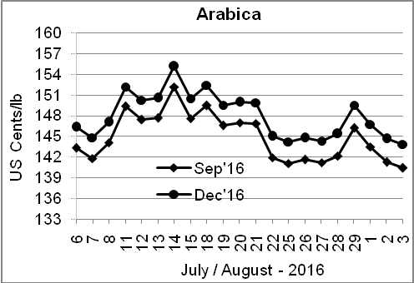
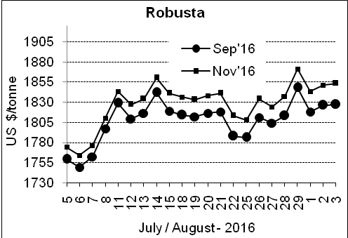

Market Analysis
ICE Arabica coffee prices have rallied 14% over the last two months on the back of unusually low inventories of coffee in Brazil. ICE Arabica coffee futures for September delivery fell 0.85 cent, or 0.6% to $1.404 a pound. Robusta coffee futures were little changed, although the market remained underpinned by tight supplies. September robusta coffee futures settled up $1, or 0.05 percent, at $1,827 per tonne.

Differentials: | Ar. Plant. A | Ar.Chy.AB | Rob.Pmt.AB | Rob.Chy.AB
Differentials: | NY +2 to +5 | NY –30 to –35 | LIFFE +500 to +550 | LIFFE +170 to +180

ICTA Auction Prices Rs/Kg as on 28.07.2016 (2015-16 season crop)
Grade | MNEB | AA | PB | A | AB | B | C | BBB
Arabica Plantation | --- | --- | 218.00 | 217.00 | --- | --- | --- | ---
Arabica Cherry | --- | --- | --- | --- | --- | --- | --- | 115.00
 | RKR | A | PB | AA | AB | B | C | BBB
Robusta Parchment | 147.00 | --- | 137.00 | 149.00 | 146.00 | --- | --- | 113.26
Robusta Cherry | --- | --- | --- | --- | --- | --- | --- | 113.00

Raw Coffee Price (Karnataka) as on 03.08.2016 in Rs/50 kg
Ar.Pmt |  |  | Ar.Chy |  |  | Rob.Pmt |  |  | Rob.Chy
8060 | - | 8150 | 3675 | - | 3750 | 5750 | - | 5925 | 2975 | - | 3200

Export update: From 1st January 2016 to 03rd August 2016 (in metric tonnes)
 | INDIAN COFFEE | Ar.Pmt | Ar.Chy | Rob.Pmt | Rob.Chy | Roasted seeds | R & G | Instant | Total
1 | Provisional exports (Indian coffee) | 32326 | 8426 | 19340 | 113370 | 25 | 131 | 14766 | 188384
2 | Provisional exports corresponding period last year | 25221 | 8163 | 24675 | 86666 | 24 | 185 | 17253 | 162186
3 | Provisional re-exports | 0 | 0 | 0 | 0 | 0 | 91 | 46690 | 46781
4 | Provisional re-exports corresponding period last year | 0 | 0 | 0 | 0 | 119 | 169 | 37172 | 37460
5 | Total provisional exports (1+3) | 32326 | 8426 | 19340 | 113370 | 25 | 222 | 61457 | 235164
6 | Total provisional exports corresponding period last year (2+4) | 25221 | 8163 | 24675 | 86666 | 143 | 354 | 54425 | 199646

Disclaimer: The Board neither guarantees the accuracy of the information nor accept any liability whatsoever for any direct or consequential loss arising from the use of this report

