COFFEE BOARD: BENGALURU
Daily Coffee Market Report Tuesday, August 02, 2016

Futures Prices 01.08.2016
ICE (New York)- Arabica- US cents / lb |  |  | LIFFE(London) – Robusta -US $ / tonne and cents / lb in brackets (10 MT contract)
Month | Price | Prev. Price | Month | Price | Prev. Price
Sep – 2016 | 143.45 | 146.20 | Sep – 2016 | 1818 (82.46) | 1848 (83.82)
Dec – 2016 | 146.75 | 149.50 | Nov – 2016 | 1843 (83.60) | 1871 (84.87)
Mar – 2017 | 149.70 | 152.40 | Jan – 2017 | 1860 (84.37) | 1888 (85.64)
ICO Group Indicator price on 29.07.2016 and previous price in brackets
Other Mild Arabica |  | Robusta |  |  | Exchange Rate Rs/ US $
US Cents/lb | Rs/kg | US Cents/lb | Rs/kg
171.31 (167.67) | 252.06 (247.78) | 92.63 (91.18) | 136.29 (134.74) |  | 66.74

Futures Price Trend
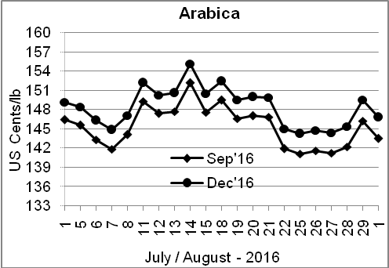
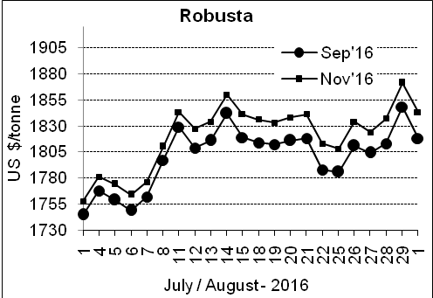

Market Analysis
ICE coffee futures prices eased, falling along with the weakness in larger commodity markets as the U.S. dollar firmed. ICE September arabica coffee futures settled down 2.75 cent, or 1.9 percent, at $1.4345 per lb, while September robusta coffee futures settled down $30, or 1.6 percent, at $1,818 per tonne.

Differentials: | Ar. Plant. A | Ar.Chy.AB | Rob.Pmt.AB | Rob.Chy.AB
Differentials: | NY +2 to +5 | NY –30 to –35 | LIFFE +500 to +550 | LIFFE +170 to +180

ICTA Auction Prices Rs/Kg as on 28.07.2016 (2015-16 season crop)
Grade | MNEB | AA | PB | A | AB | B | C | BBB
Arabica Plantation | --- | --- | 218.00 | 217.00 | --- | --- | --- | ---
Arabica Cherry | --- | --- | --- | --- | --- | --- | --- | 115.00
 | RKR | A | PB | AA | AB | B | C | BBB
Robusta Parchment | 147.00 | --- | 137.00 | 149.00 | 146.00 | --- | --- | 113.26
Robusta Cherry | --- | --- | --- | --- | --- | --- | --- | 113.00

Raw Coffee Price (Karnataka) as on 01.08.2016 in Rs/50 kg
Ar.Pmt |  |  | Ar.Chy |  |  | Rob.Pmt |  |  | Rob.Chy
8110 | - | 8300 | 3675 | - | 3800 | 5775 | - | 5950 | 2975 | - | 3250

Export update: From 1st January 2016 to 01st August 2016 (in metric tonnes)
 | INDIAN COFFEE | Ar.Pmt | Ar.Chy | Rob.Pmt | Rob.Chy | Roasted seeds | R & G | Instant | Total
1 | Provisional exports (Indian coffee) | 32181 | 8407 | 19167 | 112772 | 25 | 131 | 14627 | 187310
2 | Provisional exports corresponding period last year | 25068 | 8163 | 24356 | 85953 | 24 | 185 | 17229 | 160978
3 | Provisional re-exports | 0 | 0 | 0 | 0 | 0 | 91 | 46059 | 46149
4 | Provisional re-exports corresponding period last year | 0 | 0 | 0 | 0 | 119 | 159 | 37151 | 37429
5 | Total provisional exports (1+3) | 32181 | 8407 | 19167 | 112772 | 25 | 221 | 60686 | 233459
6 | Total provisional exports corresponding period last year (2+4) | 25068 | 8163 | 24356 | 85953 | 143 | 344 | 54380 | 198407

Disclaimer: The Board neither guarantees the accuracy of the information nor accept any liability whatsoever for any direct or consequential loss arising from the use of this report

