COFFEE BOARD: BENGALURU
Daily Coffee Market Report Wednesday, August 24, 2016

Futures Prices 23.08.2016
ICE (New York)- Arabica- US cents / lb |  |  | LIFFE(London) – Robusta -US $ / tonne and cents / lb in brackets (10 MT contract)
Month | Price | Prev. Price | Month | Price | Prev. Price
Sep – 2016 | 145.30 | 144.10 | Sep – 2016 | 1791 (81.24) | 1799 (81.60)
Dec – 2016 | 147.25 | 146.40 | Nov – 2016 | 1821 (82.60) | 1831 (83.05)
Mar – 2017 | 150.45 | 149.60 | Jan – 2017 | 1844 (83.64) | 1855 (84.14)
ICO Group Indicator price on 22.08.2016 and previous price in brackets
Other Mild Arabica |  | Robusta |  |  | Exchange Rate Rs/ US $
US Cents/lb | Rs/kg | US Cents/lb | Rs/kg
170.31 (165.59) | 251.90 (245.29) | 91.84 (91.15) | 135.84 (135.02) |  | 67.09

Futures Price Trend
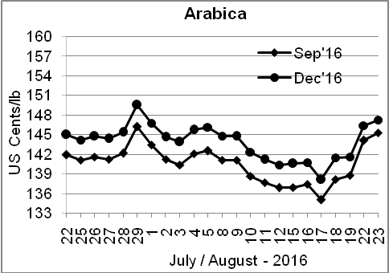
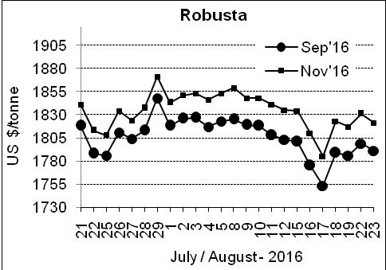

Market Analysis
ICE December arabica coffee futures rose for the fourth straight session, settling up 0.85 cent, or 0.58 percent, at $1.4725 per lb, after rising as high as $1.4775 a lb, the highest level since August 8, amid concerns about the impact of cold temperatures and rains on crops in top-producer Brazil. November robusta coffee futures settled down $10, or 0.55 percent, at $1,821 per tonne.

Differentials: | Ar. Plant. A | Ar.Chy.AB | Rob.Pmt.AB | Rob.Chy.AB
Differentials: | NY +2 to +5 | NY –30 to –35 | LIFFE +500 to +550 | LIFFE +170 to +180

ICTA Auction Prices Rs/Kg as on 18.08.2016 (2015-16 season crop)
Grade | MNEB | AA | PB | A | AB | B | C | BBB
Arabica Plantation | --- | --- | 218.00 | --- | --- | --- | 178.00 | ---
Arabica Cherry | --- | --- | 138.00 | --- | 142.00 | --- | --- | ---
 | RKR | A | PB | AA | AB | B | C | BBB
Robusta Parchment | --- | --- | 132.50 | 143.50 | 140.50 | --- | 125.00 | 113.00
Robusta Cherry | --- | --- | --- | --- | 130.00 | --- | 124.00 | 114.00

Raw Coffee Price (Karnataka) as on 18.08.2016 in Rs/50 kg
Ar.Pmt |  |  | Ar.Chy |  |  | Rob.Pmt |  |  | Rob.Chy
8000 | - | 8050 | 3585 | - | 3650 | 5750 | - | 5800 | 3070 | - | 3125

Export update: From 1st January 2016 to 23rd August 2016 (in metric tonnes)
 | INDIAN COFFEE | Ar.Pmt | Ar.Chy | Rob.Pmt | Rob.Chy | Roasted seeds | R & G | Instant | Total
1 | Provisional exports (Indian coffee) | 33365 | 8775 | 20406 | 122291 | 28 | 137 | 15961 | 200964
2 | Provisional exports corresponding period last year | 26174 | 8396 | 26063 | 94257 | 26 | 202 | 20230 | 175346
3 | Provisional re-exports | 0 | 0 | 0 | 0 | 0 | 91 | 50678 | 50769
4 | Provisional re-exports corresponding period last year | 0 | 0 | 0 | 0 | 119 | 204 | 38847 | 39170
5 | Total provisional exports (1+3) | 33365 | 8775 | 20406 | 122291 | 28 | 228 | 66639 | 251732
6 | Total provisional exports corresponding period last year (2+4) | 26174 | 8396 | 26063 | 94257 | 145 | 406 | 59077 | 214516

Disclaimer: The Board neither guarantees the accuracy of the information nor accept any liability whatsoever for any direct or consequential loss arising from the use of this report

