COFFEE BOARD: BENGALURU
Daily Coffee Market Report Wednesday, March 15, 2017

Futures Prices 14.03.2017
ICE (New York)- Arabica- US cents / lb |  |  | LIFFE(London) – Robusta -US $ / tonne and cents / lb in brackets (10 MT contract)
Month | Price | Prev. Price | Month | Price | Prev. Price
Mar – 2017 | 139.60 | 140.50 | Mar – 2017 | 2151 (97.57) | 2146 (97.34)
May – 2017 | 141.25 | 142.35 | May – 2017 | 2169 (98.38) | 2164 (98.16)
July – 2017 | 143.60 | 144.70 | July – 2017 | 2186 (99.16) | 2181 (98.93)

ICO Group Indicator price on 13.03.2017 and previous price in brackets
Other Mild Arabica |  | Robusta |  |  | Exchange Rate Rs/ US $
US Cents/lb | Rs/kg | US Cents/lb | Rs/kg
160.44 (160.13) | 234.08 (235.43) | 106.17 (106.80) | 154.90 (157.02) |  | 66.18

Futures Price Trend
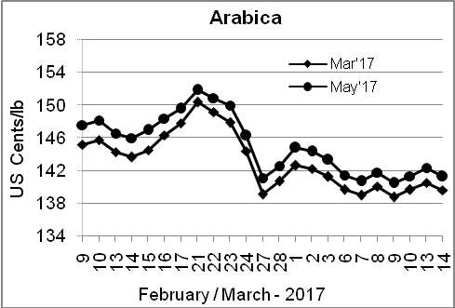
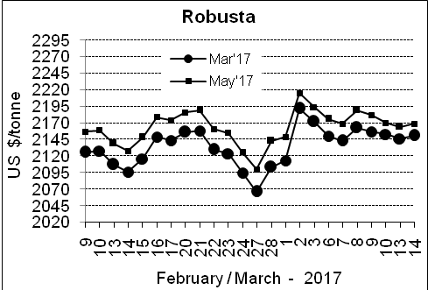

Market Analysis
ICE May arabica coffee futures settled down 1.1 cent, or 0.8 percent, at $1.4125 per lb. May robusta coffee futures settled up $5, or 0.2 percent, at $2,169 per tonne.

Differentials: | Ar. Plant. A | Ar.Chy.AB | Rob.Pmt.AB | Rob.Chy.AB
Differentials: | NY +12 to +15 | NY –25 to –28 | LIFFE +525 to +550 | LIFFE +65 to +85
2

ICTA Auction Prices Rs/Kg as on 09.03.2017
Grade | MNEB | AA | PB | A | AB | B | C | BBB
Arabica Plantation | --- | 254.00 | 216.50 | 230.00 | --- | 211.00 | --- | ---
Arabica Cherry | --- | --- | --- | --- | --- | --- | 138.00 | ---
 | RKR | A | PB | AA | AB | B | C | BBB
Robusta Parchment | --- | --- | 160.00 | --- | --- | --- | 155.00 | ---
Robusta Cherry | --- | --- | --- | --- | --- | --- | --- | ---

Raw Coffee Price (Karnataka) as on 13.03.2017 in Rs/50 kg
Ar.Pmt |  |  | Ar.Chy |  |  | Rob.Pmt |  |  | Rob.Chy
8875 | - | 9000 | 4300 | - | 4500 | 6875 | - | 7050 | 3500 | - | 3775

Export update: From 1st January 2017 to 14th March 2017 (in metric tonnes)
 | INDIAN COFFEE | Ar.Pmt | Ar.Chy | Rob.Pmt | Rob.Chy | Roasted seeds | R & G | Instant | Total
1 | Provisional exports (Indian coffee) | 8289 | 3770 | 4488 | 33444 | 11 | 65 | 5250 | 55318
2 | Provisional exports corresponding period last year | 12273 | 2711 | 4195 | 32400 | 10 | 44 | 4476 | 56108
3 | Provisional re-exports | 0 | 14 | 40 | 0 | 0 | 0 | 17517 | 17570
4 | Provisional re-exports corresponding period last year | 0 | 0 | 0 | 0 | 0 | 5 | 15855 | 15860
5 | Total provisional exports (1+3) | 8289 | 3784 | 4528 | 33444 | 11 | 65 | 22767 | 72887
6 | Total provisional exports corresponding period last year (2+4) | 12273 | 2711 | 4195 | 32400 | 10 | 49 | 20331 | 71968

Disclaimer: The Board neither guarantees the accuracy of the information nor accept any liability whatsoever for any direct or consequential loss arising from the use of this report

